|  |  |
| --- | --- |
|  | **2021-22** |
|  | Logo%20blue%20only |

**Section de français**



**Year 1 A Level and AS Standalone**

Student Guide

**Le français à Godalming**

**Bienvenue et bravo d’avoir choisi de continuer tes études de français!**

Travel broadens the mind and never more so than when you can speak the language. Learning a Language is a **challenging** but very **rewarding** adventure.

**Aims of the course**

**What will you learn on this Advanced GCE course?**

This course will help you to develop your general study skills, but most of all you will learn to **COMMUNICATE** at a higher level in French. During your GCSE you talked with confidence about personal matters which concerned you directly, e.g. family life and schoolwork. At AS (Standalone) and A Level Year 1 you will be moving to **wider issues** such as the place of voluntary work or francophone music.

**How will the work be different?**

In your GCSE course the emphasis was placed on understanding and communicating particular items of information in various everyday situations. The Advanced Level course, in contrast, is based to a large extend on the investigation and **DISCUSSION of French topical issues**. You will need to deal with purely factual information, but will also be handling more **theoretical concepts, IDEAS and opinions.**

You will be able to read, listen to, understand and extract information from written and spoken passages in the target language taken from authentic sources, such as magazines, news reports on the Internet, films or books.

You will learn how to write essays, to translate and to hold conversations and discussions in French. You will learn all the appropriate grammar, words and phrases that will help you to: present information in the target language, organise your arguments, provide opinions and analyse your ideas.

**Staff**

Frédérique Lecerf (Head of French) [fel@godalming.ac.uk](mailto:fel@godalming.ac.uk)

Françoise Marteel [fem@godalming.ac.uk](mailto:fem@godalming.ac.uk)

Laïla Gunn (Assistante) [lag@godalming.ac.uk](mailto:lag@godalming.ac.uk)

**Awarding body and Unit codes**

**AQA AS Standalone Code:** 7651

## AS Standalone and Year 1 of A Level Course overview

**Aspects of French-speaking society: current trends**

|  |  |  |  |  |
| --- | --- | --- | --- | --- |
| **1.** | The changing nature of family  * Trends in partnership * Different family structures * Problems within the family |  | **2.** | The “cyber-society”Technology and daily life  * Dangers of digital technology * Different users and possible future |

|  |  |
| --- | --- |
| **3.** | The place of voluntary work  * Who are the volunteers * The value for those helped * The value for volunteers |

**Artistic culture in the French-speaking world**

|  |  |  |  |  |
| --- | --- | --- | --- | --- |
| **4.** | A culture proud of its heritage  * National and regional heritage * Heritage and tourism * Heritage and culture |  | **5.** | Contemporary francophone music  * Diversity in contemporary francophone music * The audience * Threats and safeguard of francophone music |

|  |  |
| --- | --- |
| **6.** | Cinema: The 7th art form  * Why the 7th art form? * The evolution of French cinema * The popularity of French cinema |

|  |  |
| --- | --- |
| **7.** | The study of a film **La Haine** |

**AS Standalone exam outline ONLY:**

|  |  |  |  |  |
| --- | --- | --- | --- | --- |
| **Paper** | **Skills** | **Time** | **Marks** | **Weighting** |
| Paper 1 | **Listening, Reading and Writing**  -Listening and reading tasks responding to spoken and written passages from a range of texts, contexts covering different registers and range of authentic sources.  -Translation into English | 1 hr 45 min | 80 marks | 45% |
| Paper 2 | **Translation and essay writing**  -Translation into the language of study (a passage with a minimum of 70 words)  - essay on a film studied in class requiring a critical response in the target language to aspects such as plot, characterisation, imagery or other stylistic features. | 1 hr 15 min | 60 marks | 25% |
| Paper 3 | **Speaking**, 15 min preparation  -Discussion of two sub-themes from the course based on a stimulus card (6–7 minutes each) | 12-14 min | 60 marks | 30% |

## What you can expect from us:

* **Everything you need for the exam!**
* A variety of teaching and learning strategies.
* Individual support
* Opportunities for independent study.
* Opportunities to practise the skills acquired in real situations, both here and abroad.
* Regular homework, marked within a fortnight of it being set.
* Homework marking will always include advice on improving your performance.
* Clear guidance in examination techniques.
* Fair treatment to all students.
* Enforcement of the College’s equal opportunities policy.

**What we expect from you:**

* **The very best!**
* An interest and **active effort** to use, read and listen to the French language at every opportunity and in the current affairs and issues effecting France.
* To learn vocabulary and grammatical points on a **weekly basis**.
* All work to be **completed on time** and to the **best of your ability**.
* 100% concentration.
* To adopt strategies that will help you to constantly improve your use of language.
* To attend every lesson and to be on time.
* To inform your tutor ASAP if you are absent from or about to be away from college.
* If a lesson is missed, to catch up with the work on Godalming online or with a classmate and to complete the homework.
* All work to be organised carefully in a file and recent work to be brought in a file to each lesson.
* To bring required stationary to every lesson
* Respect for all others in the class.
* Respect for equality of opportunity.
* Mobiles should be on silent, in your bag unless needed for class activities

**Support**

We are here to support you in every possible way. *Please ask our advice whenever you feel you need it, particularly in the early stages of your course.* Do ask your subject tutor if you require further explanation of a grammar point or clarification on marking. You will also have an opportunity to attend a clinic every week during Monday and Thursday lunch time.

**Preparation for Study**

**What is involved in learning a foreign language?**

* Awareness of grammatical concepts in one’s own language
* Awareness that ideas may be expressed using different structures in different languages – *j’ai faim- I am hungry ; ça me plaît- I like it*
* Ability to recognise patterns
* **Willingness to learn rules by heart and vocabulary by heart -** Set yourself regular learning times. **Use 'dead time'**: on the bus, while listening to music and so on. Learning **'little and often'** will mean you won't be faced with huge lists to learn just before exams and with no time left to do it. Use Quizlet, record lists of vocab on your Mp3 player or your phone… etc
* A systematic approach to vocabulary – awareness that some must be learnt for active use and some for recognition only.
* Listening skills - ability to discern different sounds, some of which will not be used in one’s own language
* **Concentration – it is not possible to ‘switch off’** and then pick up the thread again as we can in our own language (this is tiring!)
* Willingness to make the physical effort to produce unfamiliar sounds – this requires **courage, humour, determination, imagination and a great deal of practice.**
* Interest in the country and willingness to spend time there.
* Organisation of vocabulary, grammar notes and material on different topics and regular use of these notes and materials.

**Extras**

**What else can you do?**

**A language is something you need to 'keep going' all the time and keep practising!**

The more you come into contact with French during your course, the more competent you will be. You need to see and hear as much French as possible. You should be doing all the following as well as your normal coursework:

Using the Internet! The resources are endless:

* Podcasts, watching French TV for pleasure **i.e** your favourite series in French on Internet!
* listening to French music
* reading French magazines or newspapers, even if only the odd article
* testing your grammar online
* Set your Facebook and phone in French

**What are the resources available?**

-Web subscriptions & software packages available from all computers in College

- Access to films you can watch on E-Stream from home

- DVDs you can borrow from the ILC

- Books, magazines subscriptions in the ILC

**Internet subscriptions and interesting websites include:**

[**www.kerboodle.com**](http://www.kerboodle.com) Username: 1st letter of your name followed by your surname Code : mye7

[**www.zut.org.uk**](http://www.zut.org.uk) Username: 3395 password: Godalming

[**www.realfrench.net**](http://www.realfrench.net) Username: godcol Password: French

[**http://www.languagesonline.org.uk**](http://www.languagesonline.org.uk)

**https://apprendre.tv5monde.com/en**

**www.conjuguemos.com**

[**http://www.bonjourdefrance.co.uk**](http://www.bonjourdefrance.co.uk)

[**http://www.columbia.edu/~ab410/drills.html**](http://www.columbia.edu/~ab410/drills.html)

[**https://www.laits.utexas.edu/tex/**](https://www.laits.utexas.edu/tex/)

**Learning opportunities**

In addition to lessons, you will have a compulsory weekly session of 30 minutes in small groups with Laïla our assistante. We will expect 100% attendance and punctuality to these as they will provide an ideal opportunity to practise your spoken French with a native-speaker and also prepare for the Oral examination.

We are also offering our first year students a week residential trip in a Chateau in Normandy in February and a week of Work experience near Lille in December for our Year 2 students. Going abroad is essential to language learning and this fantastic trip will undoubtedly help to maximise your potential for the exams.

**Homework policy and assessment**

From the very first week, you will be set homework. You will be expected to complete it prior to lessons to either prepare the learning in the classroom or consolidate what has already been covered. All homework is essential and should be seen as stepping stones to the maximisation of examinations grades. Assessment is at the heart of the learning. You need varied and specific vocabulary to express yourself and grammar knowledge & accuracy to manipulate it. This requires discipline and effort on your part. All exam question-style homework will be marked. Not all homework will be marked but we will record if you do not complete the work set.

At regular points in your course your teachers will discuss your progress with you, but don't wait if you are concerned about your work. *Please ask our advice whenever you feel you need it, particularly in the early stages of your course and remember to use our drop-in support sessions.*

You will be assessed by regular informal class tests and homework. You will receive regular feedback on the quality of your language. Full corrections are not always written in. Instead a system of abbreviations, e.g. G "grammar", WO "word order" is used. The system is fully explained in class. Mistakes are underlined.

Essential to learning a language, vocabulary tests happen twice weekly at the start of each topic lesson and are on the topics covered. You will also have grammar drills/tests weekly. Longer end of unit vocabulary & grammar tests also take place.

For each major piece of homework you will be asked to take the time to reflect on your work and set yourself targets to work on for the next piece and not forget to write these at the top of it!

Often marking will be carried out according to Examination Board criteria (translations, summaries & essays especially) and it will be explained fully to you.

**Marking abbreviations:**

**sp - spelling**

**p - punctuation**

**a - accent**

**g - gender**

**agr - agreement**

**v - verb**

**vf - verb formation**

**t - tense**

**pr - pronoun**

**wo - word order**

**n - negatives**

**adj - adjectives**

**prep - preposition**

**adv - adverb**

**voc - vocabulary**

**angl - Anglicism**

**AS Standalone and start of Year 1 Essay mark sheet:**

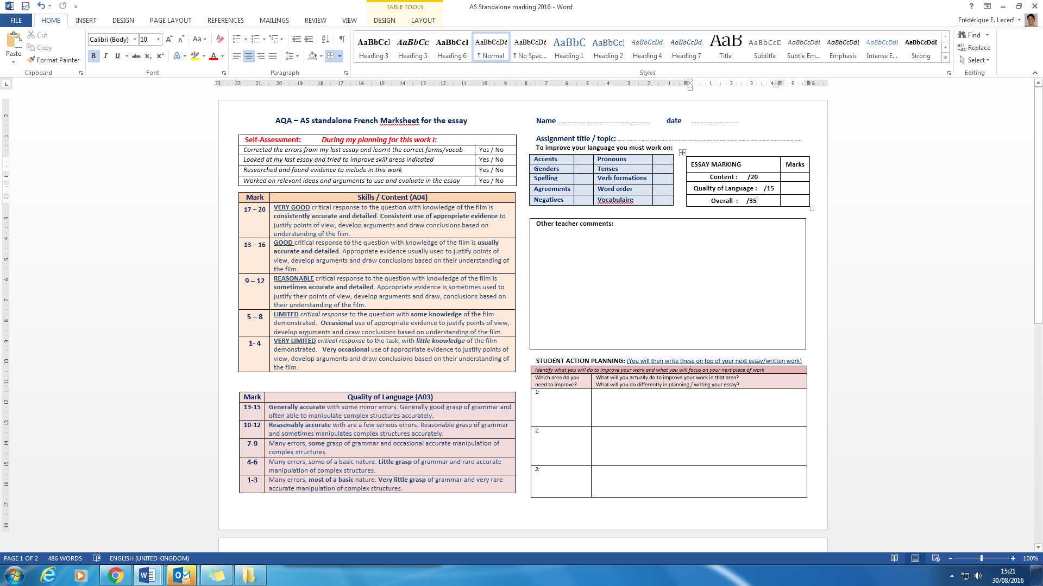

**Differentiation**

Learning should be as active and engaging as possible and ongoing assessment of and for learning an integral part of all lessons and homework. All students, whatever their target grades will be treated as individuals.

Examples of A* and C grade performance

As part of your homework or class work, you will be set work according to your ability and often have a challenging extension piece of work each week.

**Student to student**

Quotes from previous French students who were asked what advice they would pass on to new students:

*“It’s a fantastic course but start writing down new vocab & learning it EVERY WEEK from the start - also make sure to be really, really sure on grammatical concepts.” Laura - A2*

*“Make sure you stay ahead all the time, practising grammar etc because when it comes to exams you will have a lot of things on your mind. Get involved in class discussion and start planning the oral part of the exam early!!!! “*

*Emily -AS*

*“Learn your vocabulary at the beginning of the year and throughout, it's not something you can learn in the last week! Get your hands on any French materials too and familiarise yourself with them this will help you in the exam! BONNE CHANCE!”*  Max *AS*

*“Practise speaking French as much as you can in your free time, it really helps with your oral. Do reading and writing exams papers so you get used to the style of the questions and so you do not feel so panicky when you enter the real exam.” Kat AS*

“French is definitely the most fun subject in college! Don’t be shy speaking out loud - everyone is at the same stage, and you'll find you get better every day :) and plus, the French trip in February is amazing, working hard but playing harder!!”

*Lauren AS*

“*The only way to succeed is to enjoy the subject :) this way you'll  find it easy to cope with the amount of work that involves reading, learning vocab, listening and speaking.”*

*Ana-Maria A2*

*“The best thing to do is practise from the beginning! Take each class as an opportunity to practise speaking the language and formulating sentences and you'll have fun and learn at the same time! It's very rewarding knowing that it is possible to communicate and understand another language and this course is the best way to do so!” Megan A2*

**Safeguarding**

We are fully committed to safeguarding issues and promoting the welfare of our learners. This includes protecting them from maltreatment, preventing impairment to their health and development and ensuring they are safe and well cared for. Our overarching aim is to ensure that our students are able to reach their potential and enter adulthood successfully

**Equal Opportunities**

The Department will follow the College Equal Opportunities Policies which aim to:

• treat everyone with respect as an individual;

• create a climate in which students feel valued and are encouraged to develop their skills, abilities, qualities and interests;

• value the race, colour, gender, sexual orientation, social class, religion, culture, ability and age of every student;

• develop a community in which tolerance, respect, courtesy, sensitivity and understanding are encouraged;

• encourage students to achieve their potential and to raise their level of achievement.

**Safeguarding**

**Disability Equality**

Information on students with disabilities is taken from the application form and notes from interviewers. This will be added to in the course of the academic year. An Inclusion register is produced by Learning Support and distributed to all staff. The College’s Equal Opportunities Committee has responsibility for establishing and implementing the Disability Equality Scheme.

©Godalming College 2009

Information contained in this Student Guide is correct at time of press

Godalming College, Tuesley Lane, Godalming, Surrey GU7 1RS

T: 01483 423526 F: 01483 417079 E: college@godalming.ac.uk www.godalming.ac.uk



For more information about all the key Godalming College policies, visit [www.godalming.ac.uk/about_us/publications/](http://www.godalming.ac.uk/about_us/publications/)

©Godalming College 2021

Godalming College, Tuesley Lane, Godalming, Surrey GU7 1RS

T: 01483 423526 F: 01483 417079 E: college@godalming.ac.uk