**Global Systems and Global Governance Review Notes – Booklets 8 & 9**

**Booklet 8**

Differential Access to markets

International trade – the costs and benefits

* List costs and benefits of trading relationships.
* How does trade help LDE’s?
* How does differential access to markets affect cotton farmers in LDEs? Notes from video clip.

**Terms of Trade**

* Define ‘terms of trade’
* Why are terms of trade less favourable for LDEs – include evidence?

**Access to markets for Less Developed Economies**

* Summarise reasons why it may be hard for LDEs to access trade markets.

**Impacts on economic and societal well-being**

* Summarise how trade affects well-being for countries at the following levels of development:
  + Developed countries
  + Emerging economies
  + Less developed countries

**Strategies to deal with issues**

* What are Special and Differential Trading agreements?
* What are the problems with Special and Differential Trading agreements?
* What are the benefits to Mexico as part of a trade bloc/free trade agreement (NAFTA) and international trading organisations (OECD)?
* How have differential access to markets impacted the Mexican people as different areas are affected by their trading relationships?
* How can access to services make markets more accessible to LDEs?

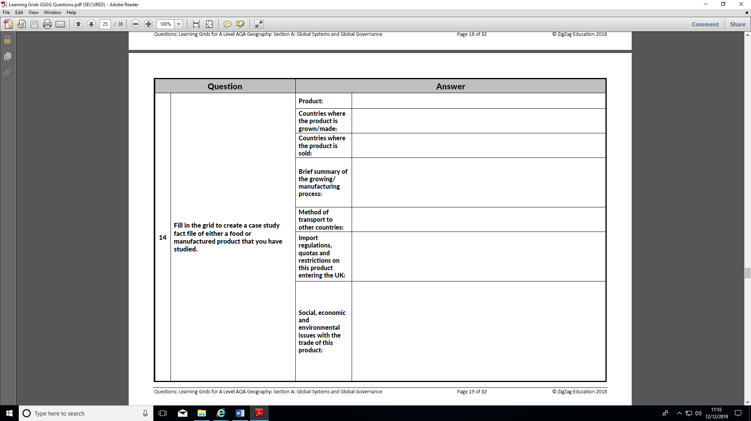

**Booklet 9**

**Fair Trade**

* + What is Fair Trade?
  + How have terms of trade between MEDCs and LEDCs change in the 1990s and what impact has this had on LEDCs?
  + Why do agricultural subsidies in MEDCs cause problems for LEDC farmers?
  + What are the benefits of Fairtrade? – identify social, economic and environmental.
  + Give an example of a Fairtrade standard and how Fairtrade is managed.

**Fair Trade or Free Trade**

* + What are the differences between Fair Trade and Free Trade?
  + Why many countries are against Free Trade?

**Fair trade – Alternative trading Organisations**

* + Example of how Fair Trade has helped people in LEDC’s – Marks and Spencer in Kenya
  + Who is Traidcraft and what are its aims?
  + Using evidence of Traidcraft in Kenya say why it is considered a more ethical organisation.

**Ethical Investment** – explain what is meant by ‘Ethical Investment’.

**Case study on the global trade of a food commodity – Bananas (see table below)**

* + Describe world trade for Bananas – where grown, sold, growing process, transportation.
  + Countries and/or trade agreements for Bananas
  + Detail of the Banana Wars – an example of a trade conflict
    - Which countries/trade blocs were involved?
    - What were the issues?
    - How was the conflict resolved?
  + Social, economic and environmental issues with the trade of this product.