**3.2.1 Global Systems and Global Governance**

**Booklet 8 – INTERNATIONAL TRADE AND MARKETS:**

*Differential access to markets associated with levels of economic development and trading agreements, and its impacts on economic and societal well-being.*

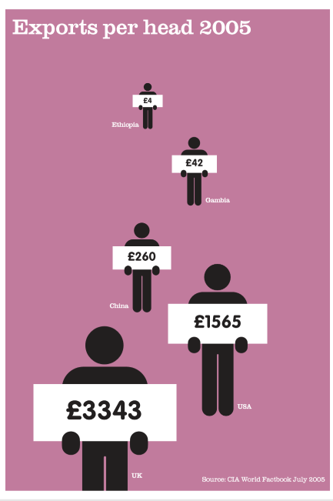

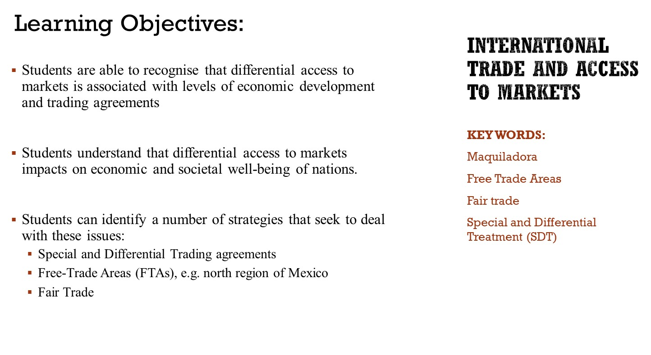

# Your role in trade

## 1.1 What is your role in international trade?

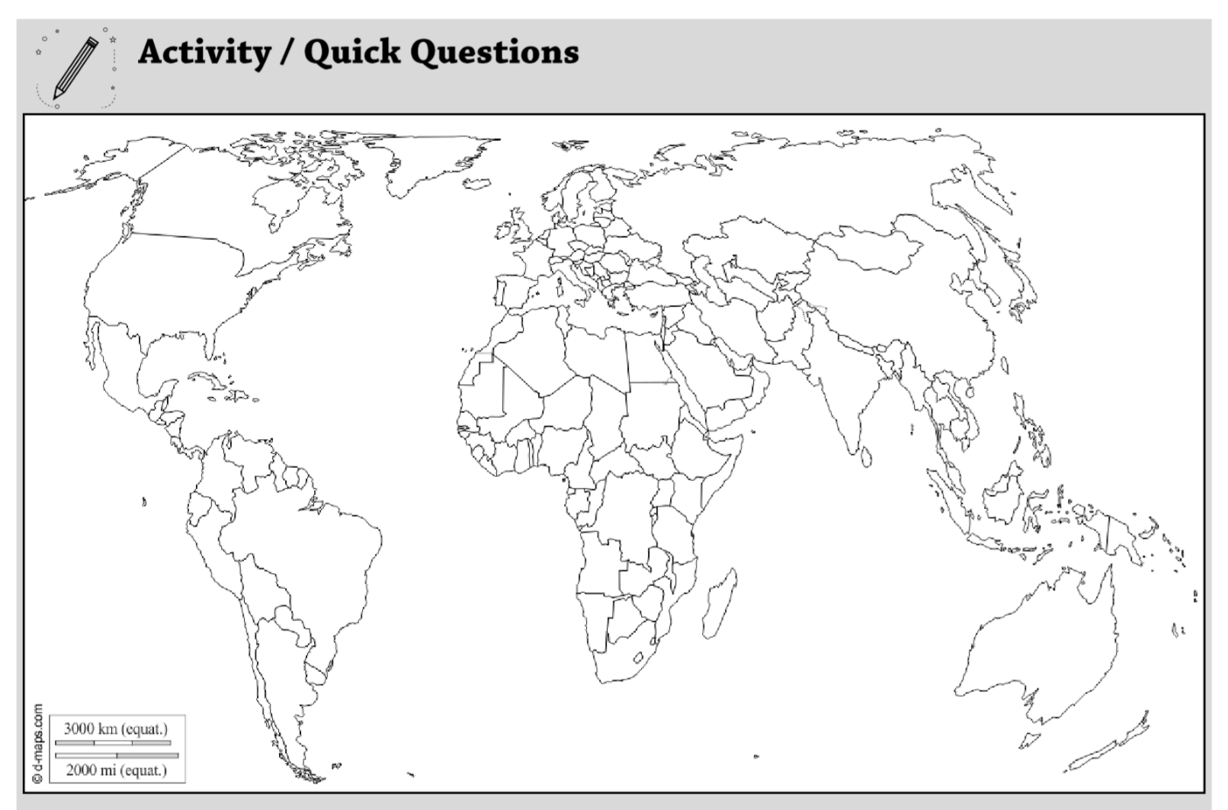

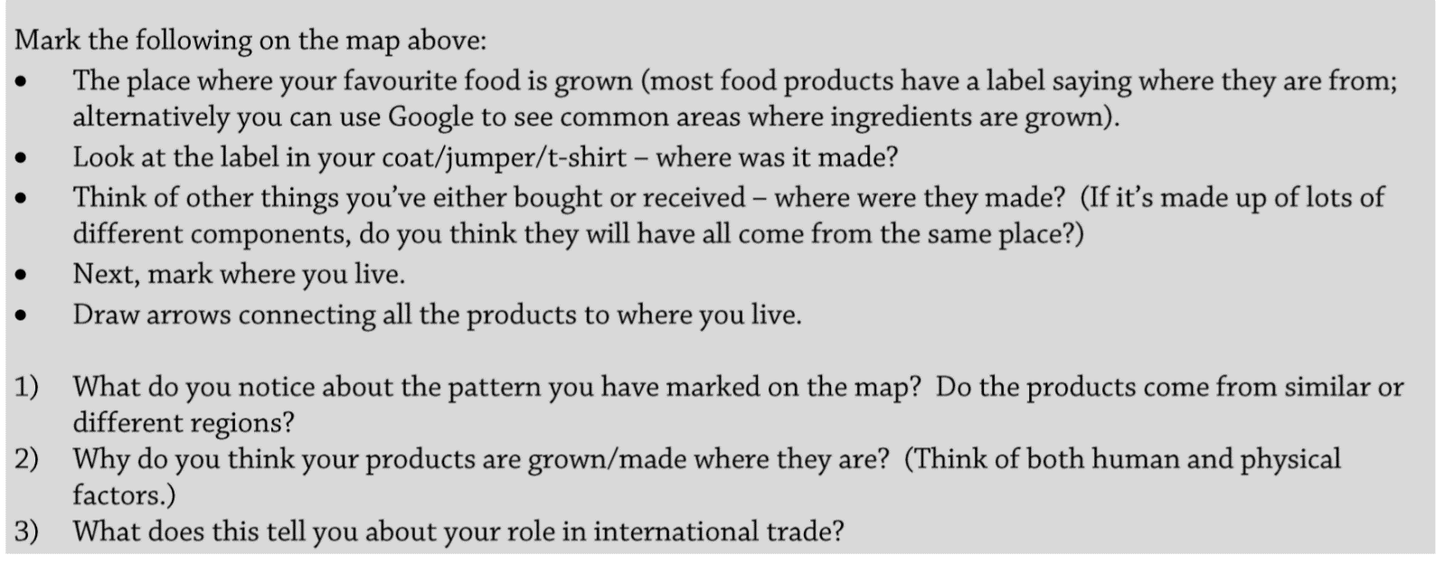

# 2. Differential access to markets

## 2.1 International trade – the costs and benefits

1. RECAP - In small groups, briefly discuss the costs and benefits of trading relationships. (<https://www.bbc.co.uk/news/av/business-37585477/is-international-trade-always-good-for-the-economy>)
2. Trade has played an important role in promoting economic development in Less Developed Economies (LDEs) and differential access has allowed many countries to diversity their economies, achieve economic take-off and lift some of their population out of poverty. <https://www.youtube.com/watch?v=Ap-M30CRGtI>
3. However, the global pattern of trade is one of great inequality, with many developing countries, or regions of countries, having limited access to global markets
4. Differential access to markets impacts on economic and societal wellbeing – there are consequences for all countries at different levels of development, but the poorer countries tend to suffer the most.

Watch the video and comment on access to markets for Less Developed Economies (LDEs): <https://www.youtube.com/watch?v=b-ekEZTypF8>

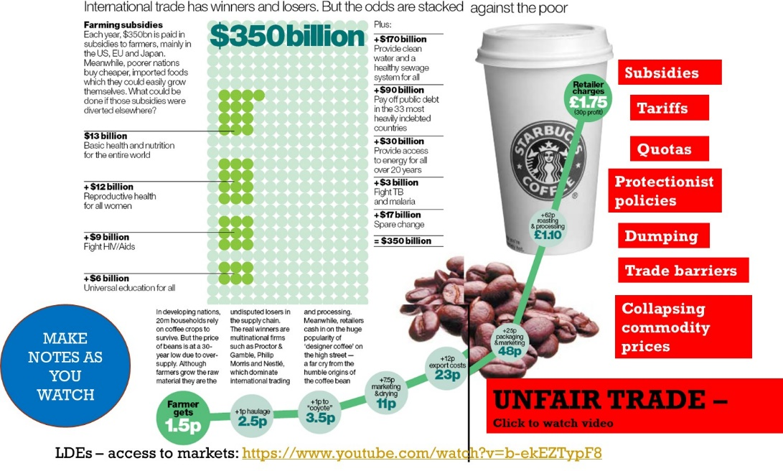

## 2.2 Terms of trade

Despite efforts of the WTO to liberalise trade, there are many aspects about trade that are unfair.

**Define ‘terms of trade’:**

 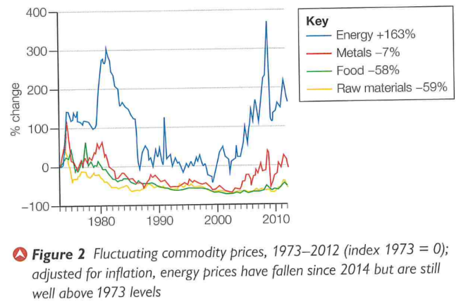

Use the PowerPoint to summarise why **terms of trade are less favourable for LDEs. Refer to Figure 1 and Figure 2 in your answer.**

## 2.3 Access to markets for Less Developed Economies

Summarise the reasons why is may be hard for LDEs to access trade markets (use the PowerPoint to help you):

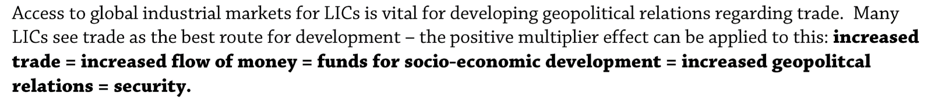

# 3. Impacts on economic and societal well-being



Use the information in the table on slide 11 of the PowerPoint to summarise the impacts that trade has on countries at different stages of development. You will need to put the impacts in the correct category.

|  |  |
| --- | --- |
| Stage of development | How trade affects well-being |
| Developed countries |  |
| Emerging economies |  |
| Less developed countries |  |

# 4. Strategies to deal with issues

## 4.1 Special and Differential Treatment (SDT) Agreements

It was recognized by the WTO that not all countries were benefitting from free trade rules and therefore, special agreements were drawn up for the poorest countries. See web link on Godalming Online: <https://www.wto.org/english/tratop_e/devel_e/dev_special_differential_provisions_e.htm>

Special and Differential Treatment (SDT) agreements:

The problems:

## 4.2 Free Trade Agreements

In many cases, SDTs have been replaced by **unilateral trade agreements** between poorer countries and richer trading partners. **E.g. Mexico now a member of NAFTA**

Other groupings exist in Asia, Latin America (MERCOSUR) and Africa. They enhance negotiating leverage of their members and offer more to LDEs long term

**Case Study Mexico and NAFTA**

* **TASK:** Read the case study on Mexico as an emerging economy (54 International trade and access to markets CS.pdf). **Make notes on the benefits that may accrue a country as part of a trade bloc or international trading organisation**.

The **Maquiladora** operates in Mexico: – manufacturing industries operating in a Mexican free trade zone close to the USA/Mexico border, where factories import material and equipment on a tariff-free basis for assembly, processing or manufacturing. The products are then re-exported back to the USA and Canada.

Mexico also has huge inequalities (differential access to trade **within the region**), as only regions in the northern border and central states to the south of it benefit from manufacturing and trade through NAFTA.

* + **TASK**: Explain how differential access to markets can impact on the people **within** Mexico as different areas are affected by their trading relationship with the USA.

Further reading: Nagle, G. (2001) ‘Maquiladora development in Mexico’, *Geofile,* 400.

## 4.3 Access to services and fair trade

Make notes on how access to services and the role of fair trade can assist in making markets more accessible to LDEs. See links on the PowerPoint slide to help you.

# Exam Question Practice

**Summarise the main features of international trade [4 marks]**

**Using Figure 2 and your own knowledge, interpret the information shown [6 marks]**

