Answers

Task 1

For each of the scenarios in the table below, explain which type of connection would work best and why this would be the most suitable type.

|  |  |  |
| --- | --- | --- |
| **Scenario** | **Connection type** | **Why this is the most suitable type?** |
| A large multinational company with over 1000 employees needs a fast Internet connection to their head office. | Fibre optic | Reliable  Fast  Copper/FTTC would not cope with the bandwidth required for 1000 employees |
| A homeowner decides that they will let out one of their rooms on Airbnb. They wish to provide guests with access to the Internet. | Wi-Fi | Guests can easily connect portable devices to it. It is easy to install and will be fast enough for one room and a few devices |
| A small community centre is being built. One of the rooms will be used as an office and have a single desktop PC. A phone line has already been installed. They will require an Internet connection. | Copper cable /  Fibre to the cabinet / FTTC | This will provide the office with a connection fast enough for streaming and cloud services  It will be cost effective  They already have a phone line so no new lines will need to be installed |

The large multinational and the community centre will also need Ethernet cables to connect the PCs to the LAN.

Task 2

Amelia lives in the countryside at the bottom of a valley. There is a mobile phone base station around two miles from her house, yet she has no signal on her phone. Her friend Mila lives five miles from the same transmitter, and she has a very good signal with her phone showing maximum bars.

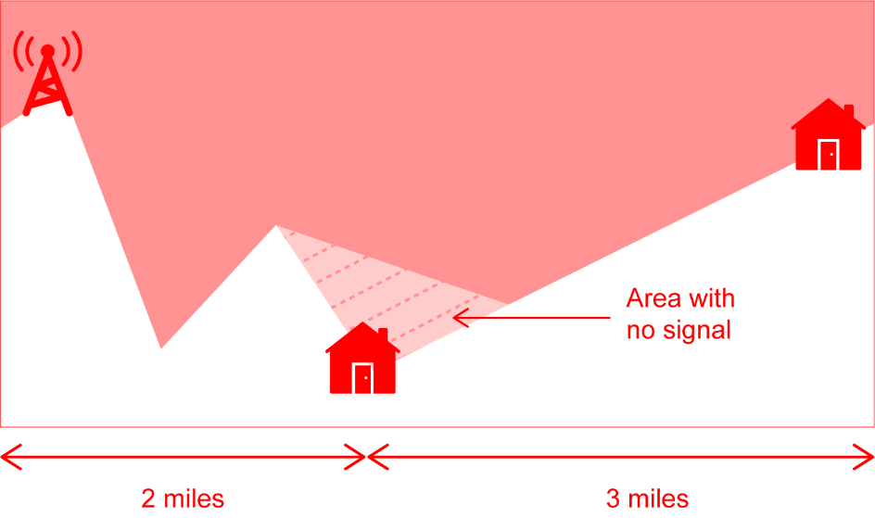(a) Draw a diagram to explain how it is possible for this situation to occur.

(b) What other factors could affect Amelia’s mobile phone reception?

Buildings / trees between her and the base station.  
The weather / rain / cloud.  
Network congestion – she may be on a virtual carrier that has no more capacity, but uses the same base station as her friend.

Task 3

EE launched the UK’s first 5G service on 30th May 2019. Research this new technology and answer the following questions

(a) How does 5G affect speed and reliability?

Much faster – speeds initially around 1Gb/s and potentially up to 10Gb/s.  
More reliable (when a signal is present).

(b) Are there any other useful features the technology provides?

Low latency / ping – 4G networks take around 40-50milliseconds, 5G takes < 1millisecond.  
Greater capacity.  
Will use less battery power.

(c) What could the implications for individuals and businesses be of 5G?

**Some possible implications include:**

Faster connections for video streaming.  
Increase in devices for Internet of Things.  
New products or services that have not yet been thought of.  
Businesses will be able to connect to fast Internet (1Gb/s) without needing to pay for a fibre line installation.  
Augmented reality and virtual reality for remote workers / conferences.  
Far better Internet connectivity for rural communities.

Further useful information for this task can be found at:  
<https://5g.co.uk/guides/5g-benefits-for-businesses/>

Task 4

An old block of 20 flats has poor Internet connections for the residents. Currently each flat is served by a 100Mb/s ethernet connection which leads to a central router. This router connects to the Internet with a copper connection running at 70Mb/s. The director of the management company is becoming increasingly frustrated with the number of complaints he is receiving. He has told his IT manager to “install fibre optic connections direct to every flat”.

(a) What are the advantages and disadvantages to this decision?

**Advantages**

A fibre line will be very reliable

The line will be able to cope with speeds in excess of 1Gbps

**Disadvantages**

It will be expensive to install the lines to each flat

There may be noise as holes are drilled / cables installed

Access will be required to the properties

The problem isn’t with the connections to each flat, which are relatively fast at 100Mb/s – there is a bottleneck with having a 70Mb/s connection to the Internet from the router. If there is a lot of traffic, then there will be congestion and just 3.5Mb/s will be given to each of the 20 properties

(b) Do you agree with the decision to install fibre optic connections direct to every flat? Justify your choice.

No. The upgrade will not give any gain in speed for the residents. It will cause disruption and every resident will have to buy specialist equipment to access it. Instead the owner should upgrade the central router’s connection to Fibre. If this were 300Mb/s then each property would get 15Mb/s if there was high traffic, and up to 100Mb/s (the maximum of their Ethernet cables).