Answers

Task 1

Lynne works as a financial consultant for many companies. She is visiting a client to discuss their company’s accounts. She takes a number of devices with her:

* A Smartphone
* A wireless printer
* A wired mouse
* A laptop

(a) What type of network will be set up with these devices?

PAN / Personal Area Network

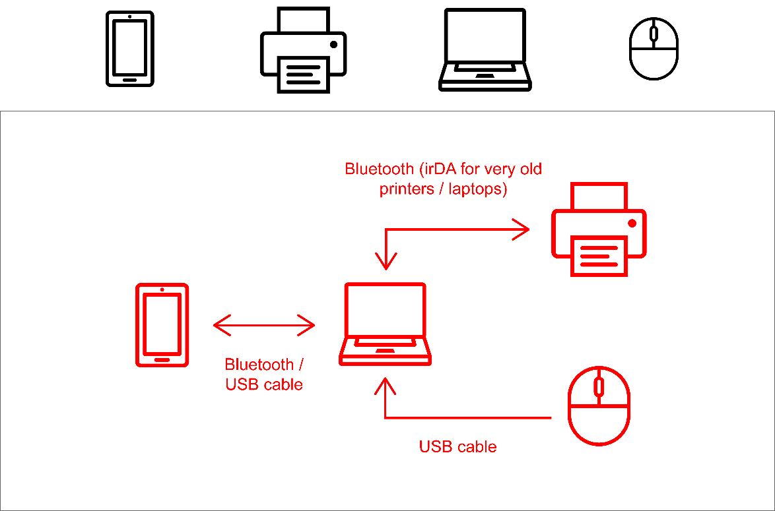(b) Use the following icons to draw a diagram of how these devices can be connected together. Annotate the diagram to show the connection type used for each of the devices in the network.

Task 2

A small software company has a sales department which consists of seven sales assistants and one manager.

Each employee has a desktop computer which is connected to form a local area network (LAN). The office printer is also connected to the LAN. All devices are connected via Ethernet cable.

(a) Add lines on the office layout below to show how the computers and printer are connected together to form a LAN.

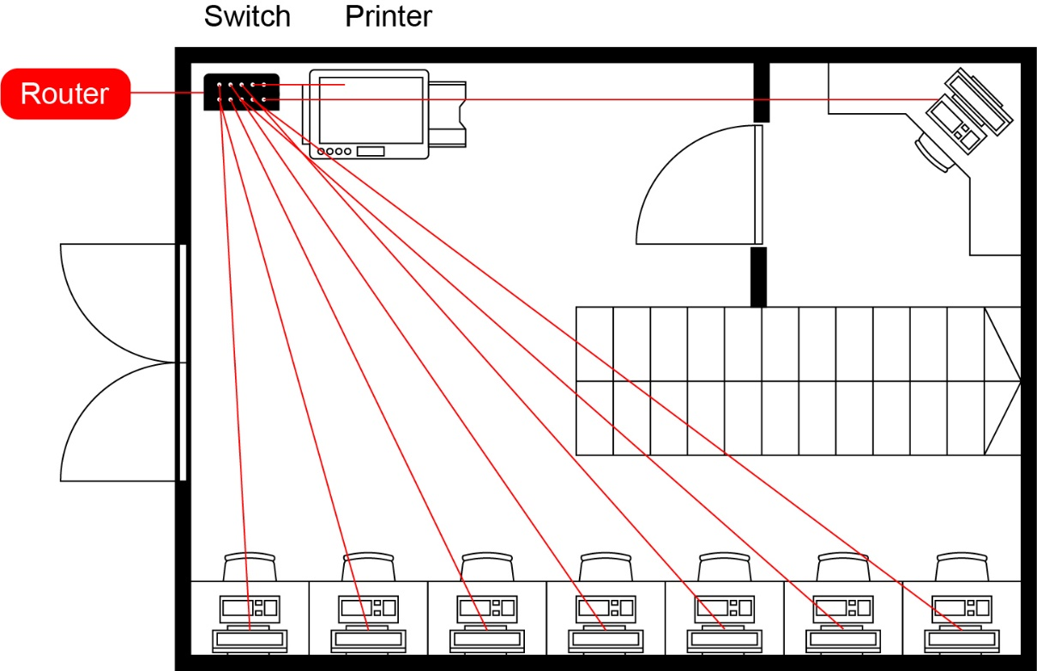Note: The cables would probably run along the walls in trunking or under the floor  
/ in the ceiling.

(b) How many ethernet cables would be required in total for this network?

9 (7 sales assistant computers, 1 manager computer, 1 printer)

(c) If each employee had an additional Voice over IP (VoIP) phone installed, how many additional cables would need to be added?

8 (no additional cable required for the printer)

(d) The company wishes to connect all the computers to the Internet. Add the necessary device to do this to the diagram.

Router – needs to be connected to the switch – see diagram

Task 3

BetterDIY is a large retail company supplying tools and materials for individuals and companies. They are a national chain with more than 100 stores and several thousand employees.

In each store there are computers in different departments and areas of the store such as the warehouse, manager’s office, customer service desk and tills.

All computers and tills are connected to a store network. Each store network is then linked to the head office via a leased line.

(a) What types of network are used in this scenario?

LAN / Local Area Network for each store network

WAN / Wide Area Network for all the stores and head office via leased lines

(b) Why do you think BetterDIY has all their stores connected to each other.

To share data such as files or sales information and to query databases

(c) The company uses leased lines to connect each store to the head office. These are normally considerably more expensive than home broadband connections.

Explain why the company is prepared to pay more for a leased line.

In standard connections, the connection is asymmetric / faster download to upload. Stores may need to upload as much information as they download so need a symmetric line – which leased lines provide

Standard broadband connections can share aspects of the connection with other customers. This can lead to slower speeds, especially when people are home in the early evening or weekends. This would be the busiest time for a DIY store which therefore needs to guarantee the speed available on their lines

All connections can have faults due to fire, flood or even a cable being eaten, degrading or falling out of its socket. In home broadband it may take days before an engineer investigates and solving the problem may take further time. A collection of 100 stores would suffer major losses were they to lose their connections (and potentially stop trading) for this amount of time. Leased lines will usually be fixed within five hours from a fault being reported. Furthermore, two leased lines allows for one to take over in the event of a fault.