Name: Class:

Task 1

Lynne works as a financial consultant for many companies. She is visiting a client to discuss their company’s accounts. She takes a number of devices with her:

* A Smartphone
* A wireless printer
* A wired mouse
* A laptop

(a) What type of network will be set up with these devices?

(b) Use the following icons to draw a diagram of how these devices can be connected together. Annotate the diagram to show the connection type used for each of the devices in the network.

Task 2

A small software company has a sales department which consists of seven sales assistants and one manager.

Each employee has a desktop computer which is connected to form a local area network (LAN). The office printer is also connected to the LAN. All devices are connected via Ethernet cable.

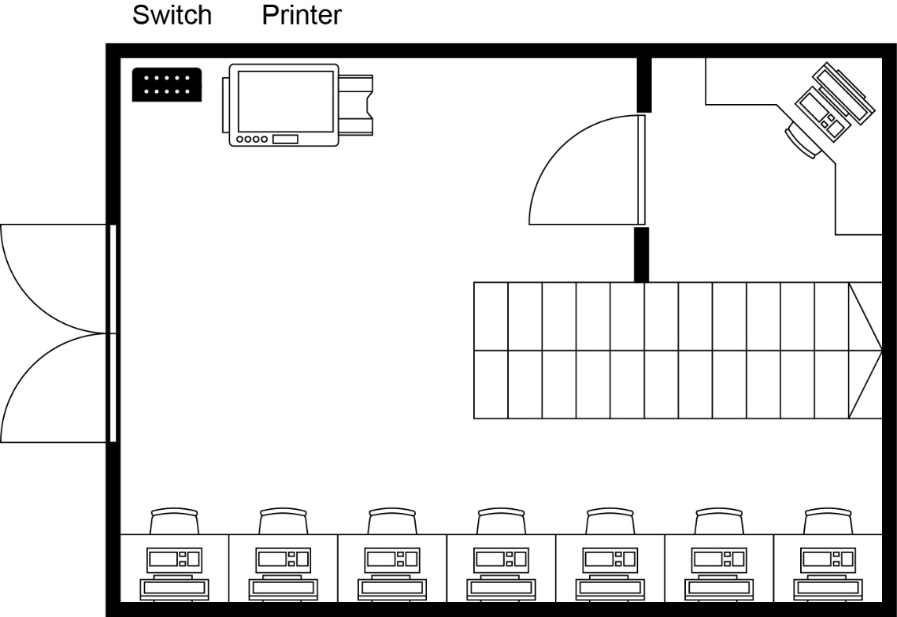(a) Add lines on the office layout below to show how the computers and printer are connected together to form a LAN.

(b) How many ethernet cables would be required in total for this network?

(c) If each employee had an additional Voice over IP (VoIP) phone installed, how many additional cables would need to be added?

(d) The company wishes to connect all the computers to the Internet. Add the necessary device to do this to the diagram.

Task 3

BetterDIY is a large retail company supplying tools and materials for individuals and companies. They are a national chain with more than 100 stores and several thousand employees.

In each store there are computers in different departments and areas of the store such as the warehouse, manager’s office, customer service desk and tills.

All computers and tills are connected to a store network. Each store network is then linked to the head office via a leased line.

(a) What types of network are used in this scenario?

(b) Why do you think BetterDIY has all their stores connected to each other.

(c) The company uses leased lines to connect each store to the head office. These are normally considerably more expensive than home broadband connections.

Explain why the company is prepared to pay more for a leased line.