Answers

Task 1

(a) Draw a diagram to show how protocols are used in the sending and receiving of email.   
Your diagram should include SMTP for sending email and either POP3 or IMAP for receiving email.

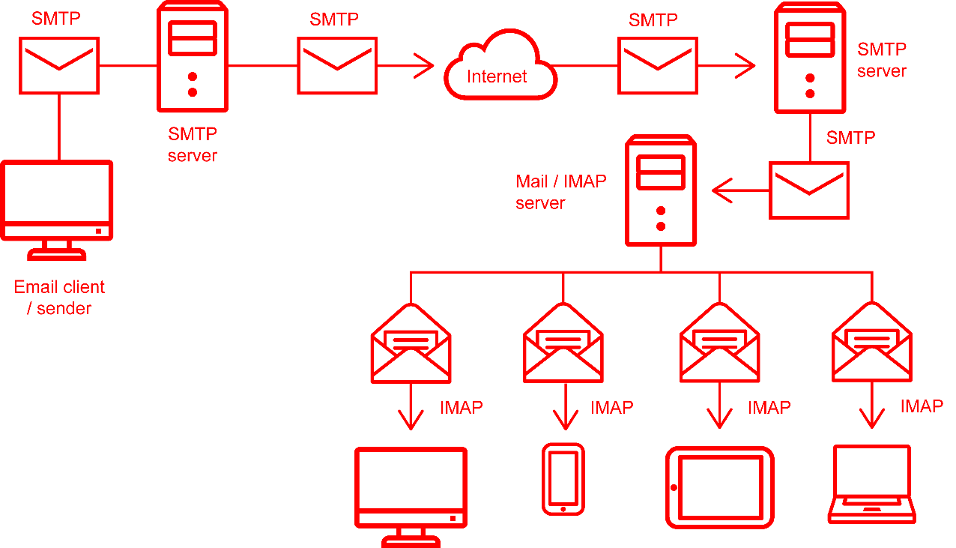(b) Annotate your diagram to label devices, servers and protocols used

Note: diagrams can differ to that given above. There needs to be at least one SMTP server – in the case of an internal email there may be no other SMTP server’s involved. The IMAP email server could be a POP3 server, in which case only one device would normally be used.

Task 2

For each of the following protocols, write what it stands for and its purpose. The first row has been completed for you.

|  |  |  |
| --- | --- | --- |
| **Protocol** | **Stands for** | **Purpose** |
| **POP3** | Post Office Protocol 3 | Retrieving emails from a mail server. When emails are retrieved, they are transferred to your device and deleted form the server. |
| **IMAP** | Internet Message Access Protocol | Used to access email from multiple devices. Any deletion of email is synchronised across all devices. All folders and email are held on the email server. Local copies are cached so that email can be read when offline. |
| **SMTP** | Simple Mail Transfer Protocol | Used for sending email. The email is sent from one SMTP server to the next. This protocol is not used for receiving email. |
| **VoIP** | Voice over Internet Protocol | Used for free (such as Skype) or low cost (such as SIPP) phone calls via the Internet / Internet Protocol (IP). |
| **HTTP** | Hypertext Transfer Protocol | Used to send requests for web pages and the web pages themselves. Defines the meaning of a web address / URL and the error codes that are returned such as if a page is not found. |
| **NFC** | Near Field Communication | A protocol used to transfer data between devices within a few centimetres of each other. Used for mobile tickets, payments and also transferring of data such as photos between devices. |
| **HTTPS** | Secure Hypertext Transfer Protocol | A secure version of HTTP where all communication is encrypted. Web browsers display a padlock in the address bar to indicate that a secure connection has been made. Certificates are used to authenticate the owner of the server that has been connected to. |

Task 3

The following table shows the bandwidth and latency of four different users Internet connections. Complete a rating for each of the connections with 1 being the best and 4 being the worst.

|  |  |  |  |  |
| --- | --- | --- | --- | --- |
| **User** | **A** | **B** | **C** | **D** |
| Bandwidth | 25.41 Mbps | 72.03 kbps | 75.59 Mbps | 2.32 Mbps |
| Latency | 19 ms | 102 ms | 7 ms | 41 ms |
| Rating | 2 | 4 | 1 | 3 |

Task 4

Go to the website <https://www.speedtest.net/>

(a) Run three different speed tests and complete the table below.

|  |  |  |  |
| --- | --- | --- | --- |
| **Test number** | **Download speed / Mbps** | **Upload speed / Mbps** | **Latency (ping) / ms** |
| **1** |  |  |  |
| **2** |  |  |  |
| **3** |  |  |  |

**Note:** Students will affect each other if they all try to do the test at the same time.   
This activity may be worthwhile doing as a whole class and then with all of them trying it to see if it makes any difference.

(b) What type of connection to the Internet do the download and upload speeds imply?

If the upload/download speeds are the same it is likely that a dedicated line (symmetric line) is in place. If it is greater than 80Mbps it is likely in 2019 that this is a Fibre Optic connection.

(c) Why are the speeds and latency not always exactly the same?

The biggest impact will be the number of users / amount of traffic from others which is also using the bandwidth.

The server that is replying to the request may have other requests that it also needs to service.

(d) Change the location of the server that is being used to one that is located in New York. What happens to the latency / ping time?

The ping time will rise significantly as the communication must now cross the Atlantic.

(e) Go to <https://wondernetwork.com/pings/London>. What is the typical ping time / latency from London to New York given on this page?

Average is 75.35ms.

(f) Why does this ping time differ slightly to what you found?

The ping time / latency found by the students is likely to be a little longer than this. WonderNetwork are likely to have good connections to the Internet that don’t need to travel through as many switches as a school/college network. Therefore, their ping may be slightly lower. It is important to note though, that the main increase in ping/latency will be down to the distance of the communication.

Task 5

Complete the table below, explaining what each file format and codec stands for, is used for and whether it is lossy or lossless.

|  |  |  |  |
| --- | --- | --- | --- |
| **File format / codec** | **Stands for** | **Used for** | **Lossy / lossless** |
| **JPEG** | Joint Photographic Experts Group | Images (mainly for photos) | Lossy |
| **MP3** | MPEG-1 Audio Layer 3 (MPEG stands for Moving Picture Experts Group) | Audio | Lossy |
| **PNG** | Portable Network Graphics | Images (includes transparency) | Lossless |
| **MPEG-4** | Moving Picture Experts Group | Video and Audio | Lossy |
| **AAC** | Advanced Audio Coding | Audio | Lossy |
| **GIF** | Graphics Interchange Format | Images (includes simple animation) | Lossless |

Task 6

A music company records, edits and sells music from upcoming artists.

(a) When they record the music, they use an audio format that is lossless. Why do they not use a lossy compression format such as MP3?

They do not want to lose any of the original data at this stage and so by using no compression or a lossless compression they can always restore the original recording.

(b) The artists want to have a CD of albums they produce. CDs are an old standard that do not make use of any compression. Why was compression not used on CDs?

Decompressing data takes processing power. When CDs were invented there was not enough cheap processing power to decompress the data – so they stored audio uncompressed.

(c) The music company distributes the music online using the MP3 audio format. Why do they use a lossy compression?

By using lossy compression the files can be reduced in size by around 10 times without a noticeable difference in quality. This means they can be downloaded 10 times as fast and require 1/10th of the storage space to save.