Answers

1. Andrea is completing a multimedia course at her university. She is spending her holiday at home but needs to continue working on an assignment that needs to be submitted before she returns.

This assignment will include photos, sound files and video clips along with a written text document. All work is currently stored on Andrea’s external hard drive and photos are on her digital camera.

She will need to submit her work via the university’s online platform. Her tutor will download and assess her work, then print feedback to present to Andrea on her return to university.

(a) Draw a diagram to show how this system works.

The diagram should include:

* Devices and systems that could be used
* Devices to be connected and the connection types used
* 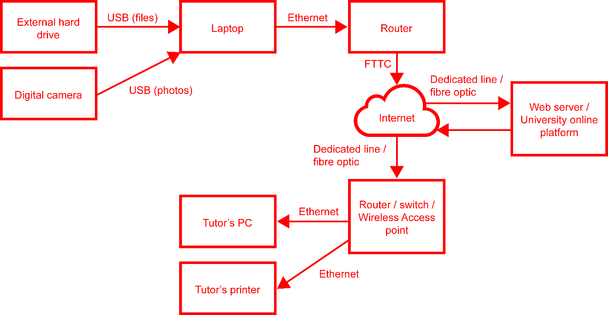Annotations indicating the information and data to be passed between   
  systems, devices and users. [6]

| **Level** | **Mark** | **Descriptor** |
| --- | --- | --- |
| Level 0 | 0 | No rewardable material. |
| Level 1 | 1-2 | Diagram provides partial coverage of appropriate devices. Storage/Data sharing and connection types are used to meet some of the requirements of the scenario.  Diagram includes annotations of the data that will be shared among the components of the system. |
| Level 2 | 3-4 | Diagram provides coverage of mostly appropriate devices. Storage/data sharing and connection types are used to meet the majority of the requirements of the scenario, but these may not always be the most efficient.  Diagram includes mostly accurate annotations of the data that will be shared among the components of the system |
| Level 3 | 5-6 | Diagram provides thorough coverage of appropriate device. Storage/data sharing and connection types are used to fully meet the requirements of the scenario.  Diagram includes detailed and accurate annotations of the data that will be shared among the components of the system. |

(b) Explain **two** security measures that can be taken by the university to protect   
Andrea’s work. [4]

The tutor could use VPN if they use a remote computer to mark the work (1) so that they connection is encrypted (1).

HTTPS could be used when connecting to the web server (1) so that eavesdroppers will not be able to view the material (1).

Username/password could be used (1) so that only the tutor can see the work (1).

The server could be security by physical locks / locked cabinet / security guard (1) so that only authorised technicians can gain access to it (1).

2. Kieran uses his smartphone to log in to the website of the Regal Cinema to book tickets for a film. He selects the film he wishes to watch and enters his credit card details. The information is transmitted to the cinema via the website.

A request for payment authorisation is sent from the cinema to the bank. Paperless tickets are then transmitted, via email, to Kieran’s smartphone.

(a) Draw a diagram to show how this ticketing system works.

* Devices and systems that could be used
* Devices to be connected and the connection types used
* Protocols used
* Annotations indicating the information and data to be passed between systems, devices and users. [8]

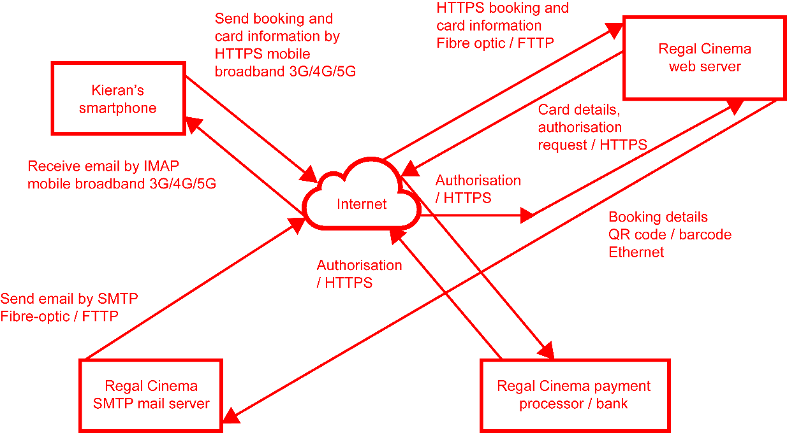

| **Level** | **Mark** | **Descriptor** |
| --- | --- | --- |
| Level 0 | 0 | No rewardable material. |
| Level 1 | 1-2 | Diagram provides partial coverage of appropriate devices. Storage/Data sharing and connection types are used to meet some of the requirements of the scenario.  Diagram includes annotations of the data that will be shared among the components of the system. |
| Level 2 | 3-4 | Diagram provides coverage of mostly appropriate devices. Storage/data sharing and connection types are used to meet the majority of the requirements of the scenario, but these may not always be the most efficient.  Diagram includes mostly accurate annotations of the data that will be shared among the components of the system |
| Level 3 | 5-6 | Diagram provides thorough coverage of appropriate device. Storage/data sharing and connection types are used to fully meet the requirements of the scenario.  Diagram includes detailed and accurate annotations of the data that will be shared among the components of the system. |

(b) The cinema also allows the printing of tickets from a machine at the cinema.

Describe how this system works. [2]

When the customer arrives, they insert their payment card to the machine (1). The card number is looked up on the web server / ticket database (1). The ticket is printed (1).

[Total 20 marks]