Answers

Task 1

When drawing system diagrams, it is useful to start by identifying all the devices, servers or hardware required by a scenario. Then connections types and further annotation can be added.

(a) List **10** different devices that might be added to a system diagram.  
PC  
Desktop  
Laptop  
Mobile / Smartphone  
Tablet  
Printer  
Scanner  
Digital Camera  
Display  
Smart TV  
Smart assistant  
Wireless headphones  
Point of service / POS

(b) List **five** different types of server or network hardware that may be added to a   
system diagram.  
**Servers:**  
Mail server  
SMTP server  
Web server  
File server  
  
**Network hardware**:  
Router  
Switch  
Firewall  
Modem  
Wireless Access Point

(c) List **five** different types of connection type or specification.  
Ethernet  
Wi-Fi  
Copper cable  
Coaxial cable  
Fibre optic cable  
FTTC / Fibre to the cabinet  
FTTP / Fibre to the premises / Full fibre  
Dedicated line  
Satellite  
Mobile

Task 2

A small office has three employees who each work on desktop computers. The manager has a laptop which they use to securely connect to the office when they are away.

All employees need access to the Internet to check news updates and send email. The office computers also have access to an internal file server and printer.

(a) Draw a diagram to show the system.

(b) Include annotation to show connection types.

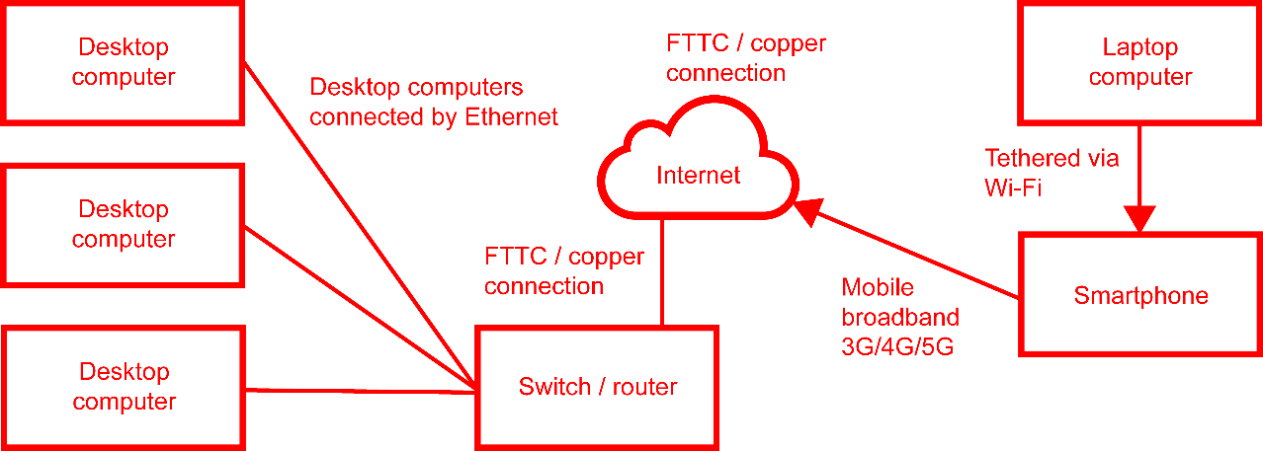

Diagrams may differ slightly to the one above – e.g. connection type from laptop   
to smartphone may be Bluetooth, or the laptop may connect directly to the Internet   
via Wi-Fi.

Task 3

A taxi company makes use of technology to link drivers to customers. Customers who want to use the service load a free app on their Smartphone.

When a customer wants a taxi, the app sends the request to the company’s web server.   
The request details are then sent to the driver.

The web server will also send the card payment information to the card processor which will confirm the details.

(a) Draw a diagram to show the system.

(b) Include annotation to show connection types and data that is transferred.

Diagrams may differ from below. For example, a switch, router and firewall may all be placed between the Internet and the web server.

