Answers

Task 1

Look at the picture of a car entertainment system below.

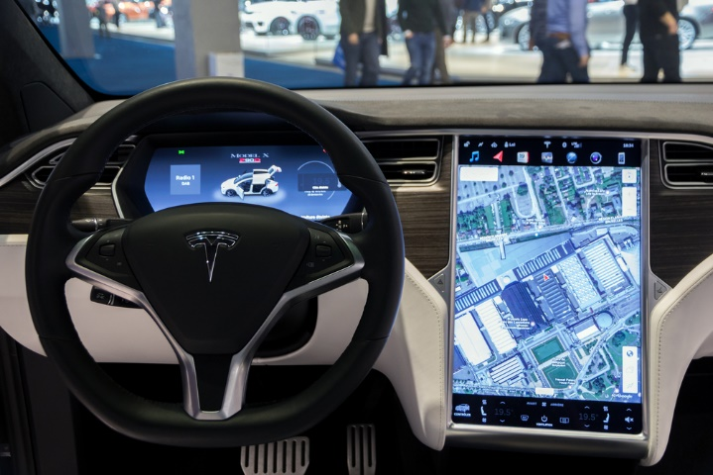

(a) List **five** functions that this system, or others like it, carry out.  
  
Functions could include:  
  
Radio, video, satnav, mobile hands-free with Bluetooth, play music, provide information such as tyre pressures, mileage, speed.  
The photo above is from a Tesla which offers extensive information such as automatic emergency braking, blind-spot warning and valet mode (limiting speed and acceleration / locks glovebox and bonnet).

(b) A car entertainment system is a multifunctional device.

(i) Give **one** more example of a multifunctional device.

Games console (Many other examples exist).

(ii) What functions does it carry out?

Dependent on device chosen. For games console: playing games, surfing the Internet, watching videos, sending messages.

Task 2

A photography studio is considering whether to buy a desktop or laptop computer to edit photographs. Write a short report discussing the benefits and drawbacks of each type of computer to the studio.

Editing photos to a high level requires a lot of processing and internal memory/RAM. It also requires the photographer to work quickly. Desktops have more powerful graphics processing units (GPUs) and are easier to upgrade the amount of RAM and install faster hard disks with SSD. They can also have second hard disks installed for more storage or backups. A desktop would allow better posture as the monitor is at eye level and larger monitors can be installed. Dual monitors can allow the final photo to be shown on one screen whilst the other screen is used for editing.  
  
Laptops are suitable for editing outside the studio or for taking to meetings with clients.  
  
It is possible to use a high end laptop and add devices such as external monitors and hard disks, so students should consider the pros and cons of each device as it will depend on the exact situation of the photographer.

Task 3

Design your ideal home entertainment system. Include the following in your diagram:

* The devices and components of the system
* How the devices will communicate with each other
* Annotate the diagram to show the functions of each device

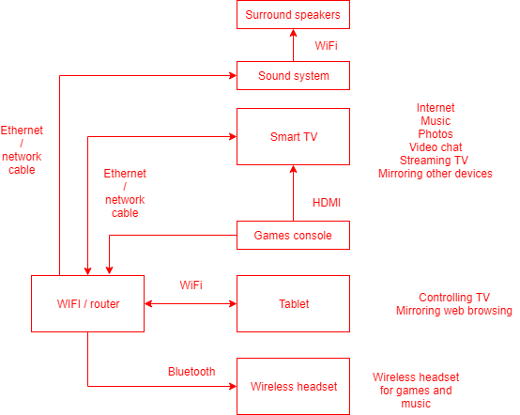

Task 4

Go to: [https://map.what3words.com](https://map.what3words.com/)

(a) Search for the location *input.caring.brain*. What is at this location?

The entrance to 10 Downing Street (the residence and office of the Prime Minister).

(b) Search for your home, school or college. What is the three word location of your front door or the main entrance?

Answers will vary for each student.

(c) What are the advantages of the what3words system over postcodes?  
  
Students may want to research this on the website before answers.

* The what3words system is global where as post codes only work for the UK
* Post codes cover a number of houses
* Some houses don’t have a street number
* Remembering a street number and postcode is difficult, whereas three words are easier to remember
* The what3words system can locate more accurately to within three meters – such as the correct entrance of a stadium or building
* The what3words system uses an algorithm to produce locations which requires far less storage space than a large database of locations – there are 57 trillion squares which the algorithm addresses

(d) In 2018, Mercedes-Benz bought 10% of the company that makes what3words. They intend to install the software into their in-car navigation systems.

(i) How does a satnav system work?  
  
The satnav first needs to work out its exact location. It does this by a system known as GPS (Global Positioning System). 31 satellites orbit the earth. By receiving a signal from at least 3 satellites, it is possible to triangulate the location based on the time it takes to receive each signal.  
  
The navigation of the system makes use of a database of maps and locations such a postcodes (or in this case the what3words algorithm). An algorithm will find the shortest or fastest path to a destination entered by the user. The GPS position can be used to locate the car to within a few meters.

(ii) What3words also works with some UK emergency services. Why would having what3words installed help in an emergency situation?  
  
If a car breaks down or is involved in an accident it can be hard for the driver to explain their location and for police/fire/ambulance to find them. This is especially true for rural locations. What3words enables the emergency services to locate the car to within three meters. No Internet signal is required for the app to work as the locations are stored on the device and GPS doesn’t use the Internet.

Task 5

A school needs to register students every morning and afternoon.

(a) Suggest two devices that could be used for this data collection.  
  
computer/laptop with mouse or keyboard  
tablet or smartphone with touchscreen  
  
Less likely:  
fingerprint scanner  
RFID reader with each student having a card/wristband

(b) What are the advantages or disadvantages of the systems you have suggested?  
  
Answers will depend on the chosen methods.  
  
Students should be aware that some people may be concerned by fingerprint scanners raising ethical issues. RFID card readers whilst fast, have the issue that students may use each other’s cards or lose cards.  
  
A computer/laptop may lose the network connection and fail to register students. A tablet or smartphone may be harder to select individual students. It may also be out of a Wi-Fi range meaning that the database won’t hold the most up to date information until the device is synchronised.  
  
All methods have the advantage that they create an electronic register which can be shared via a database. This allows the school and possibly parents to check attendance and for the data to be processed.

Task 6

What are the communication devices and media you use daily at home, school or college?

Answers will vary for each student

Likely for school/college:

PC/Mac connected by network cable, Laptop connected by Wi-Fi, Mobile phone connected by 3G/HSDPA/LTE/4G (most popular standards in 2019), Fibre to the premises (FTTP) for the school/college Internet connection, NIC, switch, router, WAP.

Home networks are likely to differ with FTTC (Fibre to the cabinet), Wi-Fi/WAP and Bluetooth being more likely methods of connection.