Name: Class:

Task 1

Look at the picture of a car entertainment system below.

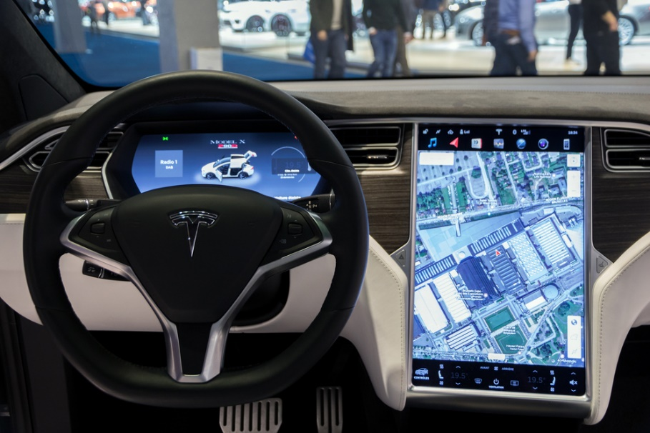

(a) List **five** functions that this system, or others like it, carry out.

**Function 1:**

**Function 2:**

**Function 3:**

**Function 4:**

**Function 5:**

(b) A car entertainment system is a multifunctional device.

(i) Give **one** more example of a multifunctional device.

(ii) What functions does it carry out?

Task 2

A photography studio is considering whether to buy a desktop or laptop computer to edit photographs. Write a short report discussing the benefits and drawbacks of each type of computer to the studio.

Task 3

Design your ideal home entertainment system. Include the following in your diagram:

* The devices and components of the system
* How the devices will communicate with each other
* Annotate the diagram to show the functions of each device

Task 4

Go to: [https://map.what3words.com](https://map.what3words.com/)

(a) Search for the location *input.caring.brain*. What is at this location?

(b) Search for your home, school or college. What is the three word location of your front door or the main entrance?

(c) What are the advantages of the what3words system over postcodes?

(d) In 2018, Mercedes-Benz bought 10% of the company that makes what3words. They intend to install the software into their in-car navigation systems.

(i) How does a satnav system work?

(ii) What3words also works with some UK emergency services. Why would having what3words installed help in an emergency situation?

Task 5

A school needs to register students every morning and afternoon.

(a) Suggest two devices that could be used for this data collection.

(b) What are the advantages or disadvantages of the systems you have suggested?

**Advantages:**

**Disadvantages:**

Task 6

What are the communication devices and media you use daily at home, school or college?