Answers
Task 1
A number of technologies are now used in education and training.
Complete the table below to show five of these technologies. For each suggested technology explain two advantages of their use. The first has been completed for you.
Educational technology | Advantages of using this technology
Interactive whiteboards | Allows the teacher to instantly show explanations or images via presentation software  Educational videos can be shown to a class
Possible technology suggestions:
Laptops, personal computers, Internet, mobile devices, educational apps, encyclopaedias, search engines, VLEs, MOOCs, learning platforms, video download and streaming, audio/podcasts, online marking and testing systems, adaptive learning systems.
Advantages will depend on the technologies suggested. It should not be assumed that all technology improves learning. You may wish to ask students how certain technologies can be both an advantage and disadvantage for learning.

Task 2
In 1979, Sony launched the Walkman – a portable cassette player that allowed people to listen to music on the move. It used two AA batteries and a cassette tape which allowed up to 90 minutes of music or audio to be stored. Music could only be played back on the device. It allowed for stereo playback and two headphones to be plugged in.
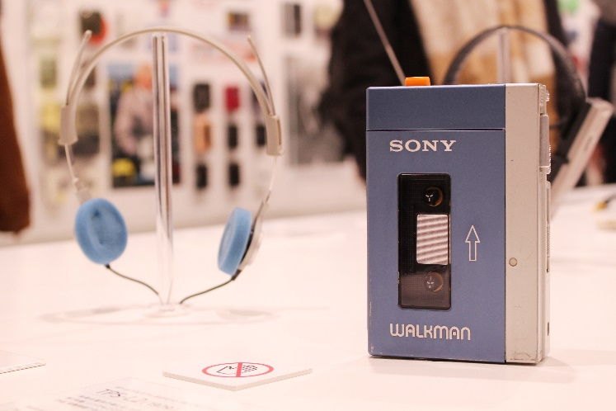
(a) Choose a modern device which is used to play music:
(b) What features or benefits does a more modern device have over the original Walkman?
Answers will depend on the device chosen. Many answers are likely to contain some of the following:
- Can store far more than 90 minutes – an 8GB SD card or internal storage can store around 130 hours of music
- Streaming music from the Internet
- Record function for audio/speech
- Devices (typically smartphones) are lighter
- Cassette tapes can be ‘chewed up’ – solid state storage is more reliable
- Modern devices (smartphones) are multifunction devices, meaning you always have your music player with you.

Task 3
Between 2008 and 2018, Internet sales have risen from 6% of all retail sales to 20%. This has resulted in many high street shops closing or becoming less profitable.
(a) What technologies have allowed e-commerce to increase sales so dramatically?
More ubiquitous use of computer equipment, including smartphones and tablets
Faster Internet connections making it easier to shop
Improved security methods (such as two-factor authentication and fraud detection) to make customers more confident shopping online
Increasing automation, such as robots, in distribution centres to decrease costs
(b) Many traditional shops have begun offering click-and-collect systems. These allow customers to shop online and then pick up their purchases at a local shop. In 2018, Boots, Marks & Spencer and Argos all saw around 70% of online purchase collected in shops.
Why do customers like the click and collect model of shopping?
Many customers work and aren’t in to wait for a delivery.
Many ecommerce only websites may have delivery up to 5 days away – and for international sales it may take months. Click and collect typically is available the same day or following day.
As shops frequently have deliveries, it costs them little to deliver to their store. This reduces postage costs (although ecommerce only sites may advertise delivery as free, it still costs them money which they must gain through higher product costs).
Customers can inspect products in store and immediately return if there is an issue or the wrong product has been ordered. Returns for ecommerce only are harder to make and may require the customer to pay for additional postage.
(c) In 2018, 2,700 shops closed but 1,600 new shops opened. What types of shops are able to compete with the Internet?
In general, shops that provide experiences are difficult to replicate online. For example, the number of coffee shops have increased from 17,000 to 25,000 in the five years between 2013 and 2018. This is around a 50% increase. It is hard to replicate the experience or social aspect of this type of shop. Similarly, convenience stores have increased in number by 17% since 2012 as customers require the products immediately.
Other stores such as Apple have allowed customers to view products. This enables them to make a purchasing decision and company isn’t badly affected if the customer buys online as the products are all made by the same company.
Students may be able to make many suggestions of the types of job that work better offline.

Task 4
Companies make use of several ways of communicating with their customers. This may be to advertise their products or offer customer support.
(a) Choose a well-known brand:
Answers will vary between students
What are the different methods that the brand uses to communicate and share information with their users?
Answers will depend on student answers, but may include:
Phone, website, Twitter, Instagram, Facebook, Post, TV, radio, magazines.
(b) Discuss with a partner which methods of advertising are most successful and then report your views back to the class.
Answers will depend on student’s choices. They may like to consider the effectiveness of different types of online advertising. Equally, this would be a good time to discuss the effectiveness of online influencers and whether any students have bought products as a result of people they know or follow online recommending them.

Task 5
The following are some areas of creative industry:
- TV or film production
- Games production
- Graphic design
- Advertising

(a) Choose one of the above areas:

(b) Research the area to find at least five different technologies that are used in it and explain how they work. Write your findings below, then report them back to the class.
Answers to these questions will depend on which industry students select. If students are struggling to research, you may like to suggest they look at motion capture (or green screen/chroma key) which has been discussed in the slides.

