Name: Class:

Task 1
A number of technologies are now used in education and training.
Complete the table below to show five of these technologies. For each suggested technology explain two advantages of their use. The first has been completed for you.
Educational technology | Advantages of using this technology
Interactive whiteboards | Allows the teacher to instantly show explanations or images via presentation software  Educational videos can be shown to a class

Task 2
In 1979, Sony launched the Walkman – a portable cassette player that allowed people to listen to music on the move. It used two AA batteries and a cassette tape which allowed up to 90 minutes of music or audio to be stored. Music could only be played back on the device. It allowed for stereo playback and two headphones to be plugged in.
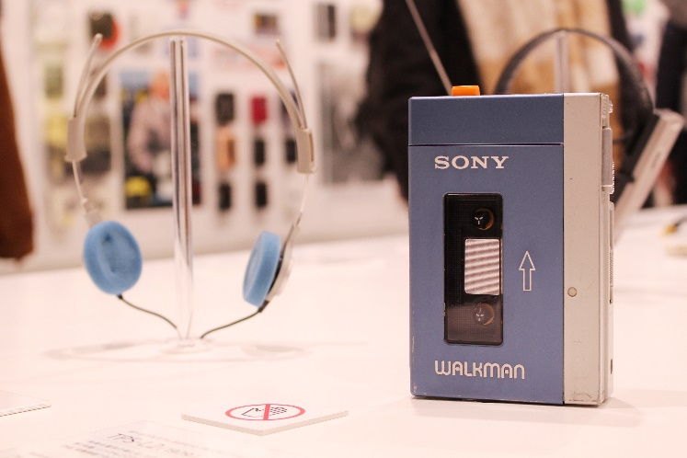
(a) Choose a modern device which is used to play music:

(b) What features or benefits does a more modern device have over the original Walkman?

Task 3
Between 2008 and 2018, Internet sales have risen from 6% of all retail sales to 20%. This has resulted in many high street shops closing or becoming less profitable.
(a) What technologies have allowed e-commerce to increase sales so dramatically?

(b) Many traditional shops have begun offering click-and-collect systems. These allow customers to shop online and then pick up their purchases at a local shop. In 2018, Boots, Marks & Spencer and Argos all saw around 70% of online purchase collected in shops.
Why do customers like the click and collect model of shopping?

(c) In 2018, 2,700 shops closed but 1,600 new shops opened. What types of shops are able to compete with the Internet?

Task 4
Companies make use of several ways of communicating with their customers. This may be to advertise their products or offer customer support.
(a) Choose a well-known brand:

(b) Discuss with a partner which methods of advertising are most successful and then report your views back to the class.

Task 5
The following are some areas of creative industry:

- TV or film production
- Games production
- Graphic design
- Advertising

(a) Choose one of the above areas:

(b) Research the area to find at least five different technologies that are used in it and explain how they work. Write your findings below, then report them back to the class.

