BTEC Music Technology Department Assessment Policy 2021-2023

The Importance of Coursework and Learning Outside the Classroom – ‘50:50’
Learning will not happen instantly and takes time; attending lessons and working on coursework during lessons is not enough, you also need to be working outside of class, to learn new information, consolidate learning and develop your work. In the process you will make mistakes, but hopefully feedback and resulting grades will enable you to learn from these mistakes. Better to make a mistake and correct it than to submit coursework which does not reflect your true capability. Feedback is essential for your learning and will take place during preparatory work as well as during coursework. For each assignment you have the opportunity to resubmit work at the level to which you attempted your initial submission. For example, if your teacher believes that you have attempted Distinction criteria at initial submission, you can reattempt to achieve this at resubmission. You will be given your initial submission grade after your work has been marked and internally verified.

There are 66 weeks of teaching and coursework in total at College to help you learn, develop and complete three units of study. The classes are taught by a singular Lead Subject Tutor for 4.5 hours per week, who will be responsible for formalised 1-2-1s, writing your Student Reviews, seeing your parents at parents evening and for writing Action Plans.

In line with the College’s ’50-50’ initiative, each week 4.5-6 hours of homework and/or coursework will be set. You are expected to spend further time completing independent study up to a total of 9-12 hours per week. Remember that although some lesson time will be given to coursework completion, the majority of the work will be completed outside of lesson time, in our studios and mac suites. There is also the weekly lunchtime workshop for you to attend if you require extra teacher support.

Unit Assessment
Each unit is made up of a number of individual assignments. Each completed unit has a total value in points; Pass – 60, Merit – 70, Distinction – 80. These points are added together to give a final outcome for the course.

Year One
Unit 25 - Music Production Techniques | Unit 29 - Live Sound Techniques | Unit 32 - Sequencing Systems and Techniques
Year Two
Unit 9 - Delivering a Music Product | Unit 20 - Music and Sound for the Moving Image | Unit 43 - Special Subject Investigation.

Assessment and Grading Criteria
Each unit is made up of specific grading criteria, some assignments meet more than one criterion, but each criteria is clearly signposted in all assignment briefs and where possible, in logbooks and on worksheets. Here is an example of a unit which has four different grading criteria:
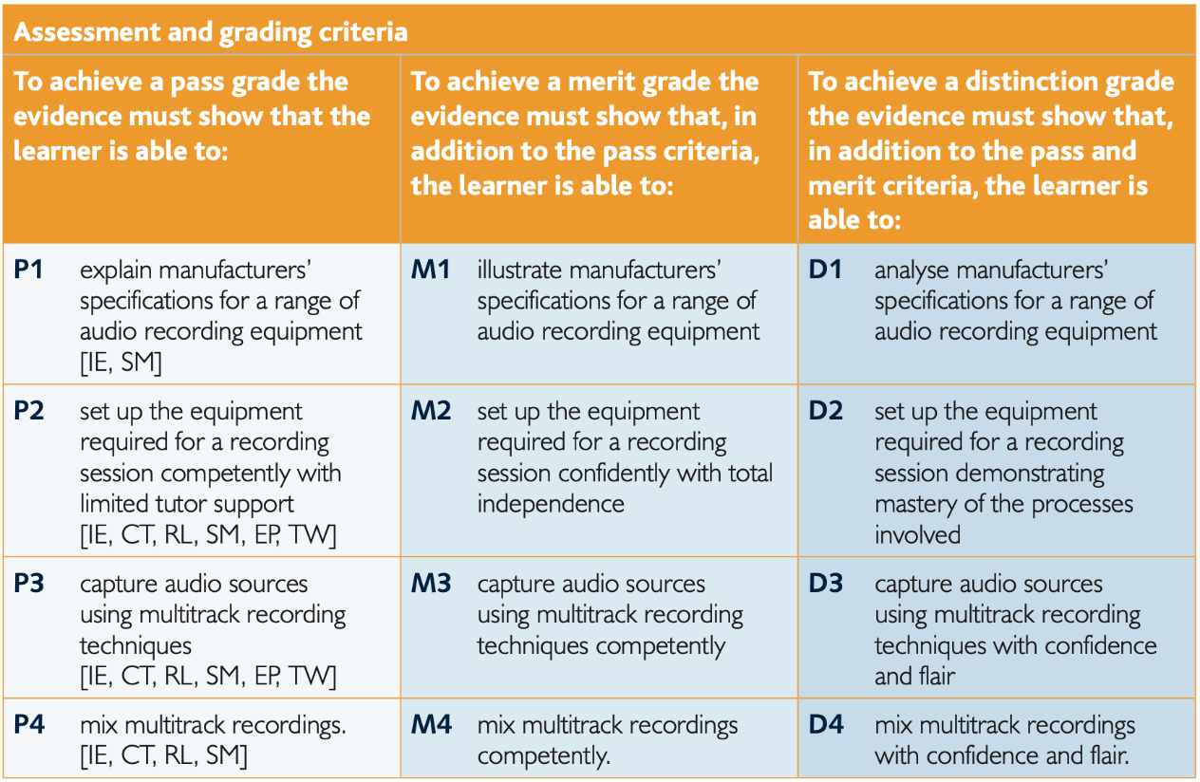

Initial Submissions and Resubmissions
After each assignment is submitted and assessed, you may receive the opportunity to complete ONE resubmission. This has to be agreed by the teacher and the Head of Department (the Lead Internal Verifier).

Resubmissions are only granted when the following applies:
- The learner has met initial deadlines set in the assignment or has met an agreed deadline extension.
- The tutor considers that the learner will be able to provide improved evidence without further guidance.
- Evidence submitted for assessment has been authenticated and accompanied by a signed and dated declaration of authenticity by the learner.

You can only attempt a resubmission for criteria you have attempted at the initial submission (e.g. if you don’t initially attempt the distinction criteria, you can’t access this grade on your resubmission).

Any resubmission evidence must be submitted within 10 working days of receipt of results of assessment.

Different types of assessment
Due to the vocational nature of the course, there are different methods of assessment methods, including:

- Practical assessment: some assignments will involve a practical task where you are able to evidence your understanding through demonstration and explanation. Practical tasks will be rehearsed in lessons with verbal feedback given, along with opportunities for both peer and self-assessment. Your submitted assessment will be recorded on video with an accompanying assessment sheet. You will have access to these on the College music drive for reflection and self-assessment as well as being provided with your outcome.
- Technological assessment: some assignments will involve the use of Logic Pro X music production software. Technological tasks will be practised in lessons with the necessary skills being taught and assessed before assignments being set. For these assignments you will submit your Logic Projects for assessment. These assessments focus on developing your skills at producing music through sequencing, quality studio recording techniques, and use of mixing and mastering skills.
- Written assessment: most assignments will involve written reports and log books that allow you to evidence and explain your understanding and approaches to the completion of practical work. The appropriate use of subject specific terminology is essential in achieving good outcomes. This will be taught throughout the year with many opportunities for preparatory work and formative assessment.

Coursework and Homework
- Coursework: You are expected to use free periods during the day to access the department facilities outside of lessons. To keep a good work/life balance, you might like to treat College as an 0845 to 1615 day and use your free periods in the department completing tasks. This will minimise the work you need to complete at home and might make you more productive. We do not expect students to buy the software and hardware needed to complete the course for use at home.
- Benchmark Checkpoints: Benchmark grades will be primarily based on your assignment outcomes at that point in the college year, however in-class tests will also be used for checking your understanding before assignments are set. The outcome of these will also be used in setting your benchmark grades.
- Coursework Assessment: Your first coursework assignment will be set in October of your lower sixth year and will continue throughout both years of study.
- Homework: This will still be set alongside your coursework. As well as producing evidence of your understanding for assessment, you are also expected to continue your learning outside of the classroom. Homework and research tasks will be set for you to complete that will allow you to develop your understanding of Music Technology and the music industry.

Tracking your Progress: Student Reviews, Action Plans and Parents Evenings
The College’s policy is to deal with the student first but we also report to your parents at regular intervals to let them know how you are progressing and to inform them of what our expectations are through four Student Reviews (Reports) spread throughout the two years at College and also four parents evenings.

If the department feel you are under-performing based on evidence such as benchmark grades and your approach to learning in between these periods, then your Lead Subject Tutor may place you onto a Formal Department Action Plan and we will formally write to your parents after a 1-2-1 with yourself and to try and get you back on track in a supportive way

Student Review 2, the ARG and Predicted Grades
At the end of the first year (June 2022), your Lead Tutor will have a 1-2-1 to discuss your Annual Review Grade or ARG and also finalise your Predicted Grade which might be used for UCAS applications for University and other destinations.

The ARG is determined by your Lead Tutor and will rely on the following evidence base:

- Benchmark Checkpoints Performance Grades (1 to 4). All coursework assignments that have been submitted throughout year 1 will be taken into account when calculating your ARG grade.
- Approach to Learning (before June 2022): How you are engaging in your learning, evidenced by attendance, punctuality, ability to meet weekly deadlines with quality work, how you have sought out extra support via workshops and your overall communication with your teachers.
- Approach to Learning (after June 2022): How you were engaging in your learning, evidenced by the ability to meet weekly deadlines with quality work, attendance at any lessons (unless previously communicated to state your unavailability) and communication with your teachers via Email and/or Microsoft Teams.

The ARG plays a key part in determining the context in which you progress to the second year. Students who receive a Dist*-Merit grade are encouraged to continue with their studies into the 2nd year. However, for students who receive a Pass as their ARG, it suggests that for whatever reason they have struggled with the transition from Level 2 Courses (GCSE) to Level 3 Courses (A-level/BTEC). This will be evidenced by poor performances throughout their benchmarks and an inconsistent or poor approach to learning in their student reviews and via formal Action Plans. Students who receive a Pass Grade we would not recommend continuing with the course and they would need to speak to a Senior Tutor about alternative pathways.

The College adopts a consistent and optimistic approach to predicting grades to ensure that they are both aspirational and achievable. A predicted grade is what we believe a student is likely to achieve by the conclusion of their course in positive circumstances and the predicted grade provides universities and colleges with some understanding of a student’s academic potential alongside their Personal Statement and a written Reference from their Personal Tutor.

The ARG is important in forming the basis for the predicted grade as well but the predicted grade will also be aspirational for the students’ ambitions although it must remain realistic and cannot be based on the idea that only now will the student start to work harder in the second year!

Other Considerations
- LATE POLICY: In line with the ‘College Assessment Policy’, the department are under no obligation to provide feedback to a student who does not meet the internal deadlines for weekly independent tasks, benchmark assessments or coursework drafts. Please be warned that a failure to meet any coursework deadline is the equivalent to missing an exam and it will be recommended that the student should be removed from the course. Students who fail to prepare adequately for the lesson as requested, maybe excluded for part of the lesson and asked to work independently at the back of the classroom. A continued failure to meet work requirements will result in a reference to the pastoral team and a phone call home to parents.
- RETURNED WORK: All returned work will be given with an Assessment Record Sheet that shows the criteria achieved, it is the students responsibility to note this grade and track their progress throughout each assignment, unit and submission. Students should actively seek feedback before a submission date as this cannot be given after work has been submitted. (See Initial Submissions and Resubmissions above)
- PLAGIARISIM: Plagiarism is submitting another person’s written work as one’s own original work or using someone else’s idea without referencing the source or using pictorial work without permission or referencing the source. If there is a suspicion of plagiarism, the Head of Department and Senior Tutor will be informed and a meeting will take place. If a student is found guilty, they will be subject to disciplinary action by the College and the awarding body will be informed. Students should be aware that the College is subscribed to software designed to detect plagiarism.

Benchmark Checkpoints, Student Reviews (Reports) and Mock Exams 2021-23
Below is an overview of all the key assessment checkpoints

CHECKPOINT | DATE | DETAILS
Benchmark 1 Checkpoint | Nov 2021 | Initial submission outcomes from assignment U32.3.
Parents Evening (For All) | Nov 2021 | Meetings with your parents to discuss how you have settled in and transferred from GCSE to BTEC learning based upon:  - Approach to learning (how you are engaging in your learning, evidenced by attendance, punctuality, ability to meet weekly deadlines with quality work, how you have sought out extra support via workshops and your overall communication with your teachers)  - Performance Grade in Benchmark 1 and from your homework tasks
XMAS BREAK
Benchmark 2 Checkpoint | Jan 2022 | Initial and resubmission outcomes from assignments: U32.1, U32.3, U32.4.
Student Review 1 | Jan 2022 | A review of your progress in the first term (12-13 weeks of teaching) after a 1-2-1 with your Lead Tutor:  - Performance grade (D* to P) (based on benchmark 1 and 2 but also your current assignment outcomes)  - Approach to Learning (how you are engaging in your learning, evidenced by attendance, punctuality, ability to meet weekly deadlines with quality work, how you have sought out extra support via workshops and your overall communication with your teachers).
Parents Evening (Targeted) | Mar 2022 | Meetings with your parents primarily where teachers may have a concern about your progress since Student Review 1 in January.
Benchmark 3 Checkpoint | March 2022 | Based on resubmission outcomes for all Units completed in year one; Unit 25, Unit 29 and Unit 32.
EASTER BREAK
Benchmark 4 Checkpoint | June 2022 | Based on resubmission outcomes for all Units completed in year one.
Student Review 2 | June 2022 | A review of your progress for the academic year (30-35 weeks of teaching) after a 1-2-1 with your Lead Tutor  - Approach to Learning  - Performance Grade (Annual Review Grade or ‘ARG’ – performance for whole year (see notes above in main doc.)  - Predicted Grade
SUMMER BREAK
Benchmark 5 Checkpoint | Oct 2022 | Initial submission outcomes from assignments U9.1 and U20.1.
Parents Evening (All) | Oct 2022 | Meetings with your parents to discuss how you have settled in to the second phase of learning:  - Approach to learning (how you have engaged since Student Review 2 including completion of summer work and the first five weeks of teaching – deadlines met, engagement in class and communication with teacher)  - Performance with reference to your coursework outcomes so far and approach to unit 9 organisation.  - How to support you: Discuss how parents can further support you and what is coming up in this year
Benchmark 6 Checkpoint | Dec 2022 | Initial and resubmission submission outcomes from assignments U9.1, U9.2, U20.1 and U20.2/3.
Student Review 3 | Dec 2022 | A review of your progress for the academic year since last Student Review (July) after a 1-2-1 with your Lead Tutor  - Approach to Learning  - Performance Grade (based upon benchmark 6) compared to Predicted Grade
XMAS BREAK
Benchmark 7 Checkpoint | Mar 2023 | Initial and resubmission outcomes from all completed assignments.
Student Review 4 | Mar 2023 | A review of your progress for the academic year (30-35 weeks of teaching) after a 1-2-1 with your Lead Tutor (see above)  - Approach to Learning  - Performance Grade (based upon benchmark 7) compared to Predicted Grade
Parents Evening (Targeted) | Mar 2023 | Meetings with your parents primarily where teachers may have a concern about your progress since Student Review 4.
EASTER BREAK

Rationale for Assessment Programme
Benchmark grades are awarded using outcomes from completed BTEC assignments to date, at that point.

In Year One these are Units 32, 25 and 29, and in Year Two these are Units 9, 20 and 43. As this course is 100% coursework-based and internally assessed, each assessment contributes to your final overall award.

ARG grade calculation – This will largely be calculated on your performance across all 3 units completed in Year One, along with your approach to learning inside and outside of lessons.

Grade Boundaries

BTEC grades are calculated by point scores from each completed unit where a Pass = 70, Merit = 80 and Distinction = 90. The following point scores are required for six completed units at the end of the Subsidiary Diploma course:

Pass = 420+
Merit = 460+
Distinction = 500+
Distinction* = 520+

