Answers
- Catherine runs a company that designs and manufactures ornamental clocks.
The designers each work at a desktop computer but also use laptops for working
at home and to show products to customers.
One of the clocks is a simple cube as shown below.
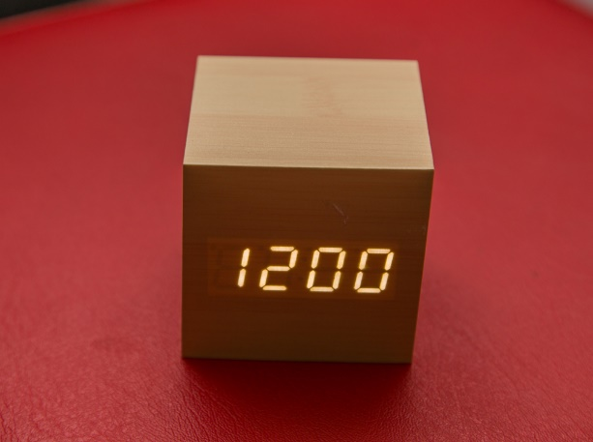

The clock is battery operated and is blank until it is activated by a user tapping it or making
a loud noise such as a clap. The clock then displays the time and also speaks it.
(a) Identify two input devices used by the clock. [2]
Button (1), microphone. (1)
(b) Identify two output devices used by the clock. [2]
LED display (1), speaker. (1)
(c) The designers in the company have reported that their computers are running slowly. Catherine has investigated the issue and decided to upgrade the magnetic hard disk drives with solid state drives.
Explain two features of magnetic hard disks that make them slow. [4]
The drive head must move to the correct location/track on the disk (1) in order to
read a file. This movement takes time and makes the disk slow (1)
The drive spins (with a motor) (1) it takes time for it to have spun to the correct
location for the start of the file (1)
If the files are fragmented across the disk (1) then the drive head must repeatedly move to access all the components of the file (1)
(i) Until now, company backups have been to external hard disks. The file server
is now storing around 5 Terabytes of data. Explain two reasons why a magnetic tape backup would be a good alternative. [4]
Magnetic tape backups are reliable for backups (1) so will be likely to have the data on if recovery is required (1)
The tapes can store over 5TB of data (1), so all the file server can be backed up onto one tape (1) Tapes are small in size (1) so they can easily be stored (1)
The cost per Gigabyte of data is the cheapest for tapes (1) therefore this will be the most economical solution (1)
2. Catherine’s company strives to be inclusive and not to discriminate against employees
with special needs and disabilities. Describe four different accessibility devices or
features that she could provide for partially sighted computer users. [8]
There are many devices available for people with various degrees of sight impairment.
Screen magnifiers can be used for those with partial eye sight (1). These are often carried out in software and will enlarge a section of the screen/graphics/text (1). They can also enhance the mouse and text cursors (1).
Braille keyboards can be used (1) for those who cannot see the letters on the keyboard (1). It is then possible to feel what each key is used for (1).
A braille embosser printer (1) and provide a hard copy of documents to read (1).
Narration software (1) will say the keys that are entered / where the mouse has selected (1) so that the user knows where they are on the screen / how many options there are (1).
Screen readers (1) can convert text to speech (1) to read what is on the screen (1).
Speech recognition software can be installed/activated (1) which allows the user to speak instead of typing / using the mouse (1).
Screen colours can be altered (1) so that they are higher contrast / easier to read (1).
[Total 20 marks]

