Name: Class: Mark:

1. Catherine runs a company that designs and manufactures ornamental clocks.
The designers each work at a desktop computer but also use laptops for working
at home and to show products to customers.
One of the clocks is a simple cube as shown below.
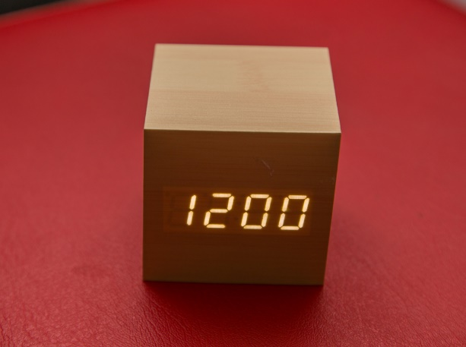

The clock is battery operated and is blank until it is activated by a user tapping it or making
a loud noise such as a clap. The clock then displays the time and also speaks it.
(a) Identify two input devices used by the clock. [2]

(b) Identify two output devices used by the clock. [2]

(c) The designers in the company have reported that their computers are running slowly. Catherine has investigated the issue and decided to upgrade the magnetic hard disk drives with solid state drives.
Explain two features of magnetic hard disks that make them slow. [4]
Feature 1:

Feature 2:

(i) Until now, company backups have been to external hard disks. The file server
is now storing around 5 Terabytes of data. Explain two reasons why a magnetic tape backup would be a good alternative. [4]
Reason 1:

Reason 2:

2. Catherine’s company strives to be inclusive and not to discriminate against employees
with special needs and disabilities. Describe four different accessibility devices or
features that she could provide for partially sighted computer users. [8]

[Total 20 marks]

