Answers
Task 1
Complete the following table of devices to state whether each device is input or output and to give an example of use. The first one has been completed for you.
Name of device | Input or output | Image | Example of use
Lapel microphone | Input | 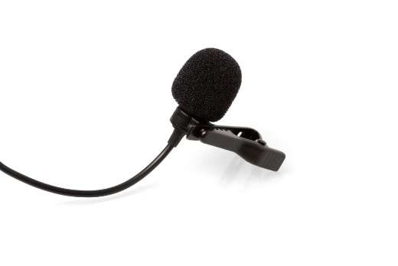 | Record sound for a TV presenter
Games controller | Input | 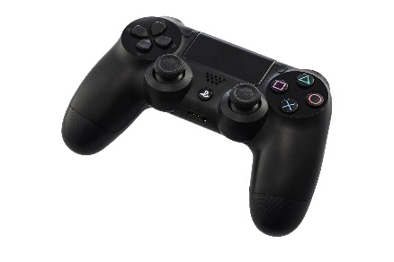 | Playing a video game
4K display | Output | 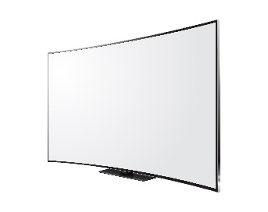 | Viewing ultra-high definition content
3D printer | Output | 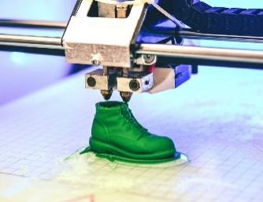 | Producing 3D models of objects and designs
Webcam | Input | 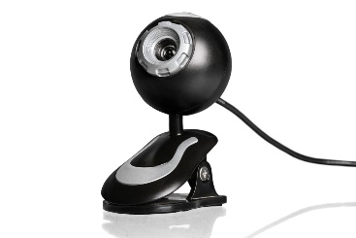 | Provide a moving image of a person when communicating with others online
Stadium speakers | Output | 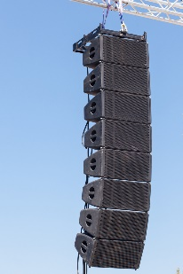 | Listen to sound and dialogue when watching a video or playing a game
Task 2
In many developing countries adult literacy is below 75%. If people are unable to read or write, they find it very difficult to learn or find employment.
One solution to this has been to use speech recognition and speech synthesis.
(a) Describe which input and output devices are required to perform speech recognition and speech synthesis.
- Microphone(s) for speech recognition (input)
- Speaker/headphones for speech synthesis (output)
(b) Discuss the benefits of voice recognition being carried out by a smartphone rather than a desktop computer.
- Smartphones are portable; therefore, the voice recognition can be available all the time, not just when there is access to a computer
- Less power is required for a smartphone
- Smartphones can make use of the internet for processing the speech recognition
Task 3
A graphics design company has several remote workers. It makes use of phone handsets which work through the internet using a technology known as VoIP. This allows their users to work remotely using their home internet connection. The handsets are more advanced than standard home telephones and have the following features.
- 20 buttons allow a quick dial of an extension. The button lights up if the employee on that extension is currently on the phone
- Soft key buttons allow the user to access their voicemail and transfer a call
- When in use, caller details will display on the screen
- When someone calls, the phone rings and an LED flashes
- The phone has the option of hands free or using the handset
(a) Identify the input devices used in this device.
Buttons (for dialling and soft keys)
Microphone (on headset, handset and phone for hands free)
(b) Identify the output devices used in this device.
Screen for outputting caller details
LED on handset to indicate ringing
Speaker for ringtone and handsfree
Handset/headset speakers
LEDs in buttons to show if an extension is being used

(c) Smartphones are more sophisticated in the input devices they contain. What additional input devices do they have compared to a VoIP phone.
Gyroscope
GPS receiver
Wi-Fi receiver
Video camera(s)
Compass
Ambient light sensor
Fingerprint sensor
Task 4
Research each of the following storage devices and media to complete the table below with a typical capacity and cost.
The examples have been completed with costs of a branded device/media in 2019.
Storage device  or media | Capacity | Cost | Price per GB
USB flash drive | 128 GB | £15 | 12p
SD card | 128 GB | £20 | 16p
Micro SD card | 128 GB | £18 | 14p
Internal hard disk (magnetic) | 1 TB | £38 | 4p
Internal hard drive (solid state) | 500 GB | £72 | 14p
DVD  (writeable) | 4.7 GB  (Pack of 50) | £12 | 5p
Blu-ray  (writeable) | 100 GB  (pack of 10) | £79 | 8p
Sony Ultrium  tape cartridge | 6 TB  (compressed these will store up to 12TB) | £26 | 0.4p

Task 5
A courier company is choosing devices for its head office and the delivery drivers. The drivers will use handheld devices and the main office uses a network consisting of a server and desktop computers.
(a) Discuss the storage devices that would be most suitable for the computer devices mentioned.
Flash memory is suitable for the portable devices as it is ‘solid state’ as it has no moving parts which could be damaged if the device was knocked or dropped and therefore there is less chance of losing data. It is small, light and easily portable. Solid state memory is relatively expensive but as these are small, handheld devices their data storage needs are relatively low.
Hard disk drives (magnetic storage) would be most suitable as they are cost effective in that they have a low cost per storage capacity and drives storing several terabytes of data are relatively cheap. They store and read data very rapidly which is vital for a server with many network users and they are durable and reliable if not moved. They are not very portable as physical knocks may cause the read-write heads to hit the discs and corrupt data but that is not a problem for desktop computers and servers.
Although solid state hard drives could be used, they are significantly more expensive. It is likely that a business such as a courier company is unlikely to need the benefits of faster access times or data transfer that such disks would give.
(b) Every evening the network data is backed up and the backup is stored off-site. Discuss the most suitable storage medium for these backups.
The media used for storage will have to be portable as it has to be stored off-site. The choice will depend on the amount of data to be backed up. Optical storage such as CDs, DVDs or Blu-ray could be used as they are portable and cheap, but they have limited storage capacity – 700 MB, 4.7 GB or 128 GB respectively. For larger amounts of data, digital tape could be used each of which can store up to 6TB of data.
A large capacity portable hard disk drive could be used but they are more susceptible to damage through physical knocks. Solid state memory could be used but is comparatively very expensive.
It is most likely that for a large business, tape backups will be used as they need to backup a lot of data. The cost of tape drives can be several thousand pound and therefore are not suitable for home backups, where hard drives would be far cheaper.
Task 6
(a) Choose two accessibility devices from the following:

- Alternative keyboards
- Sip and puff devices
- Braille input and output devices
- Speech recognition and screen readers
- Eye gaze trackers

(b) Make notes about each device below.
Alternative keyboards
These are large boards with a grid of sensitive areas that function as individual keys or can be combined into larger ones. They are covered with removable paper or plastic overlays, which indicate what will be input when they are pressed. These could be images or letters. The larger key area can help people with movement disabilities. The simplified design and use of images can help people with learning difficulties. They can have high contrast or Braille overlays to help people with visual impairment.
Sip and puff devices
With sip-and-puff devices, users sip (inhale) or puff (exhale) air through a special tube. The user can move the on-screen cursor by moving their head to move the tube. A left click can be performed by blowing or puffing and a right click by sucking or sipping. It is ideal for people who do not have use of their hands.
Wands and sticks
A mouth stick is a stick that goes into a person’s mouth and can be used to select onscreen items or to type on a computer. A head wand is strapped to the person's head. These devices would be used by someone who is quadriplegic and has no use of their limbs or hands.
Braille input and output devices
Braille keyboards allow visually impaired users to enter data into a computer whilst a refreshable Braille display converts the screen display to a Braille equivalent. Braille printers or embossers can be used to output hard copy of a document in Braille format.
Speech recognition and screen readers
Speech recognition software allows a user to control the actions of a computer, such as moving the cursor and left and right clicking, by speaking commands. Data can also be entered in a similar way. This method can be used by people who cannot move or who are visually impaired. Screen readers convert text to speech and will ‘read out’ what is on the screen. They can also notify the user what icon or item on the screen the pointer is indicating.
Eye gaze trackers
These devices allow a user to navigate and control their computer with their eyes. They only require the movement of the eyes and no other muscles are required. Highly sensitive cameras capture infrared light reflected from the retina and cornea of the eye. The software then builds a 3D model to determine the ‘gaze point’ – where the eyes are looking at relative to the computer screen. The device can thus control a cursor in a similar way to a mouse. To ‘press’ buttons, the user simply needs to look at a specific command or icon on the screen for a certain amount of time, usually a fraction of a second. Each computer can be programmed based on a user’s preferences. For instance, a ‘yes’ command can be looking at the ‘yes’ icon on the screen for a full second, or a ‘no’ command can be set to 1.5 seconds.

