Name: Class:

Task 1
Complete the following table of devices to state whether each device is input or output and to give an example of use. The first one has been completed for you.
Name of device | Input or output | Image | Example of use
Lapel microphone | Input | 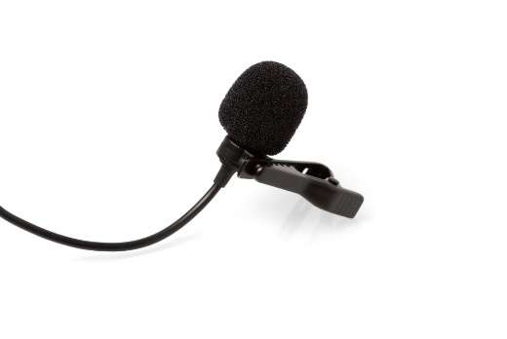 | Record sound for a TV presenter
Games controller |  | 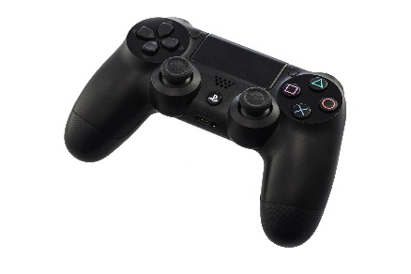
4K display |  | 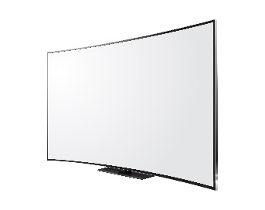
3D printer |  | 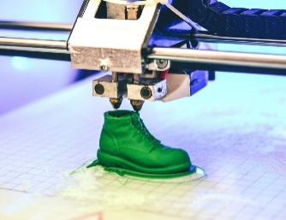
Webcam |  | 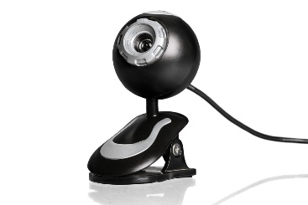
Stadium speakers |  | 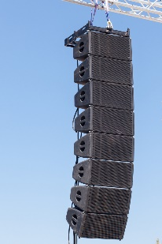
Task 2
In many developing countries adult literacy is below 75%. If people are unable to read or write, they find it very difficult to learn or find employment.
One solution to this has been to use speech recognition and speech synthesis.
(a) Describe which input and output devices are required to perform speech recognition and speech synthesis.

(b) Discuss the benefits of voice recognition being carried out by a smartphone rather than a desktop computer.

Task 3
A graphics design company has several remote workers. It makes use of phone handsets which work through the internet using a technology known as VoIP. This allows their users to work remotely using their home internet connection. The handsets are more advanced than standard home telephones and have the following features.
- 20 buttons allow a quick dial of an extension. The button lights up if the employee on that extension is currently on the phone
- Soft key buttons allow the user to access their voicemail and transfer a call
- When in use, caller details will display on the screen
- When someone calls, the phone rings and an LED flashes
- The phone has the option of hands free or using the handset
(a) Identify the input devices used in this device.

(b) Identify the output devices used in this device.

(c) Smartphones are more sophisticated in the input devices they contain. What additional input devices do they have compared to a VoIP phone.

Task 4
Research each of the following storage devices and media to complete the table below with a typical capacity and cost.
Storage device  or media | Capacity | Cost | Price per GB
USB flash drive | 128 GB | £15 | 12p
SD card
Micro SD card
Internal hard disk (magnetic)
Internal hard drive (solid state)
DVD
(writeable)
Blu-ray
(writeable)
Sony Ultrium
tape cartridge

Task 5
A courier company is choosing devices for its head office and the delivery drivers. The drivers will use handheld devices and the main office uses a network consisting of a server and desktop computers.
(a) Discuss the storage devices that would be most suitable for the computer devices mentioned.

(b) Every evening the network data is backed up and the backup is stored off-site. Discuss the most suitable storage medium for these backups.

Task 6
(a) Choose two accessibility devices from the following:

- Alternative keyboards
- Sip and puff devices
- Braille input and output devices
- Speech recognition and screen readers
- Eye gaze trackers

Device 1:

Device 2:

(b) Make notes about each device below.

