

Environmental Science

**Course Handbook**

**Introduction to the department**

Welcome to Environmental Science. We hope that you enjoy your time in the department and find the process of studying the course a challenging and rewarding one.

The purpose if this guide is to provide you with a range of information and advice to help you organise your programme of study, learn independently, and equip you with important information about the department and how it can support you.

**AIMS OF THE DEPARTMENT**

* To help students gain high standards in public examinations.
* To deliver biological teaching that:
* Stimulates students and fosters a passion for the subject;
* Allows students to work according to their own ability, but also strive to achieve personal targets;
* Is supportive and caring;
* Is built upon the Scientific Education of Key Stage 4;
* Develops a broad range of transferable practical and data-handling skills;
* Is valuable for vocational and higher education;
* Takes into account issues of equality and diversity

|  |  |
| --- | --- |
| **Teaching Staff:** |  |
|  | Mrs Justine Chatwin (second in Department)  Dr Debbie Haggar  Mrs Nicola Rokadia (Technician)  Mr Huw Halleybone (Technician) |

**Head of Department:**

* Mr Alex Chappelow

**Director of Faculty (Arts and Sciences):**

* Mr Jonathan Sparshott

Along with the names above, the following departments and places will be useful whilst studying on the course:

**The ILC** – your go-to place to complete work and independent study outside of lessons. The Silent Study area provides an area to work individually, whilst the library contains an excellent selection of wider reading. Make sure that you have familiarised yourself with the ILC when you start the course

**The Exams Office** – for any questions you have about your exam entries, exam timetable or remarks and script requests.

**Learning Support** – for any extra support or advice you need to help you study in general. If you are struggling to organise and manage your workload; need help refining your essay-writing technique; help with revision; or if you think you might be entitled to any exam concessions, learning support are the people to talk to.

**Careers** – when you start to think about your options after college, whether university or employment based, careers can give you advice on where to apply and help in producing a personal statement.

**ExpecTations**

**What is expected of students?**

1. **Attendance and punctuality** – learning cannot begin if you are not in lessons or if you arrive late to them and miss important content. Students should maintain full attendance and punctuality. Any unavoidable and legitimate absences should be accounted for properly, meaning that students get a parent or a guardian to contact college and then email their teacher(s) to catch up on missed work
2. **To maintain a mature and respectful learning environment** – this means behaving in and out of lessons in a way expected of a Sixth-Form student: listening carefully to the views of others and offering constructive contributions in class
3. **To stay up-to-date** – you will be set weekly structured preparation or homework tasks and it is essential that these are completed on time and in the required level of detail. We use structured homework to consolidate particular content or to set up lessons to come. If work is incomplete your understanding will be incomplete and you will under-perform. If you arrive at a lesson having not completed preparation work then your teacher may also ask you to leave and complete this elsewhere.
4. **To stay organised** – managing the demands of a minimum of three subjects is challenging, especially when you are being taught more than one unit in each. You need, therefore, to stay organised. This means preparing a folder for each of your units, bringing the correct materials to each lesson and recording homework in the same place every time
5. **To meet the 50/50** – students are expected to conduct 4.5 to 6 hours of independent study a week. This will include structured preparation or homework tasks set by your teachers along with proactive tasks you complete yourself to consolidate and extend your understanding. See the advice later in this booklet for more help on doing this.
6. **To make the most of feedback and support** – you will get a lot of feedback during your time on the course. This will come as written feedback on assessed work, verbal feedback on general class or homework, and targets set at formal 1-1s. Feedback needs to be recorded carefully by you and acted upon. When you get back assessed work, for example you will be asked to record your own targets based on this, and may, in addition, be asked to attend a lunchtime workshop to help process feedback.
7. **To be resilient** – any subject will at times be very challenging. At times you will not do as well as you want or will struggle to understand a new topic or idea. You need to be prepared to spend more time on areas such as these and to seek out extra help when needed. These experiences of finding areas where you are not doing so well and improving them are what lead to success.

**What can you expect of your teachers?**

1. **To deliver structured and engaging lessons** – your teachers will deliver lessons designed to challenge your understanding whilst also helping you to gradually build up your knowledge and skills. These lessons will follow the scheme of work, a version of which you can see in this handbook.
2. **Regular assessment and feedback** – in addition to your benchmark assessments (four in the first year and three in the second) your teachers will regularly set you exam-style questions to give you opportunities to practice and improve. Feedback will be given on standardised sheets which include the relevant mark scheme and clear developmental targets
3. **Structured weekly work** – you should expect to be given a significant amount of work to do by your teachers each week. You will be given guidance on how long this should take and completed work will be checked and/or taken in
4. **Additional support** – your teachers will be happy to provide extra help outside of lessons either informally, by responding to emails, or more formally through departmental workshops. Workshops are the best opportunity to received additional help and work best when students come to lunchtime sessions with a specific area of confusion or set of questions to get answered

**Approach to remote teaching and learning**

Following the closure of schools and colleges in March 2020, teachers and students have adapted to a new environment of remote teaching and learning. How ‘remote’ this is depends on the wider context of COVID-19, but the department has clear plans, and expectations of its students, in each of the scenarios below.

1. ***Normal Opening: The College is open as normal; all students attend and follow a full, face-to-face timetable***

In this situation the department would run lessons, as normal and all of the expectations of students and teachers on the page before would apply

1. ***Blended Learning: students will receive a mixture of physical and remote lessons, attending college physically one week and remotely the other***

The department will continue to offer high quality lessons in this scenario although the exact nature of teaching and learning may vary depending on what content is being covered. Students should expect a mixture of:

* **Streamed lessons** – when appropriate, lessons including half of the class will be streamed live through Microsoft Teams to the other half of the class learning from home
* **Recorded content** – tutorials, demonstrations, presentations etc. will be pre-recorded for students to watch and complete a set of follow-up tasks
* **Structured independent work –** students may be longer project-style work, or work that is made up of several structured tasks and asked to work on this independently for a period of time, during which their teacher will be available for support
* **Preparation work** **–** class time may be used to set students independent work in the form of research or pre-learning to prepare them for a specific live lessons, which will then be used to assess students’ level of understanding of the work they have completed.
* **Homework** – students will also be expected to complete homework tasks

1. ***Remote Learning: students will receive remote lessons and assessment will be conducted remotely***

In the event that college is not open for physical lesson, teaching and learning will move online through the combined use of Microsoft Teams and Godalming Online. The specific nature of each week’s learning will vary depending on what is being covered, but students should expect a mixture of:

* **Live lessons through Microsoft Teams** – this is a fantastic platform that allows classes to video-call, watch presentations, take part in Q&A, group work, 1-1s all in real-time. Teams lessons will be the main part of remote teaching and learning but may take a slightly different form or length than physical lessons to help students engage fully. For example, a 1.5 hour physical lesson might translate to a 30-45 minute Teams lessons, made up of a brief teacher-led presentation and class Q&A, followed by 45 minutes of structured independent work, during which time the teacher conducts 1-1s with students
* **Online submissions** – students will upload work regularly to help their teacher monitor their progress and offer support when needed. This will be done through the ‘Assignments’ feature on Teams or through Godalming Online
* **Remote Workshops** – in addition to remote lessons, department workshops will continue remotely to provide students with extra points in the week to get 1-1 help on content, homework or remote learning in general

**Expectations of students in scenario 2&3 –** if students find themselves learning remotely or in a mixture of physical and remote lessons, then the department has clear expectations of how they should work in this environment. The department has considerable experience in delivering content remotely and key to this is students remaining engaged, establishing a clear working routine and communicating effectively with staff. More specifically it is expected that students will:



* Attend all remote lessons unless told otherwise by their teacher
* Actively take part in remote lessons e.g. contribute questions and answers, take part in group work, turn webcams on (with the background blurred) when asked to by their teacher
* Submit all work via Godalming Online or Microsoft Teams by the deadline set
* Communicate regularly with their teachers, either as part of scheduled 1-1s or more informally to discuss work or any problems they might be having. This will be through Email or Teams.

To identify where your remote strengths and weaknesses might be, complete the specific department audit below. This is made up of the essential skills you would need to learn in a remote or blended environment.

|  |  |
| --- | --- |
| **Remote Learning Skills Audit that you need to master to succeed on this course** | ***Tick*** |
| Log on to Office 365 using your college details (in college and at home) |  |
| Open Microsoft Teams and find a class team |  |
| Join a lesson on Teams and post a comment |  |
| Download the Teams app on your phone |  |
| Upload or attach documents in Teams |  |
| Save documents on OneDrive |  |
| Access your OneDrive files at home |  |
| Share documents, PowerPoints etc without attaching them to emails |  |
| Access Godalming Online course pages and download files |  |
| Visit the Library webpage on Godalming Online and find the Environmental Science section |  |
| Access E-textbooks needed on the course |  |
| Log on to any magazines or websites needed on the course |  |
| Access Estream to watch films/documentaries/pre-recorded content |  |
| Find the department Youtube channel |  |



There are lots of places you can go to get help with the skills listed above.

To begin with, speak to your teachers to get help with the basics of using Microsoft Teams or Godalming Online. This can be done at the start of the year through departmental surgeries and through workshops. A good idea would be to bring the completed audit above to a workshop and go through this with your teacher to fill in any gaps.

The IT Department are also available to offer more technical support or if you run into a problem your teacher cannot resolve. If in college, IT can be found on the top floor of the 300s. Also have a look at the IT Helpdesk on Godalming Online, which has help on using features such as Office 365. Finally IT are also contactable via [ITsupport@godaming.ac.uk](mailto:ITsupport@godaming.ac.uk)

*[](https://www.google.co.uk/url?sa=i&url=https%3A%2F%2Flogotyp.us%2Flogo%2Fmicrosoft-teams%2F&psig=AOvVaw2Wl1l6bVS-gskR2jhCsLQD&ust=1594130388988000&source=images&cd=vfe&ved=0CAIQjRxqFwoTCNDg_8_kuOoCFQAAAAAdAAAAABAD)*If you are concerned about how to organise your time and working habits during a period of remote learning, then speak to your tutor for ideas and techniques to work independently. The Learning Support Department are also available to discuss specific concerns or individual learning needs further.

**Course Overview**

*(nB: Scheme of work is currently being adapted and rewritten)*

|  |  |  |
| --- | --- | --- |
| **YEAR ONE** |  | * **The Physical Environment** |
|  | * **The living environment** |
|  | * **Pollution** |
|  | * **Energy** |
|  |  |  |
| **YEAR TWO** |  | * **Pollution** |
|  | * **Energy** |
|  | * **Biological Resources** |
|  | * **Sustainability** |

**Research methods is embedded throughout both years and can be taught as a part of each of the above units.**

**The Exams**

At the end of your second year you will take two exams:

**Paper 1: (3 hours, 120 marks)**

• The physical environment

• Energy resources

• Pollution

• Research methods

**Includes one 25 mark essay question**

**Paper 2: (3 hours, 120 marks)**

• The living environment

• Biological resources

• Sustainability

• Research methods

**Includes one 25 mark essay question**

**Student scheme of work**

Below is a summary of how you will be taught the different units of the course and how this fits into the approximately 66 weeks of teaching time over the two years of your A-Level. You will also see the key assessment points given below. It is important that you know when these are so that you can organise your revision and preparation. An important idea to understand when looking at this student scheme of work, is that the course flows consistently over two years. The topics you study at the start of your first year are as ‘difficult’ as those you will look at the end of your second year. You need to treat all work in the same way and apply yourself fully throughout. Also consider that the May half term in the first year is, in reality, the mid-point of the course not the summer holiday. This time will go quickly so make sure you understand the structure of the course fully and get any help when it is needed.

|  |  |  |  |
| --- | --- | --- | --- |
|  | **A-LEVEL YEAR 1** | | |
| **Week** | **Teacher 1** | **Teacher 2** | **Assessment**  **(shows approximate date of benchmark assessments)** |
| **Start of term/L6 Enrolment** | | | |
| **L6 Enrolment** | | | |
| 1 | **Research methods**  3.7.1 Scientific methodologiesRecap sampling induction work | **Living Environment**  **3.1.2 Conservation of biodiversity**  3.1.2.1 The importance of the conservation of biodiversity  3.1.2.1.1 Resources and how sustainable habitat management strategies can be used to secure future supplies |  |
| 2 | 3.7.1 Scientific methodologies  General research methods | 3.1.2.1.2 Knowledge and how decisions over habitat conservation can be made to protect those species that have not yet been investigated |  |
| 3 | General research methods  Random sampling practical – comparison plant diversity trampled vs non-trampled | 3.1.2.1.3 Ecosystem services and their interaction with each other  3.1.2.2 How humans influence biodiversity, with examples in a range of different context |  |
| 4 | Random sampling practical – comparison plant diversity trampled vs non-trampled | 3.1.2.2 How humans influence biodiversity, with examples in a range of different context |  |
| 5 | Assessing biodiversity; use of Tullgren funnel/earthworm extraction and pitfall traps. | **3.1.2.3 Methods of conserving biodiversity**  3.1.2.3.1 Setting conservation priorities  3.1.2.3.2 Legislation/protocols |  |
| 6 | **Benchmark 1** | **Benchmark 1** | **Benchmark 1** |
| *Half Term - 25thth – 29th October* | | | |
| 7 | Answering investigation questions | 3.1.2.3.3 Captive breeding and release programmes |  |
| 8 | Answering investigation questions | 3.1.2.3.3 Captive breeding and release programmes |  |
| 9 | **Living Environment**  **3.1.3 Life processes in the Biosphere**  3.1.3.1 How adaptation to the environment affects species’ habitat requirements and  influences conservation decision-making | 3.1.2.3.4 Habitat conservation |  |
| 10 | 3.1.3.2 Terminology to describe the roles of living organisms in their habitats and their interactions with the physical environment  3.1.3.3 The control of ecological succession in conserving plagioclimax habitats | 3.1.2.3.4 Habitat conservation – specific habitats |  |
| 11 | 3.1.3.3 The control of ecological succession in conserving plagioclimax habitats | 3.1.2.3.4 Habitat conservation – specific habitats |  |
| 12 | **Benchmark 2**  3.1.3.4 How population control and the management of desire and undesired species affects the conservation of biodiversity | **Benchmark 2** | **Benchmark 2** |
| 13 | 3.1.3.4 How population control and the management of desire and undesired species affects the conservation of biodiversity | 3.1.2.3.5 The importance of ecological monitoring in conservation planning  3.1.2.3.6 The development of new technologies for ecological monitoring |  |
| *Christmas Holiday –20th December – 3rd January* | | | |
| 14 | **The Evolving Atmosphere**  3.1.1 **Conditions for Life on Earth**   3.1.1.1 How the main conditions, which allowed early life to develop and survive on earth came about | **Resources from the Earth’s Crust**  **3.2.3 Mineral resources**  3.2.3.1 Minerals extracted from the lithosphere |  |
| 15 | 3.1.1.2 How the presence of life on Earth has brought about environmental change  3.1.1.3 How historical conditions for life were monitored | 3.2.3.2 Geological processes that produced localised concentrations of recoverable mineral deposits |  |
| 16 | 3.2.1 **The atmosphere**  3.2.1.1 Energy processes involving UV, IR and visible light in the stratosphere and troposphere | 3.2.3.2 Geological processes that produced localised concentrations of recoverable mineral deposits  3.2.3.3 reserves and resources |  |
| 17 | 3.2.1.2 Global climate change  Greenhouse gases  Changes in oceans | 3.2.3.4 exploratory techniques | **Student Review 1 Available** |
| 18 | 3.2.1.2 Global climate change  Changes in the cryosphere and climate processes  Difficulties in monitoring and predicting climate change. | 3.2.3.5 Factors affecting mine viability |  |
| 19 | 3.2.1.2 Global climate change  Feedback mechanisms and tipping points  Carbon footprints and sustainable development  **Investigation: Carbon sequestration** | 3.2.3.6 Environmental impacts |  |
| *Half Term - 14th February – 18th February* | | | |
| 20 | 3.2.1.3 Ozone Depletion  Example of environmental issue where all the stages of scientific investigation are present.  Rowland-Molina hypothesis  Collection, analysis an interpretation of data. | 3.2.3.7 Future mineral supplies |  |
| 21 | 3.2.1.3 Ozone Depletion  Ozone depletion and Antarctica  Restoration of ozone layer  Evaluation of the effectiveness of methods to restore ozone layer | **3.4 Pollution**  3.4.1 The properties of pollutants  3.4.2 How environmental features affect the severity of pollution |  |
| 22 | **Benchmark 3**  **3.3 Energy resources**  3.3.1 The importance of energy supplies in the development of society  3.3.2 The impact of the features of energy resources on their use | **Benchmark 3**  3.4.3 Strategies to control pollutants based on their properties and features of the environment | **Benchmark 3** |
| 23 | **3.3 Energy resources**  3.3.1 The importance of energy supplies in the development of society  3.3.2 The impact of the features of energy resources on their use | 3.4.3.2.10 AMD and heavy metal pollution |  |
| 24 | 3.3.3 The sustainability of current energy resource exploitation – fossil fuels  Fossil fuels – features methods and environmental impact | 3.4.3.2.10 AMD and heavy metal pollution  3.4.3.2.12 Solid waste pollution |  |
| 25 | **3.4 Pollution**  Atmospheric pollution  3.4.3.2.1 Smoke/PM10 (Particulate matter less than 10 microns in diameter) | 3.4.3.2.12 Solid waste pollution |  |
| *Easter Holiday - 2nd April – 16th April* | | | |
| 26 | 3.4.3.2.2 Acid precipitation  3.4.3.2.3 Oxides of nitrogen (NOx) and PANS | 3.4.3.13 Noise pollution |  |
| 27 | 3.4.3 photochemical smog | 3.4.3.13 Noise pollution  **Investigation: Assessing noise pollution** |  |
| 28 | 3.4.3 photochemical smog  **Investigation: Assessing air quality/biotic index** | **Aqua Resources and Nutrients**  **3.2.4 Biogeochemical cycles**  3.2.4.1 The importance of biogeochemical cycles for living organisms  3.2.4.2 carbon cycle |  |
| 29 | **Forests and Water Resources**  **3.2.2 The hydrosphere**  3.2.2.1 The impact of unsustainable exploitation | 3.2.4.3 Nitrogen cycle |  |
| 30 | **Benchmark 4**  3.2.2.2 Analysis and evaluation of strategies for sustainable management | **Benchmark 4**  3.2.4.3 Nitrogen cycle | **Benchmark 4** |
| 31 | 3.2.2.3 Ocean currents: the importance of thermohaline circulation in distributing heat and regulating climate | 3.2.2.4 Phosphorus cycle |  |
| *Half Term 30thMay – 3rd June* | | | |
| 32 | 3.2.2.4 Increasing sustainability by treating contaminated water | **3.5.2 Aquatic food production systems**  2.5.2.1 Marine productivity  3.5.2.2 Fishing |  |
| 33 | 3.2.2.5 Increasing sustainability by economical use and the exploitation of new sources | 3.5.2.2 Fishing |  |
| 34 | Recap how humans influence biodiversity  3.5.3 Forest resources | 3.5.2.2 Fishing |  |
| 35 | 3.5.3.1 Life support services  3.5.3.2 Forest productivity and biodiversity | 3.5.2.3 Aquaculture | **Student Review 2 and Predicted Grade Available** |
| 36 | 3.5.3.3 Deforestation | 3.5.2.3 Aquaculture |  |

|  |  |  |  |
| --- | --- | --- | --- |
|  | **A-LEVEL YEAR 2 *(Scheme currently being reviewed and likely to change)*** | | |
| **Week** | **Teacher 1** | **Teacher 2** | **Assessment** |
| **Start of term/L6 Enrolment** | | | |
| **L6 Enrolment** | | | |
| 38 | Recap of properties of pollution, atmospheric pollution  Recap 3.4.3.2.1 Smoke/PM10    3.4.3.2.3 Oxides of nitrogen (NOx) and PANS 3.4.3.2.6. | Recap of energy properties and environmental impacts  Recap 3.3.4.1 Strategies to secure future energy supplies  Renewable energy technologies  Solar power  HEP  Wind  Biofuels  Geothermal |  |
| 39 | 3.4.3.2.10 AMD and heavy metal pollution | 3.3.4 Strategies to secure future energy supplies  Hydraulic fracturing  Coal gasification  Coal liquification  Methane hydrates from marine sediments |  |
| 40 | **Benchmark 5** | **Benchmark 5** | **Benchmark 5** |
| 41 | 3.4.3.2.6. Thermal pollution  3.4.3.2.7 Oil pollution | 3.3.4.1 Strategies to secure future energy supplies  Fossil fuels  Secondary/tertiary recovery of oil |  |
| 42 | 3.4.3.2.8 Nutrient pollution  3.4.3.2.8 Monitoring nutrient pollution | 3.3.4.1 Strategies to secure future energy supplies  Fossil fuels  Secondary/tertiary recovery of oil |  |
| 43 | 3.4.3.2.8 Monitoring nutrient pollution  Nitrate levels practical | 3.3.4.1 Strategies to secure future energy supplies  Directional drilling  Oil shales/tar sands  Carbon capture and storage  Nuclear  Nuclear power: fission and fusion |  |
| *Half Term - 19thth – 30th October* | | | |
| 44 | 3.4.3.2.8 Pesticide pollution | 3.3.4 Strategies to secure future energy supplies  Developments in energy storage technologies |  |
| 45 | 3.4.3.2.8 Pesticide pollution  3.4.3.2.12 Solid waste pollution | 3.3.4 Strategies to secure future energy supplies  Developments in energy storage technologies |  |
| 46 | 3.4.3.2.12 Solid waste pollution | 3.3.4.2 New energy conservation  3.3.4.2.1 Transport energy conservation |  |
| 47 | **Benchmark 6** | **Benchmark 6** | **Benchmark 6** |
| 48 | 3.4.3.2.14 Ionising radiation student booklet | 3.3.4.2 New energy conservation  3.3.4.2.1 Transport energy conservation |  |
| 49 | 3.4.3.2.14 Ionising radiation student booklet | 3.3.4.2 New energy conservation  3.3.4.2.2 Building energy conservation |  |
| 50 | 3.4.3.13 Noise pollution | 3.3.4.2 New energy conservation  3.3.4.2.3 Industrial energy conservation | **Student Review 3 Available** |
| *Christmas Holiday - 21st December – 1st January* | | | |
| 51 | 3.4.3.13 Noise pollution | **3.5.1 Agriculture**  3.5.1.1 Agroecosystems |  |
| 52 | **3.5.2 Aquatic food production systems**  2.5.2.1 Marine productivity  3.5.2.2 Fishing | 3.5.1.1 Agroecosystems |  |
| 53 | 3.5.2.2 Fishing | 3.5.1.2 Manipulation of food species to increase productivity |  |
| 54 | 3.5.2.2 Fishing | 3.5.1.3 Environmental impacts of agriculture |  |
| 55 | 3.5.2.3 Aquaculture | 3.5.1.4 Social/economic/political factors which influence agricultural production |  |
| 56 | 3.5.2.3 Aquaculture | 3.5.1.5 Strategies to increase the sustainability of agriculture |  |
| *Half Term - 25th February – 19th February* | | | |
| 57 | **MOCK EXAMS** | |  |
| 58 | 3.4.3.13 Noise pollution | **3.6 Sustainability** |  |
| 59 | **3.5.2 Aquatic food production systems**  2.5.2.1 Marine productivity  3.5.2.2 Fishing | 3.6.1 Dynamic equilibria |  |
| 60 | 3.5.2.2 Fishing | **3.6 Sustainability** | **Student Review 4 Available** |
| 61 | 3.5.2.2 Fishing | 3.6.1 Dynamic equilibria |  |
| 62 | 3.5.2.3 Aquaculture | **3.6 Sustainability**  3.6.3 Material cycles  3.6.4 Circular economy |  |
| *Easter Holiday - 2nd April – 16th April* | | | |
| 63 | Revision | Revision |  |
| 64 | Revision | Revision |  |
| 65 | Revision | Revision |  |
| 66 | **Last Day of U6 Teaching - Friday 14th May** | | |

**Assessment**

When starting the course, it is important to know how the course is assessed. All assessed work is marked around what are known as **‘assessment objectives’** (AOs) which have been set by the exam board. You need to understand what each of these is and how many marks it carries for each type of question. If you can do this then you will know what skills to demonstrate and to what extent for each question on the exam.

|  |  |  |
| --- | --- | --- |
| **AO1** | Demonstrate knowledge and understanding of scientific ideas, processes, techniques and procedures | **35-40%** |
| **AO2** | * 1. Apply knowledge and understanding of scientific ideas, processes, techniques and procedures:   2. in a theoretical context   3. in a practical context   4. when handling qualitative data   5. when handling quantitative data | **40-45%** |
| **AO3** | * 1. Analyse, interpret and evaluate scientific information, ideas and evidence, including in relation to issues, to:   2. make judgements and reach conclusions   3. develop and refine practical design and procedures. | **20-25%** |

***What do these mean?***

***AO1 –*** Recall concepts and processes and demonstrate this knowledge by (for example) naming key features, describing sequences of events or labelling diagrams.

***AO2 –*** Using your knowledge to explain why something has happened, or to make predictions about what might happen. This can involve explaining practical results, analysing data or interpreting unfamiliar situations.

***AO3 –*** Evaluating conclusions others have drawn from experiments and look for strengths and weaknesses in their statements. Use statistics to analyse your own results and assess whether your conclusions are significant or not. Look at practical procedures and suggest strength, weaknesses and improvements.

**A-Level Environmental Science sample Mark schemes**

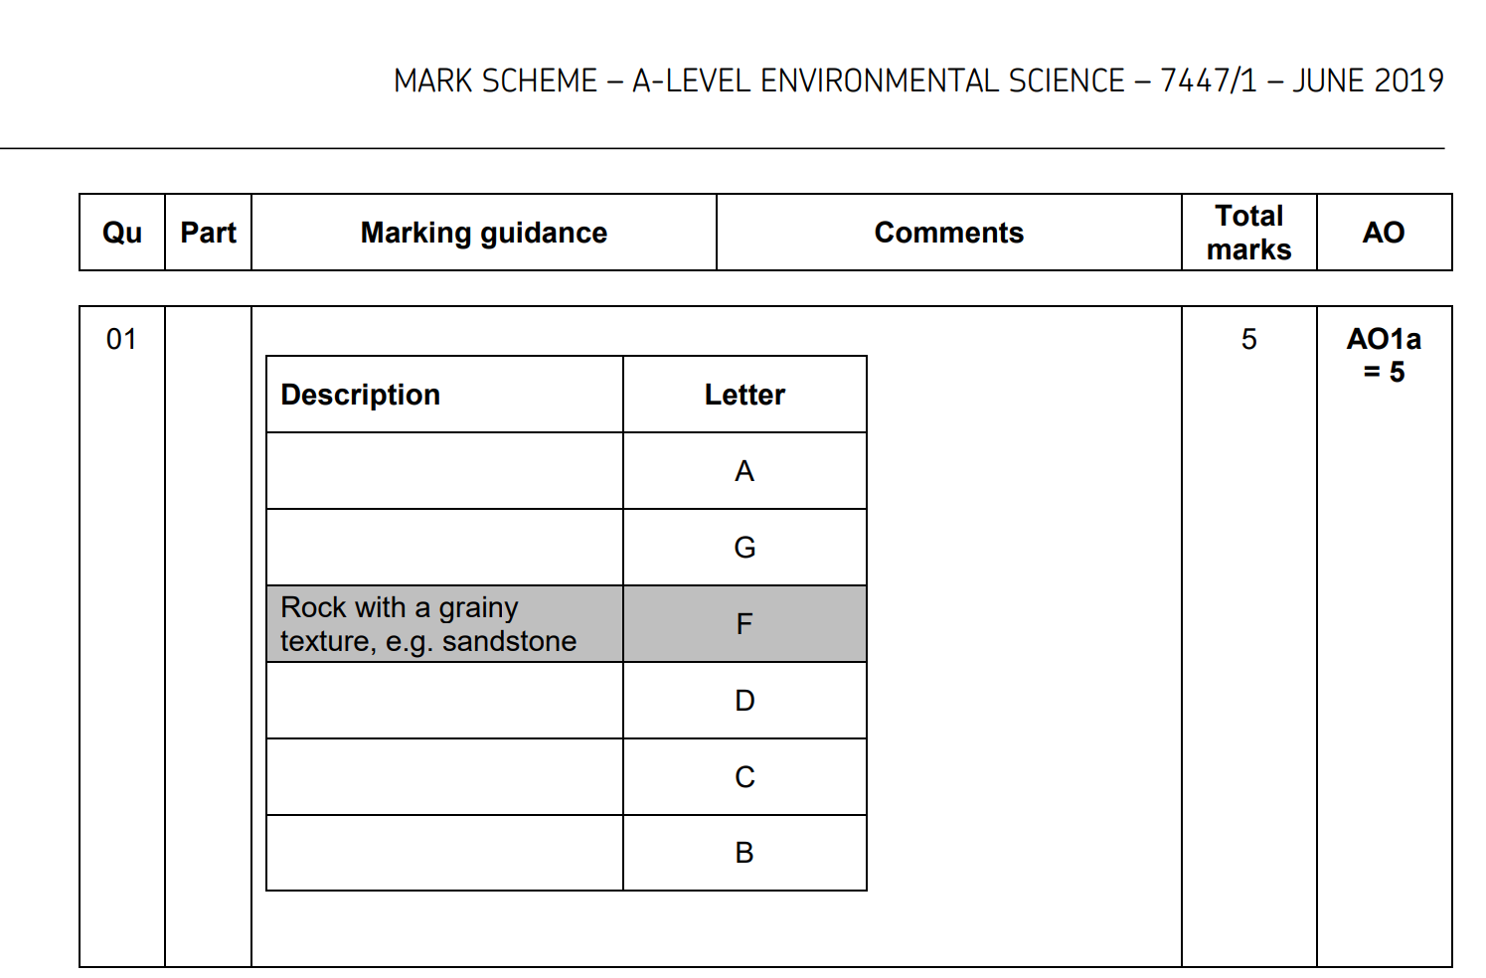

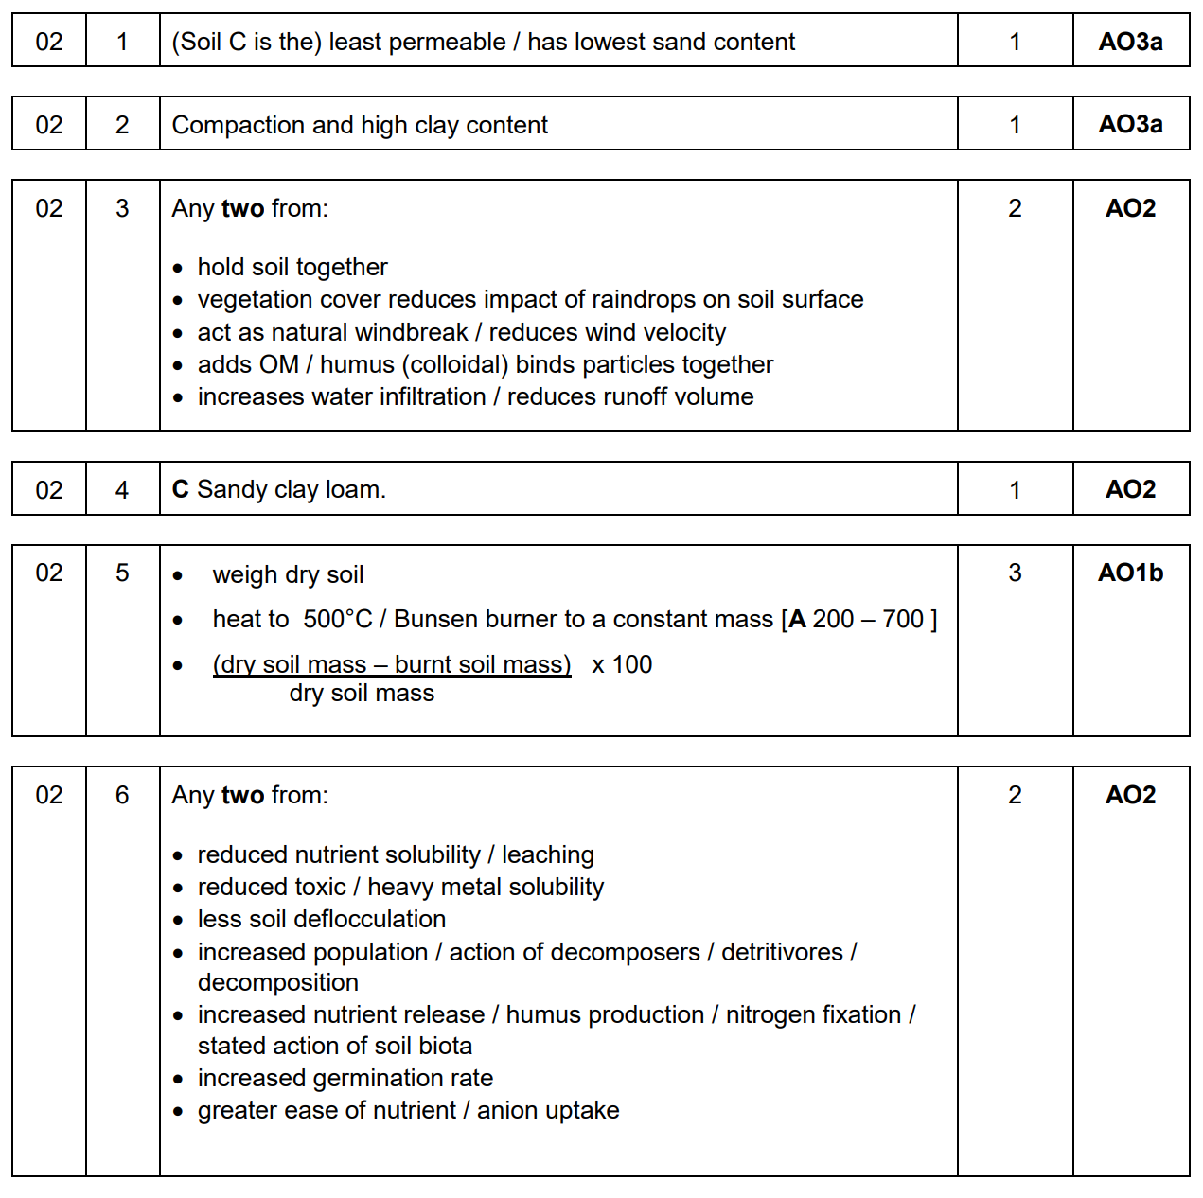

**Example Exam Paper**

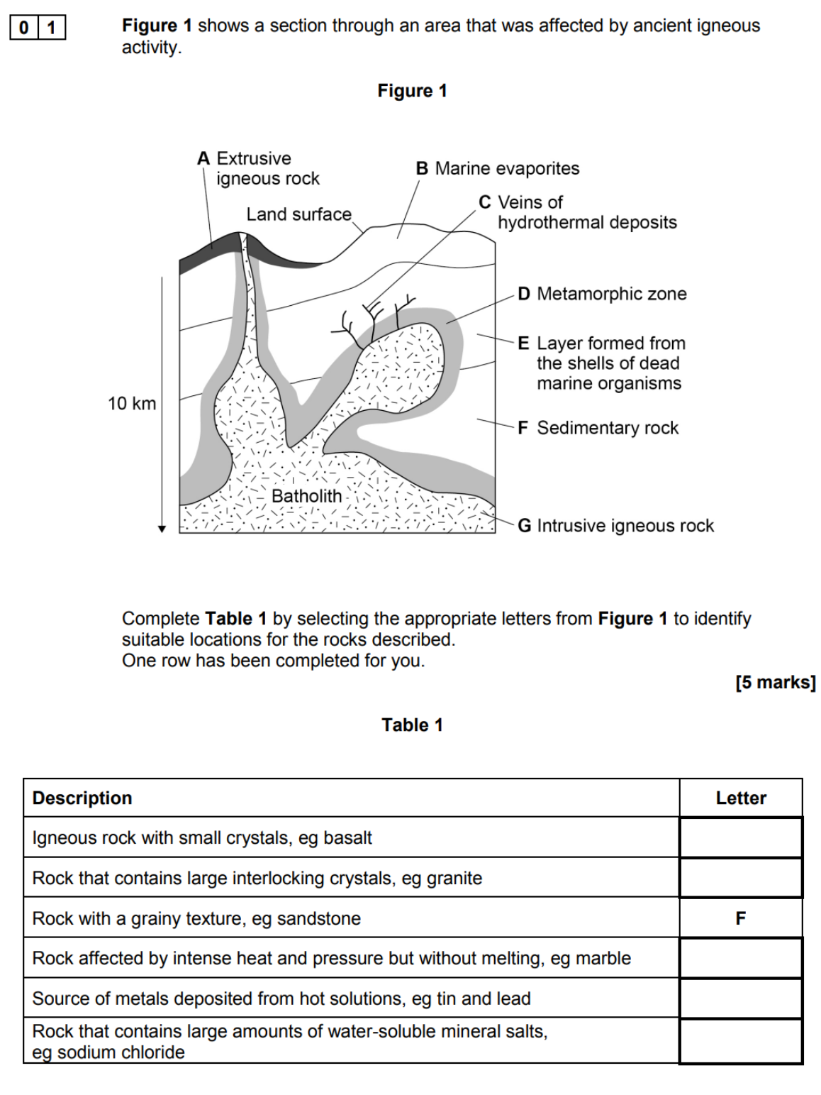

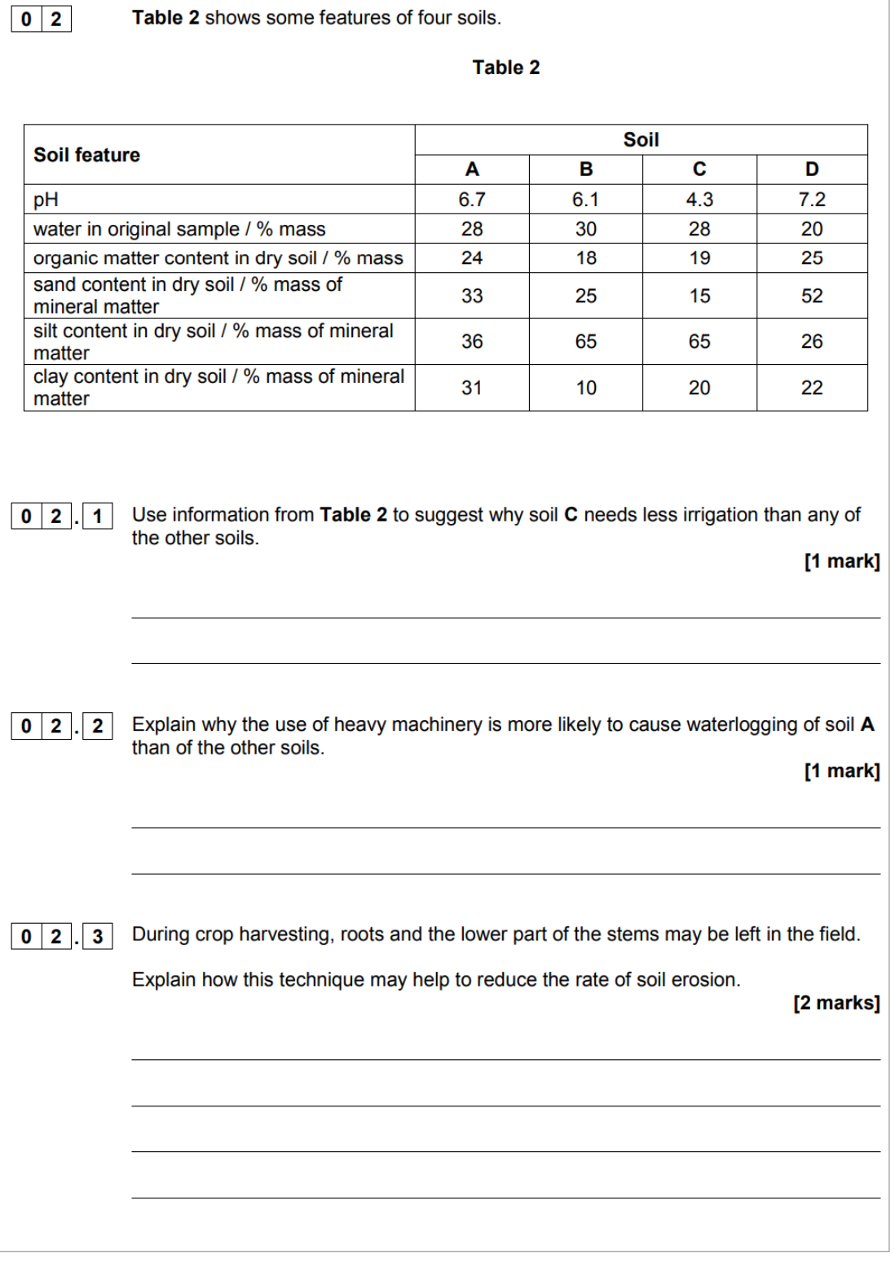

**Environmental Science Department Assessment Policy (AQA) 2021-23**

**The Importance of Feedback**

Learning will not happen instantly and takes time; attending lessons is not enough, you also need to be working outside of class, to learn new information and consolidate learning. In the process, you will make mistakes but hopefully feedback will enable you to learn from these mistakes. Better to make a mistake during the year and correct it, than make your first mistake in the actual exam! Feedback is essential for your learning and will consist of written (teacher marking), peer (where you feedback on someone else’s work in the class) and self (where you assess yourself).

**The Final Assessment**

Final assessment at the end of the second year is made up of **two** exams (3 hours each). Paper 1 will examine

• The physical environment

• Energy resources

• Pollution

• Research methods

Paper 2 will examine

• The living environment

• Biological resources

• Sustainability

• Research methods

**Weekly Independent Tasks (Homework)**

Homework does not necessarily need to be completed at home! You can use free periods during the day to complete these tasks outside of lessons. To keep a good work/life balance, you might like to treat College as an 0845 to 1615 day and use your free periods in the library completing tasks. This will minimise the work you need to complete at home and might make you more productive!!

The classes are shared equally between two teachers for 2.25 hours, with each teacher delivering one of the two units. Each week, homework will be set and could take up to 5 hours in total. Each teacher therefore could set you up to 2 ½ hours homework per week. If the homework only takes you 1 hour for a week, then you will have a further 1 ½ hours to conduct further reading and consolidate learning. Homework tasks will consist of two types:

* *‘PREP WORK’:* Not all homework will be marked. It will be given a quick inspection in class and then will involve peer and self-assessment as part of a class exercise. This work will ‘prepare’ you for the lesson.
* *REVISION WORKSHEETS and past exam practice:* Throughout the year, for each unit, there will be 6-8 revision worksheets set. These revision worksheets should take you 2.5 hours to complete and consist of a summary of the work we have done in class on 2 sides of A4. We will also set a range of past exam questions to help with exam technique and to check your understanding.

## **Benchmark Assessment Tasks**

Throughout the course, you will be set benchmark assessments. These will consist of the type of questions that you would see in the exam and will cover the topics covered to date. How you perform in these assessments will be formally logged and will directly contribute towards your ARG.  Benchmarks provide a valuable opportunity for feedback regarding your knowledge and understanding as well as an opportunity to develop your exam technique. Feedback can take the following forms:

* *WRITTEN TEACHER FEEDBACK:* Some benchmark assessments and home works will receive written feedback in the form of comments that relate directly to the assessment criteria of the exam board.  Alongside this, comments and questions will be posed about how to improve.
* *VERBAL TEACHER FEEDBACK:* This may take place during lesson time however formal 1-2-1’s will also occur in November and March at which point progress with assessments can be discussed.
* *WRITTEN PEER FEEDBACK*: One some occasions, your teacher will ask you to formally mark and feedback on a classmate’s common work in lesson. This is valuable experience for you to not only learn from others but gain a better understanding of the assessment objectives and mark schemes.
* *REFLECTION AND TARGET SETTING:* After each assessment, students will be expected to reflect on the written/verbal feedback from their teacher and set themselves targets for improvement in the period in question.

Benchmarks and home works tasks are an ideal way to assess your knowledge and understanding and get valuable feedback.

**Tracking your Progress: Student Reviews, Action Plans and Parents Evenings**

The College’s policy is to deal with the student first but we also report to your parents at regular intervals to let them know how you are progressing and to inform them of what our expectations are through four Student Reviews (Reports) spread throughout the two years at College and also four parents evenings.     If the department feel you are under-performing based on evidence such as benchmark grades and your approach to learning in between these periods, then your Lead Subject Tutor may place you onto a Formal Department Action Plan and we will formally write to your parents after a 1-2-1 with yourself and to try and get you back on track in a supportive way.

**Student Review 2, the ARG and Predicted Grades**

At the end of the first year (June 2021), your Lead Tutor will have a 1-2-1 to discuss your Annual Review Grade or ARG and also finalise your Predicted Grade which might be used for UCAS applications for University and other destinations.

The ARG is determined by your Lead Tutor in communication with your other teacher and will rely on the following evidence base:

1. **Benchmark Checkpoints Performance Grades (1 to 4).**
2. **Approach to Learning:** How you are engaging in your learning, evidenced by attendance, punctuality, ability to meet weekly deadlines with quality work, how you have sought out extra support via workshops and your overall communication with your teachers.

The ARG plays a key part in determining the context in which you progress to the second year. Students who receive an A*-D grade (A-level) are encouraged to continue with their studies into the 2nd year. However for students who receive a U or E Grade (A-level) as their ARG, it suggests that for whatever reason they have struggled with the transition from Level 2 Courses (GCSE) to Level 3 Courses (A-level/BTEC). This will be evidenced by poor performances throughout their benchmarks and an inconsistent or poor approach to learning in their student reviews and via formal Action Plans. Students who receive a U Grade we would not recommend to continue with the course and they would need to speak to a Senior Tutor about alternative pathways.

The College adopts a consistent and optimistic approach to predicting grades to ensure that they are both aspirational and achievable. A predicted grade is what we believe a student is likely to achieve by the conclusion of their course in positive circumstances and the predicted grade provides universities and colleges with some understanding of a student’s academic potential alongside their Personal Statement and a written Reference from their Personal Tutor.

The ARG is important in forming the basis for the predicted grade as well but the predicted grade will also be aspirational for the students’ ambitions although it must remain realistic and cannot be based on the idea that only now will the student start to work harder in the second year!

**Other Considerations**

* *LATE POLICY:* In line with the ‘College Assessment Policy’, the department are under no obligation to provide feedback to a student who does not meet the internal deadlines for weekly independent tasks, benchmark assessments or coursework drafts. Please be warned that a failure to meet the final coursework deadline is the equivalent to missing the exam and it will be recommended that the student should be removed from the course. Students who fail to prepare adequately for the lesson as requested, maybe excluded for part of the lesson and asked to work independently at the back of the classroom. A continued failure to meet ‘PREP’ work requirements will result in a reference to the pastoral team and a phone call home to parents.
* *RETURNED WORK:* Work will be assessed and returned within 10 working days of it being submitted unless it is the final coursework submission. The exam board stipulates that no feedback or formal grade can be released to students by the teacher. The exam board reserve the right to inform you of the final grade in August with your results. Please do not ask the teacher for your final mark as they will be unable to provide it.
* *PLAGIARISIM:*  Plagiarism is submitting another person’s written work as one’s own original work or using someone else’s idea without referencing the source or using pictorial work without permission or referencing the source. If there is a suspicion of plagiarism, the Head of Department and Senior Tutor will be informed and a meeting will take place. If a student is found guilty, they will be subject to disciplinary action by the College and the awarding body will be informed. Students should be aware that the College is subscribed to software designed to detect plagiarism.
* *ACCESS ARRANGEMENTS FOR EXAMS:* These are pre-examination adjustments for candidates based on evidence of need and normal way of working which must approved by the Learning Support department.  For example, use of a computer or extra time in the exam.  Since these arrangements are your ‘normal way of working’, you must practice them in class and with your homeworks – please see the Learning Support department for how you might do this.  Homework is always set to take between 4.5 to 6 hours to allow students who have extra time for example, more time to complete the homework compared to their peers.  Equally, in timed assessments it is vital that we are accommodating any access arrangements you might have.  Your teachers will speak to you individually, and in confidence about how they will best be able to support you through your studies with us.

**Benchmark Checkpoints, Student Reviews (Reports) and Mock Exams 2021-23**

Below is an overview of all the key assessment checkpoints

|  |  |  |
| --- | --- | --- |
| **CHECKPOINT** | **DATE** | **DETAILS** |
| **Benchmark 1 Checkpoint** | Oct 2021 | **One hour Mock Exam on both sides of the course**  A mixture of past exam questions |
| **Parents Evening (For All)** | Nov 2021 | **Meetings with your parents to discuss how you have settled in and transferred from GCSE to A-level learning based upon:**   1. **Approach to learning** (how you are engaging in your learning, evidenced by attendance, punctuality, ability to meet weekly deadlines with quality work, how you have sought out extra support via workshops and your overall communication with your teachers) 2. **Performance Grade** in Benchmark 1 and from your homework tasks |
| **XMAS BREAK** |  |  |
| **Benchmark 2 Checkpoint** | Dec 21/Jan 2022 | **One hour Mock Exam on both sides of the course**  A mixture of past exam questions |
| **Student Review 1** | Jan 2022 | **A review of your progress in the first term (12-13 weeks of teaching) after a 1-2-1 with your Lead Tutor:**   1. **Performance grade (A to U)** (based on benchmark 1 and 2 but also your homework tasks) 2. **Approach to Learning** (how you are engaging in your learning, evidenced by attendance, punctuality, ability to meet weekly deadlines with quality work, how you have sought out extra support via workshops and your overall communication with your teachers). |
| **Parents Evening (Targeted)** | Mar 2022 | **Meetings with your parents primarily where teachers may have a concern about your progress since Student Review 1 in January.** |
| **EASTER BREAK** |  |  |
| **Benchmark 3 Checkpoint** | March 2022 | **One hour Mock Exams on both sides of the course**  A mixture of past exam questions |
| **Benchmark 4 Checkpoint** | July 2022 | **One hour Mock Exam on both sides of the course**  A mixture of past exam questions |
| **Student Review 2** | July 2022 | **A review of your progress for the academic year (30-35 weeks of teaching) after a 1-2-1 with your Lead Tutor**   1. Approach to Learning 2. Performance Grade (Annual Review Grade or ‘ARG’ – performance for whole year (see notes above in main doc.) 3. Predicted Grade |
| **SUMMER BREAK** |  |  |
| **Benchmark 5 Checkpoint** | Oct 2022 | **One hour Mock Exam on topics from the Lower Sixth and new topics from the Upper Sixth**  A mixture of past exam questions |
| **Parents Evening (All)** | Oct 2022 | **Meetings with your parents to discuss how you have settled in to the second phase of learning:**   1. **Approach to learning** (how you have engaged since Student Review 2 including completion of summer homework and the first five weeks of teaching – deadlines met, engagement in class and communication with teacher) 2. **Performance** with reference to your draft coursework mark and to talk about the final deadline for after half-term. 3. **How to support you:** Discuss how parents can further support you and what is coming up in this year |
| **Benchmark 6 Checkpoint** | Dec 2022 | **One hour Mock Exam**  A mixture of past exam questions |
| **Student Review 3** | Dec 2023 | **A review of your progress for the academic year since last Student Review (July) after a 1-2-1 with your Lead Tutor**   1. Approach to Learning 2. Performance Grade (based upon benchmark 6 and homework tasks) compared to Predicted Grade |
| **XMAS BREAK** |  |  |
| **Timed essay** | Feb 2023 | **25 mark timed essay** |
| **Benchmark 7 Checkpoint** | Mar 2023 | **Two hour Mock Exam**  Paper 1 or Paper 2 |
| **Student Review 4** | Mar 2023 | **A review of your progress for the academic year (30-35 weeks of teaching) after a 1-2-1 with your Lead Tutor (see above)**   1. Approach to Learning 2. Performance Grade (based upon benchmark 7 Mock Exam only) compared to Predicted Grade |
| **Parents Evening (Targeted)** | Apr 2023 | **Meetings with your parents primarily where teachers may have a concern about your progress since Student Review 4.** |
| **EASTER BREAK** |  |  |

**Rationale for Assessment Programme**

The purpose of Benchmark Assessments is to ensure that you are fully prepared to sit your three 2 hour exams at the end of your second year, and perform at your highest ability. These exams will take place under timed conditions, and therefore so will our benchmarks. Any students who have exam concessions will be entitled to the same arrangements in our benchmarks (e.g. extra time). The first few benchmarks will introduce you to the types of examination questions at A level, and you will become familiar with both the short answer and the extended answer styles. At the end of the first year, in Benchmark 4, you will be tested on a whole year’s worth of content. This is the assessment in your first year that most resembles one of the terminal exams, and is therefore a good indicator of student performance. Consequently, Benchmark 4 is a valuable piece of evidence in determining the ARG.

In the second year, students are introduced to the 25 mark essay questions. They will have to write one essay in each of their exams at the end of the course, so these are included in some of the later benchmarks in the Upper sixth to allow students to practice. In February of the second year, students will complete a full 3 hour paper under exam conditions in the hall. This big mock exam is a key assessment and should be treated very carefully – it is perhaps the only time you will be able to sit in an exam hall under timed conditions to complete an assessment.  It is positioned there for you to learn from the experience with enough time to correct any issues before you sit the final A-level assessment after Easter.

**Grade Boundaries**

When marking benchmark assessments, all teachers will use exam board produced materials to award marks. Teachers will regularly meet to discuss and moderate papers to ensure consistency. The grade boundaries are decided by using a normal distribution of outcomes. This ensures that all students have a realistic chance of accessing each grade. We also compare our grade boundaries to external ones used by the exam board, and this reference point can also help ensure that the grades we award are both fair and realistic.

**Environmental Science Department**

**50:50 Help and Advice**

Key to your success whilst studying in the Department is the level of effort and work you put into your subjects outside of lessons. The college’s expectation is that you match every hour of class time with an hour of independent study – **50:50**. This will include completing **structured homework** tasks set by your teachers but will also require you to **work independently**; finding ways to consolidate and extend your understanding. To help you to do this, the list below gives some ideas or activities to consider each week.

**yOU SHOULD SPEND ROUGHLY 5 HOURS OUTSIDE OF LESSONS ON HOMEWORK AND CONSOLIDATION.**

Complete all set homework tasks for your teachers first. This might be past paper questions, or preparatory reading and tasks to get ready for the next lesson. The remaining time should be set aside for consolidation and revision. Below are some suggestions for how to approach this.

1. **READ THE ONLINE NOTES** to prepare for you next lesson
2. **WATCH AN ENVIRONMENTAL SCIENCE VIDEO** – crash course/Blue Planet/Anything Attenborough
3. there are lots to choose from! Use the videos to either prepare for your next lesson or consolidate what you have done in class
4. **MAKE FLASHCARDS/MIND MAPS** or other revision tools to consolidate what you have learnt
5. **READ NATIONAL GEOGRAPHIC OR RELATED ARTICLES IN JOURNALS LIKE NEW SCIENTIST**– the library has copies or look in the ‘Further reading folder’ On Godalming on line
6. **COMPILE A LIST OF KEY WORDS** to check you know their definitions
7. **LEARN ESSENTIAL DIAGRAMS** eg chloroplasts, mitochondria, Muscle structure, neurones, action potential, synaptic transmission etc
8. **DRAW OUT PROCESSES** as a flow diagram eg LDR. ETC, formation of tissue fluid
9. **GO THROUGH THE SPECIFICATION** to identify any areas you are unsure of
10. **COMPLETE THE MULTIPLE CHOICE QUIZZES** on Godalming online
11. **CONSOLIDATE, CONSOLIDATE, CONSOLIDATE** – read through your notes from class, go back over the powerpoints and raise any questions with your teacher before the course moves on

