Answers

Task 1

The screenshot below shows an example of a Graphical User Interface (GUI).  
  
Annotate the screenshot to highlight the GUI features.

**Icons**

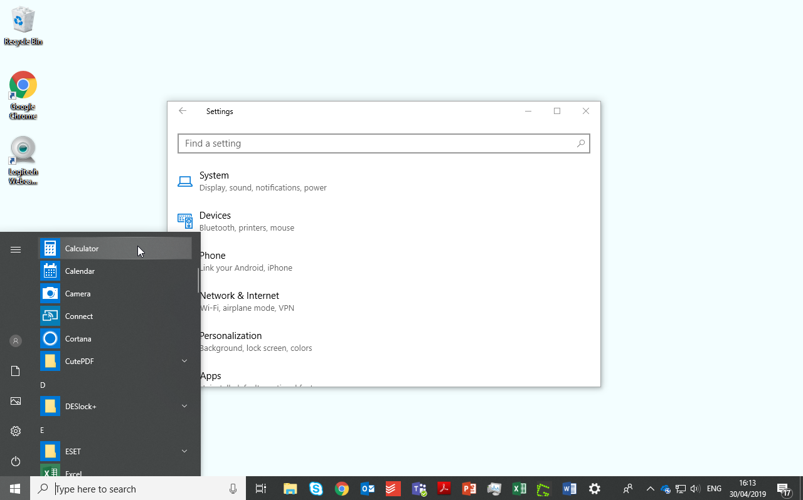­

**Window**

**Pointer**

**Menu**

Task 2

Rachael runs a web development company with clients including on-line estate agencies and major retailers. She employs a team of developers and programmers in addition to administrative and office staff. They are currently designing a new website for a major retail company.

The programmers have to enter and send complex commands to the server which will improve performance and upload new computer code.

They use a command line interface.

(a) What are the advantages of using a command line interface for the developers?

Quicker for them to enter commands than select items from a menu and click on icons  
They are experienced so will know the commands required  
Very little processing required by the server (so it won’t affect its speed in serving web pages).

(b) Why would a Graphical User Interface (GUI) be most suitable for the administrative and office staff?

Easy for users to understand.  
Most users have used a GUI, so no need for training costs.  
Menus and icons are more intuitive.  
Mouse pointer (or touch screen) give the ability to drag and drop items.  
Modern office software is designed to be used with GUI based operating systems.

Task 3

QuickHouse is a new online estate agent company being created. House buyers will be able to view houses via an app. They have decided to use an adaptive user interface to show houses that are available to buy and features about them such as photos, plans, local facilities and historical prices.

The app will be responsive and adapt to the orientation of screen

(a) Draw an outline of how the app could appear differently on a tablet to a smartphone.



Detached   
3-bedroom house  
More information…

**£250,000**

House photo

2-bedroom flat  
More information…

dethatched 4-bedroom house  
More information…

detached 3-bedroom house  
More information…

**£210,000**

**£360,000**

**£250,000**

House photo

House photo

House photo

*Tablet in landscape orientation Smartphone in   
portrait orientation*

Student answers will differ to the above examples. The tablet version is likely to   
show a number of properties – perhaps in a list layout with further information or   
grid layout with many properties. Icons or further information links will be present.   
The phone version is likely to only have room to show one property on a screen or reduced information.

(b) Explain how the app’s interface can also be adaptive to user preferences.

The user may consistently click on certain options. These can then be shown more prominently. For example, if the customer constantly clicks on the plans of each house, an icon could appear on the main list of properties that allows them to go straight to this option. If a user constantly looks at the historic price of a property this could be displayed beside the properties actual price.

(c) QuickHouse will have a customer support line. They have decided to use a menu-based interface. What are the advantages to the company of using this type of interface?

Customers can use the keypad on their phone to select options.  
Customers can be filtered to support agents / reduce training costs.  
Common queries can be automatically answered. The menu system can estimate how long a user will wait or where they are in a queue. Key information can be entered to a phone (such as an account number) – this can then be displayed to the customer service assistant and reduce them needing to ask questions.

Task 4

Lucy is buying a new computer and is considering which operating system to use. Many of her friends use Windows, whilst others speak highly of MacOS on their computers. One friend, who is very technical, uses an operating system called Ubuntu.

(a) Choose **two** of these operating systems  
  
Operating system 1: ___  
  
Operating system 2: ___

(b) Research the benefits and drawbacks of each of your chosen operating systems then discuss these below.  
  
**MacOS**  
Less susceptible to viruses and malware than Windows and upgrades are always free.  
More free software is provided with the operating system, such as Garageband for making music. Overall there is less software provided for the operating system as it has fewer users. Users who wish to use Windows software can use virtual machine software (Parallels). This can add to the cost and complexity though.

There are fewer computers to choose from as it can only be used as the native operating system on Apple computers – this means that the cost of the computer if often significantly higher. As the same company produce the hardware and operating system it is less likely to have issues with compatibility. There will only be one company responsible if things go wrong. The OS uses a GUI making the interface easy to use.   
A terminal window can be loaded for users who need a command line interface.  
  
**Windows**  
There are many Windows users so she will find it easy to get help.  
There is a larger selection of software available. Hardware manufacturers will be most likely to support drivers for Windows as it’s the most popular system. It is more targeted by viruses and malware as the operating system has more users.

Traditionally, security has not been as strong as the other two operating systems.  
The OS uses a GUI making the interface easy to use. A terminal window (using DOS commands/Powershell/Command Prompt) can be loaded for users who need a command line interface.  
  
**Ubuntu**  
This operating system is free and can be used with a wide variety of hardware (it is a Linux based operating system). As this OS has fewer users, software choices are limited – although free and open source software is common. The operating system is more likely to have compatibility issues.

As users are often more technical, support online can also be harder to understand. There will be fewer friends who can offer help to Lucy. The OS uses a GUI making the interface easy to use. A terminal window can be loaded for users who need a command line interface.