Name: Class:

Task 1

The screenshot below shows an example of a Graphical User Interface (GUI).  
  
Annotate the screenshot to highlight the GUI features.

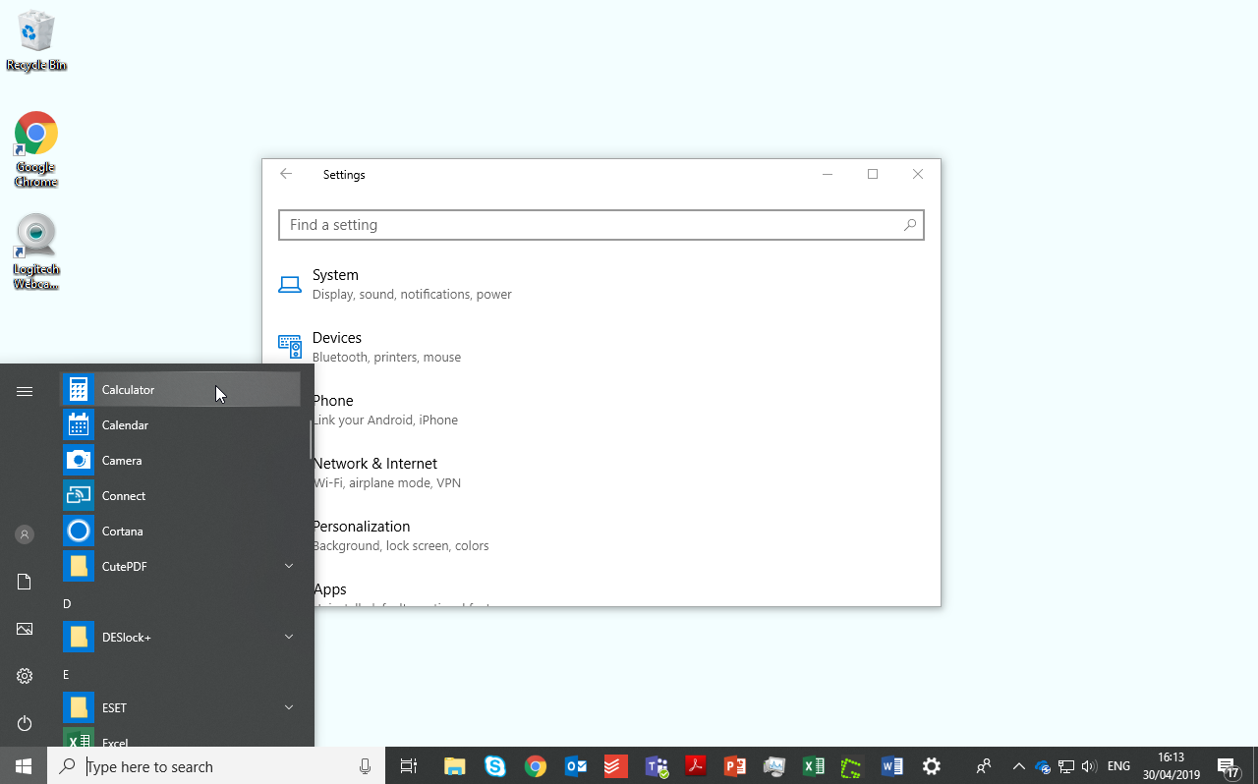­

Task 2

Rachael runs a web development company with clients including on-line estate agencies and major retailers. She employs a team of developers and programmers in addition to administrative and office staff. They are currently designing a new website for a major retail company.

The programmers have to enter and send complex commands to the server which will improve performance and upload new computer code.

They use a command line interface.

(a) What are the advantages of using a command line interface for the developers?

(b) Why would a Graphical User Interface (GUI) be most suitable for the administrative and office staff?

Task 3

QuickHouse is a new online estate agent company being created. House buyers will be able to view houses via an app. They have decided to use an adaptive user interface to show houses that are available to buy and features about them such as photos, plans, local facilities and historical prices.

The app will be responsive and adapt to the orientation of screen

(a) Draw an outline of how the app could appear differently on a tablet to a smartphone.



*Tablet in landscape orientation Smartphone in   
portrait orientation*

(b) Explain how the app’s interface can also be adaptive to user preferences.

(c) QuickHouse will have a customer support line. They have decided to use a   
menu-based interface. What are the advantages to the company of using this   
type of interface?

Task 4

Lucy is buying a new computer and is considering which operating system to use. Many of her friends use Windows, whilst others speak highly of MacOS on their computers. One friend, who is very technical, uses an operating system called Ubuntu.

(a) Choose **two** of these operating systems

**Operating system 1:**

**Operating system 2:**

(b) Research the benefits and drawbacks of each of your chosen operating systems then discuss these below.