**Cinematography** – *Describe the cinematography-* *Shot types and movement. Who are we being asked to align ourselves with? When do we see the use of POV? When are particular angles used?*

**Lighting** – *Consider the use of colour, isolated lighting, high key lighting, low lighting, what is being highlighted?*

*Is this lighting typical of the genre?*

**Editing** – *Continuity or non-continuity? Interesting effects and transitions? Shot Length? When does it become fast pace or slow pace?*

[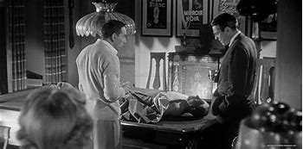](https://www.bing.com/images/search?view=detailV2&ccid=%2bnBWUPrS&id=34222348432B7BB057439EAC367DB40BBECDB2E7&thid=OIP.-nBWUPrSXDcosw9F_FBG5gHaDq&mediaurl=https%3a%2f%2f3.bp.blogspot.com%2f-xqBIBlVf12c%2fW_9l9T3Y2_I%2fAAAAAABBWxk%2f5zqN1qtywgkjjbcwLsBOWQAj9ylTpcBkwCLcBGAs%2fs1600%2fInvasion_of_the_Body_Snatchers-1956-Don_Siegel-051.jpg&cdnurl=https%3a%2f%2fth.bing.com%2fth%2fid%2fR.fa705650fad25c3728b30f45fc5046e6%3frik%3d57LNvgu0fTasng%26pid%3dImgRaw%26r%3d0&exph=793&expw=1600&q=invasion+of+the+body+snatchers&simid=607993534754132983&FORM=IRPRST&ck=606E1847223F57E0F1367BE051CD3903&selectedIndex=96)

**Representation**

*Men*

*Women*

*Authority*

*Age*

**Genre** – *What conventions do you see which are conventional to this genre? Are there any elements of iconography used?*

**Mise en scene** – *Notable* *costumes, props, locations / décor and performance?*

**Sound** *– Describe the musical score, non-diegetic music chosen and sound design?*