Shot / Movement/  Framing | What we see: OPENING SCENE | Meaning? Link to context and audience.
Passage of clouds across the sky behind the title sequence.  Sped up using time lapse photography effect. | 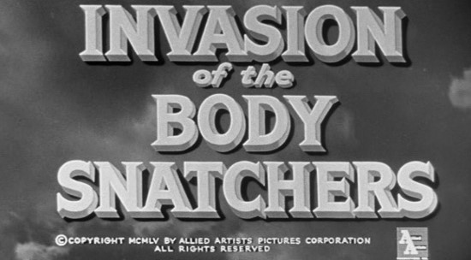 | The sped up clouds are used to unsettle the audience. May make them remember 1950’s sci-fi warning to ‘Watch the skies’.  Links to the American fear of the threat of war/ nuclear bombs from  Russia.
Long distance shot  Tracking movement  Following the car.  Establishing shot of a back street at night; leading to the city hospital. A police car races through the dark street and pulls up outside the hospital. The men inside the car get out and enter the hospital. | 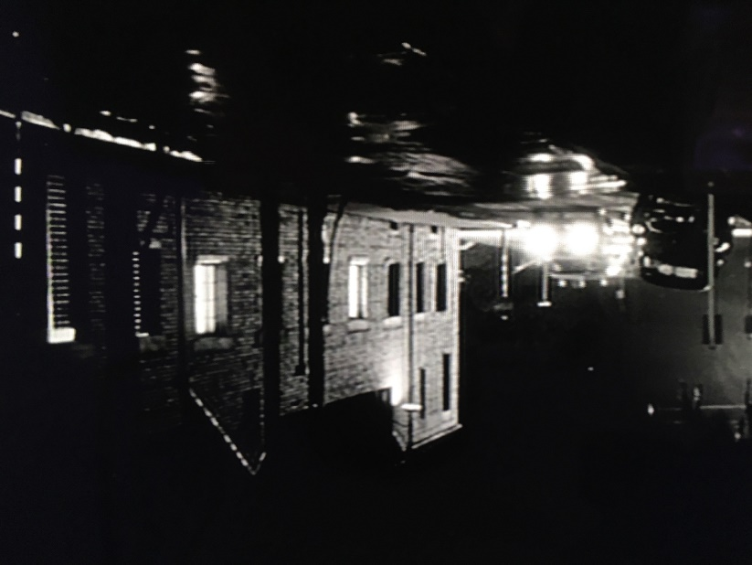  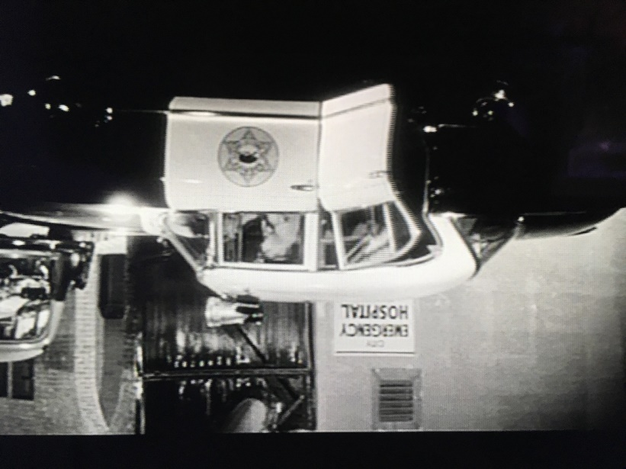
The action moves inside. The plain clothed police officer enters the ward and speaks to the doctor.  The police and the doctor walk towards a room and open the door. Inside is the main protagonist, Dr. Miles Bennell. He is shouting and being held by the police.  _______________________ | 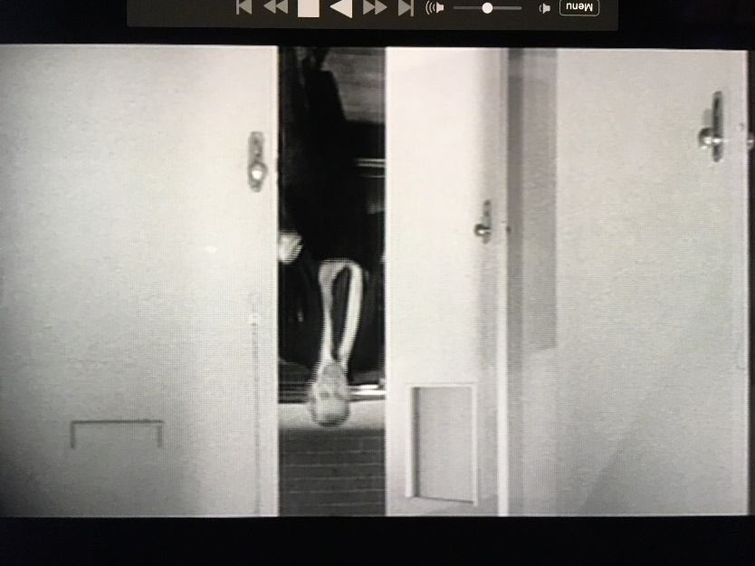  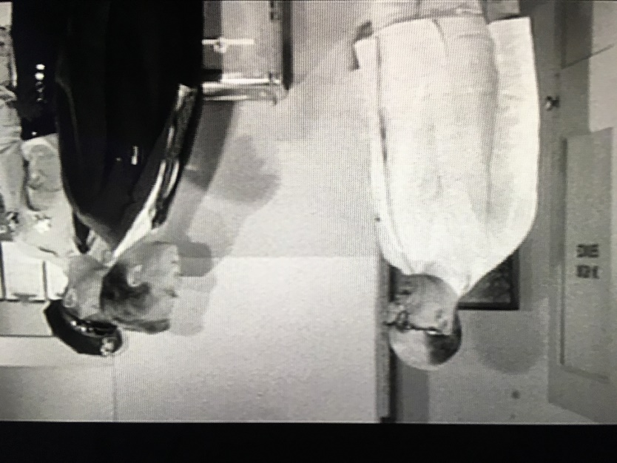  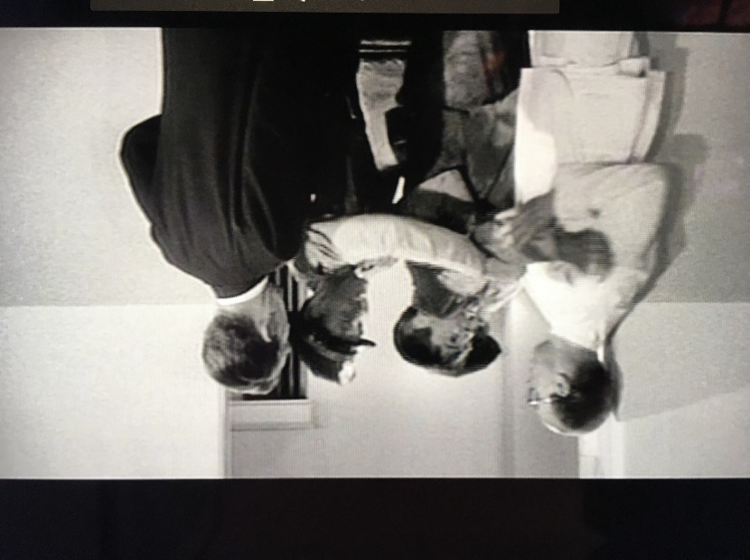
The policeman asks questions to Dr. Miles Bennell who is upset and trys to protest his sanity. | 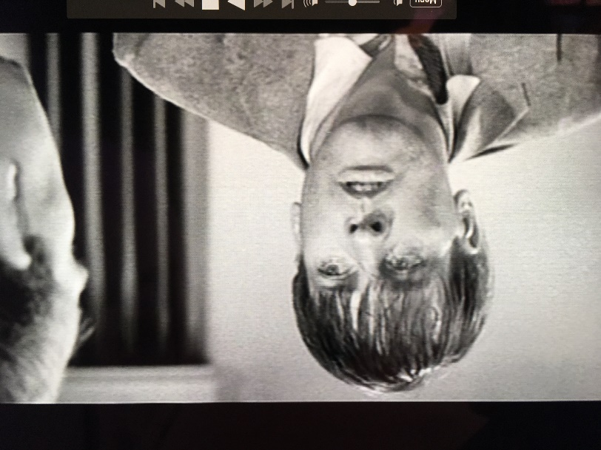
Establishing shot of Santa Mira’s rural railway station, surrounded by hills. People go about their business: carrying luggage; talking to one another; crossing the lines. | 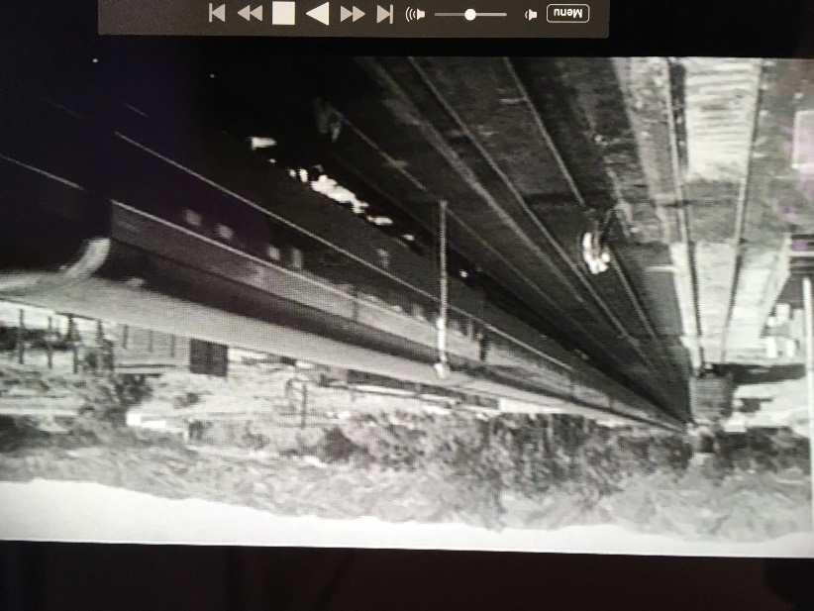  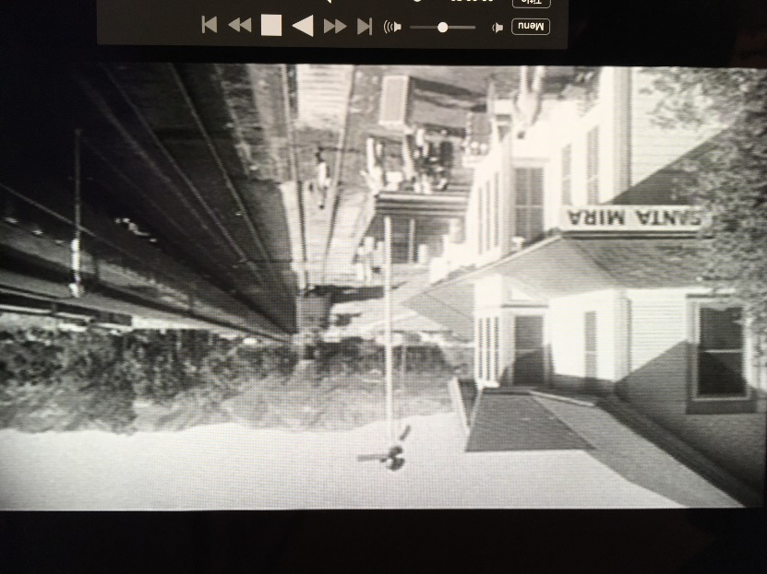
Dr. Miles Bennell greets people at the train station in a friendly manner. | 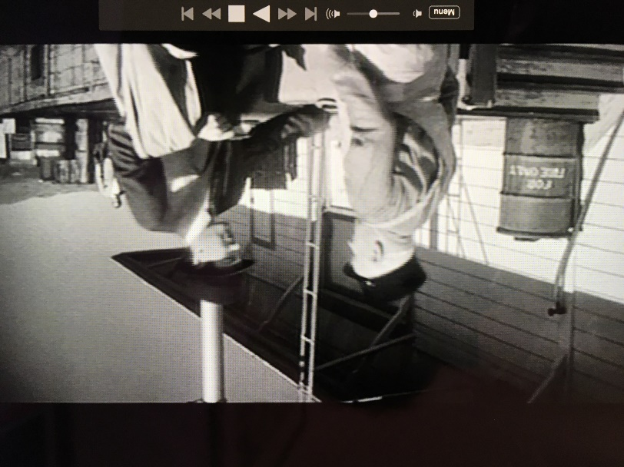
Bennells nurse, Sally Withers arrives at the station to pick him up. She waves to him.  Sally and the Dr. greet each other and Sally leads him to the waiting car. | 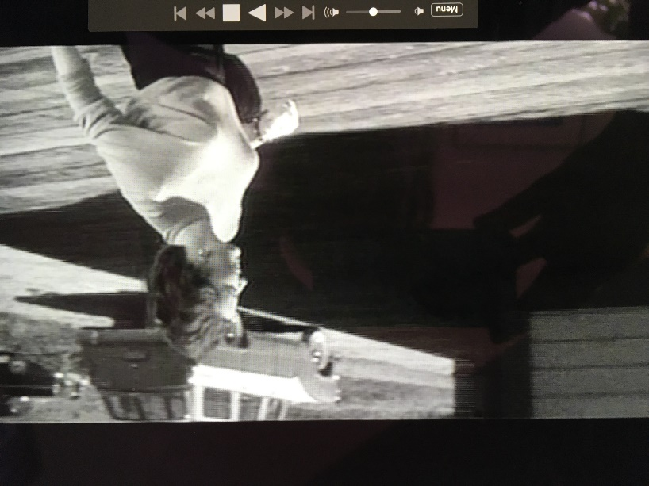  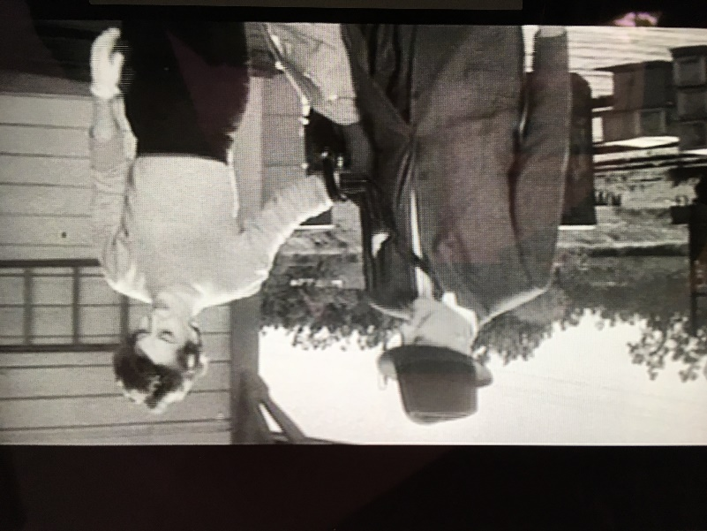
Back projected  In the car, Sally tells Dr. Bennell that lots of people are desperate to see him. | 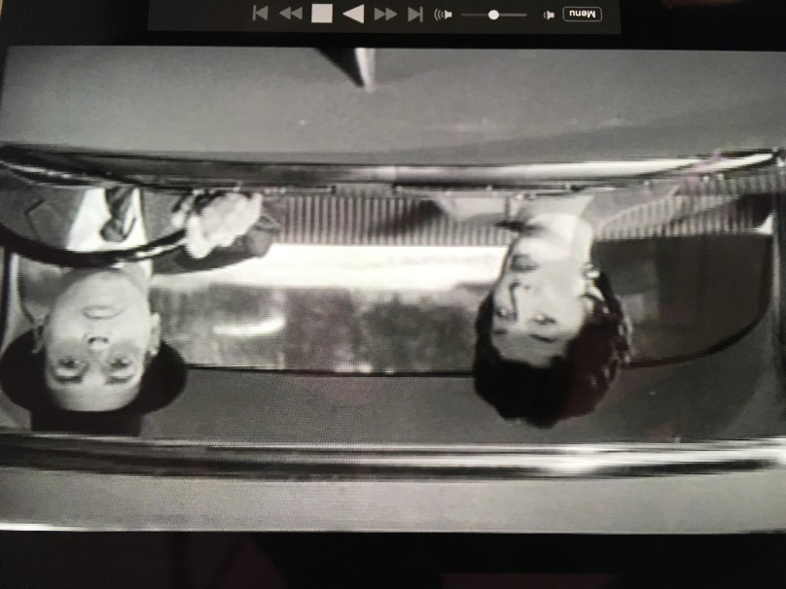
Dr Miles Bennell listens to what has been happening in the town. | 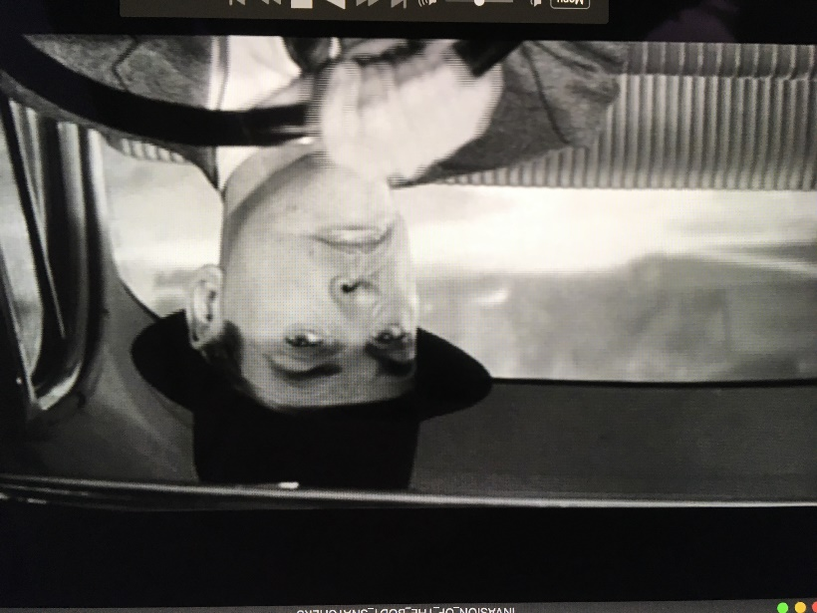
Sally explains the town gossip and mentions Becky Driscoll. | 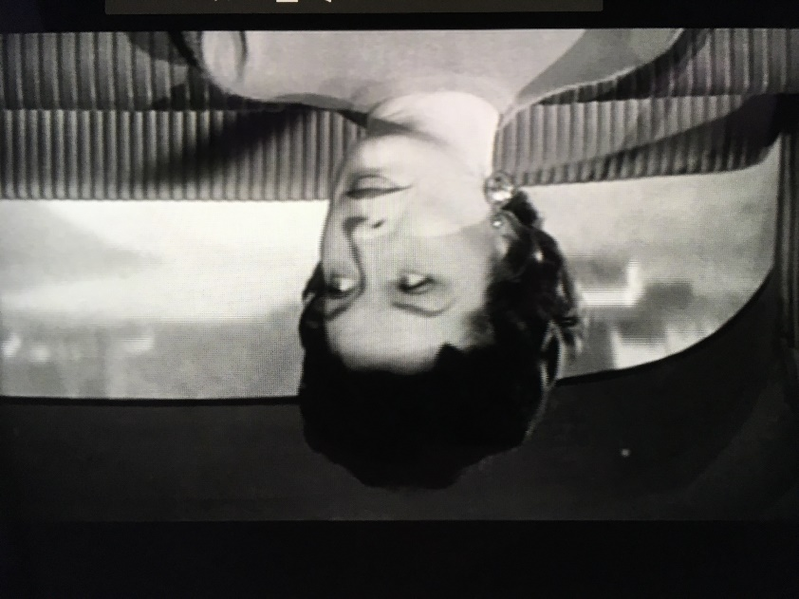
Sally and Doctor Miles Bennell carry on discussing what is going on in the town of San Mira. | 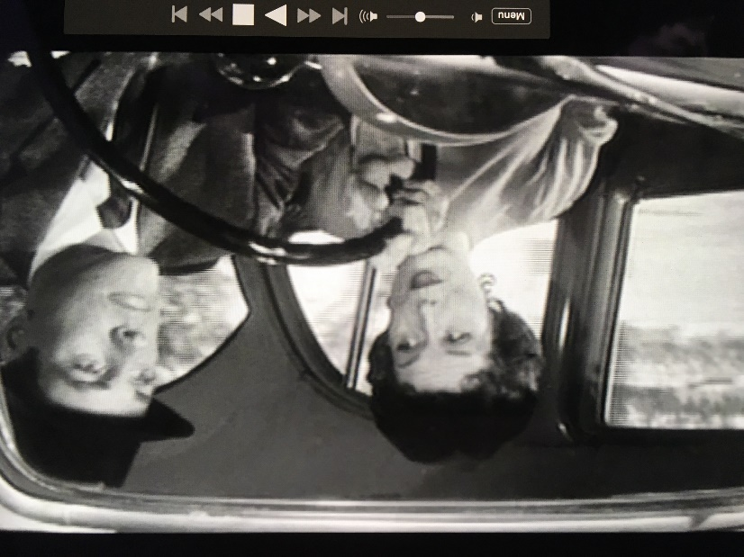
Outside the car, little Jimmy Grimaldi runs out into the road. | 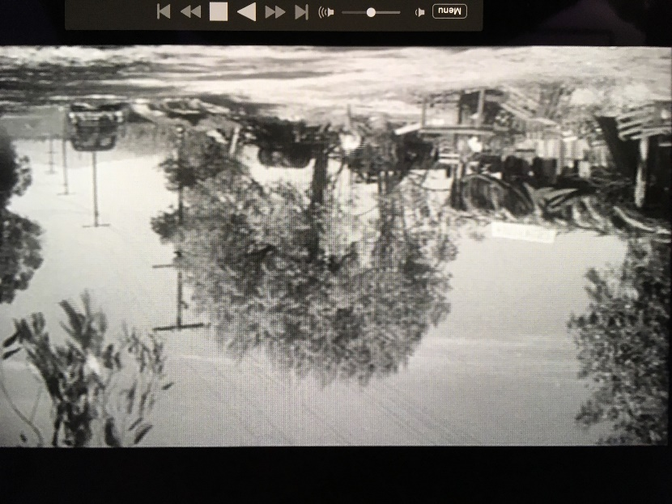
Inside the car Sally and Dr Miles see Jimmy run in front of the car. | 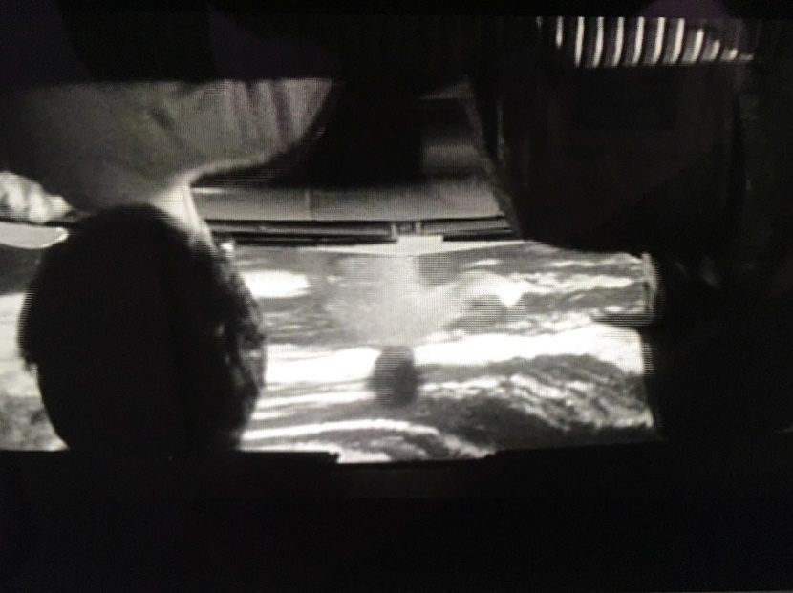
Jimmy is chased by a lady from the house. Dr. Bennell also joins the chase. | 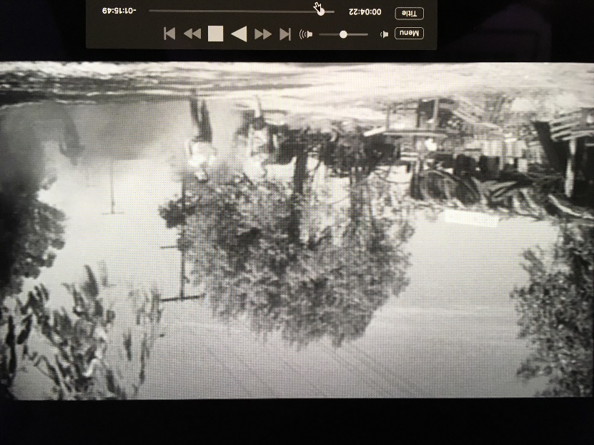
Little Jimmy runs off the road and into the surrounding countryside. | 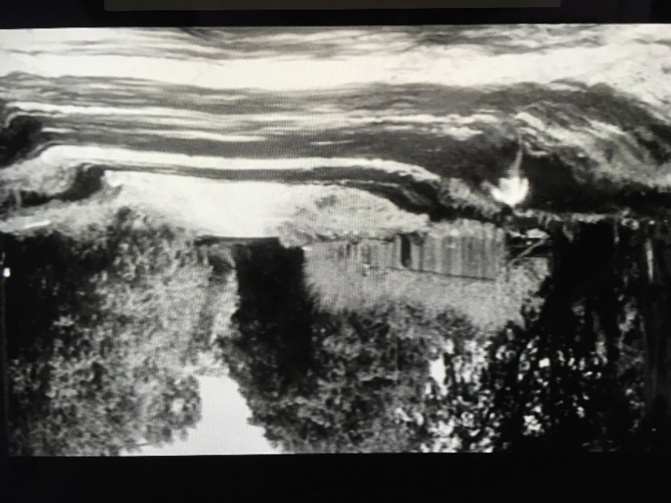
Jimmy’s Grandmother talks to Dr Bannell about why he ran away. | 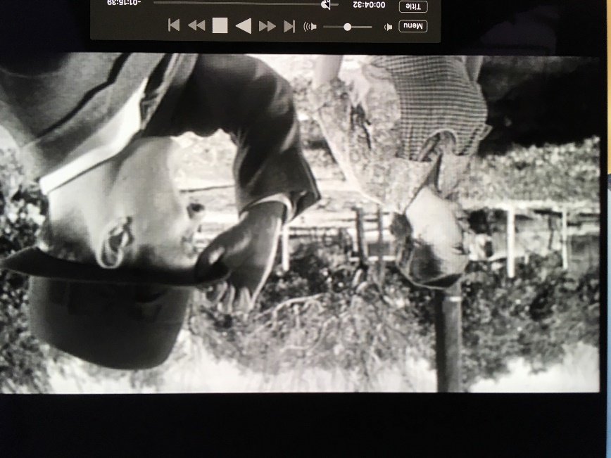
A shot of the Grimaldi’s vegetable stall, which is completely closed up. | 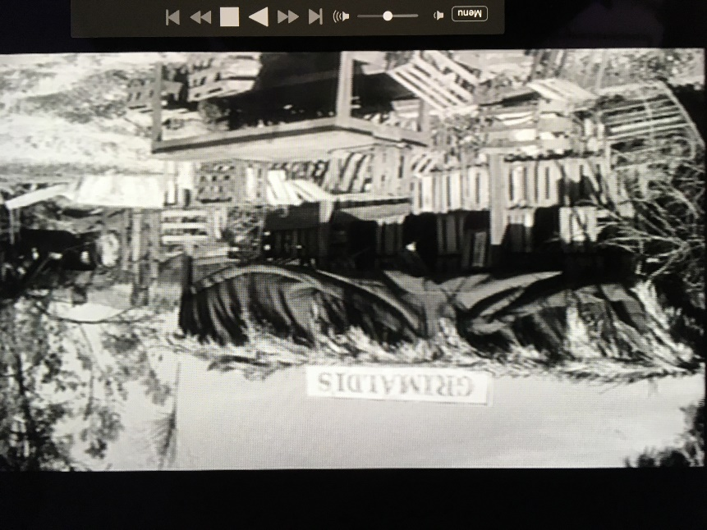
Dr. Miles Bennell talks to the Grandmother about why the shop is shut. | 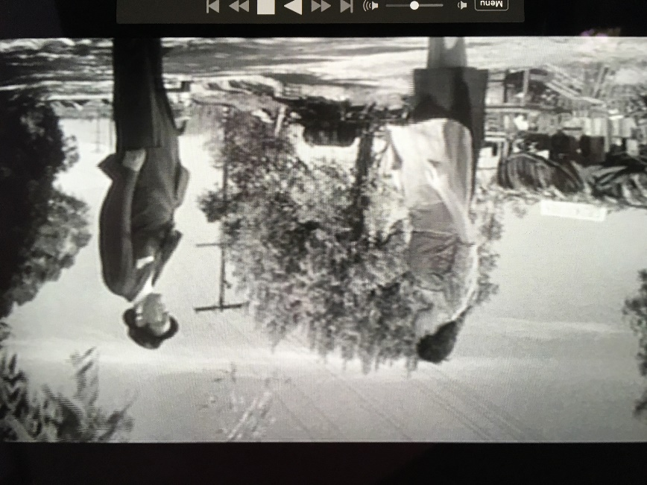
Back in the car, Sally and Dr. Bennell discuss how strange it is that the shop is shut. | 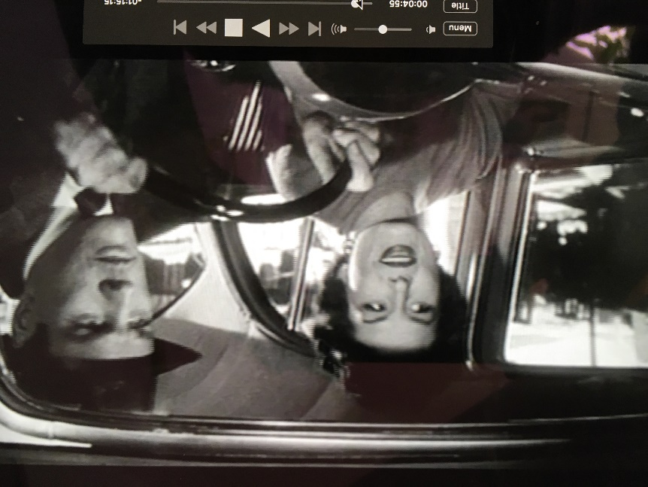
Shot / Movement | What we see: FIRST VIEW OF BODY SNATCHER | Meaning. Link to context and audience
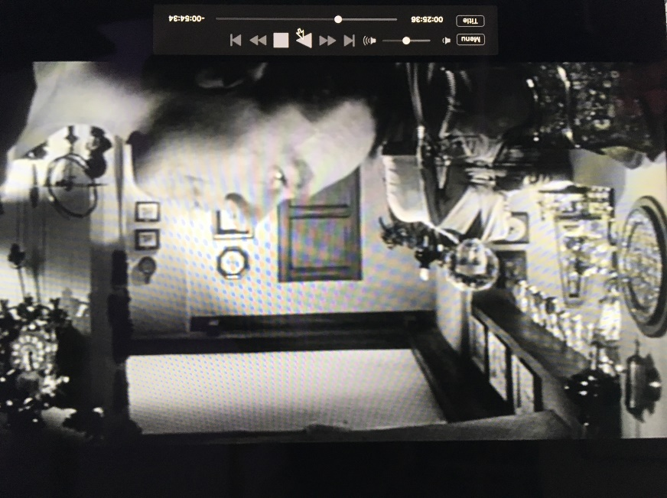

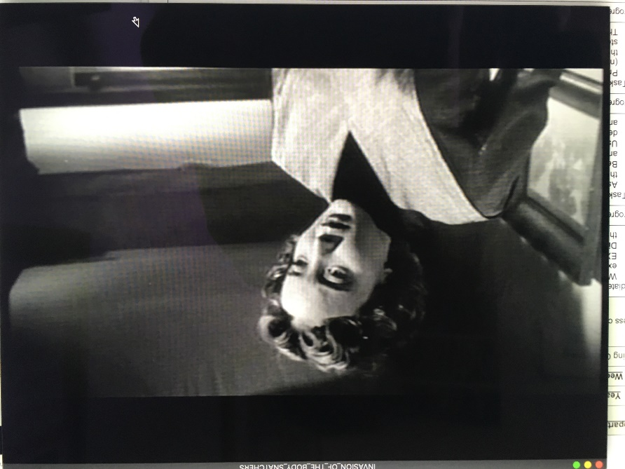

 | 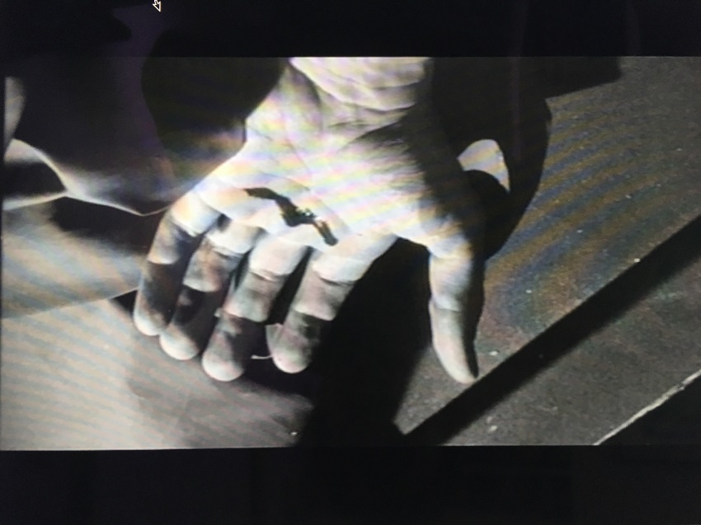
 | 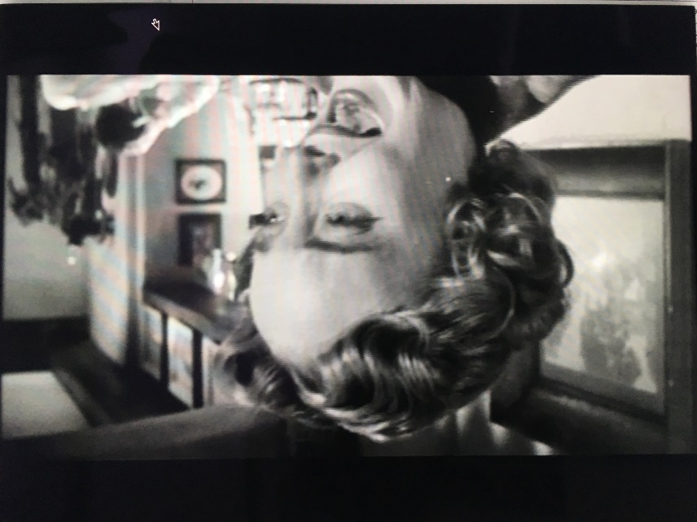
 | 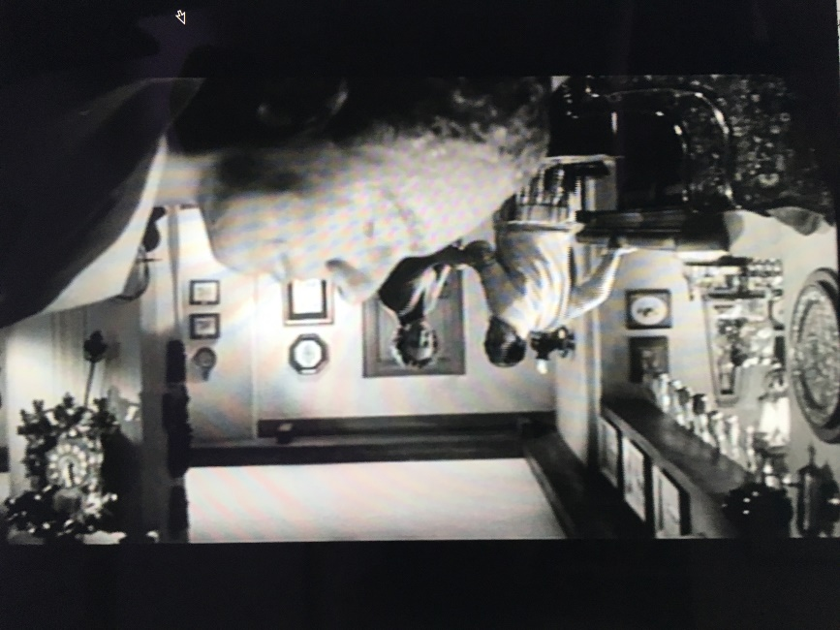
 | 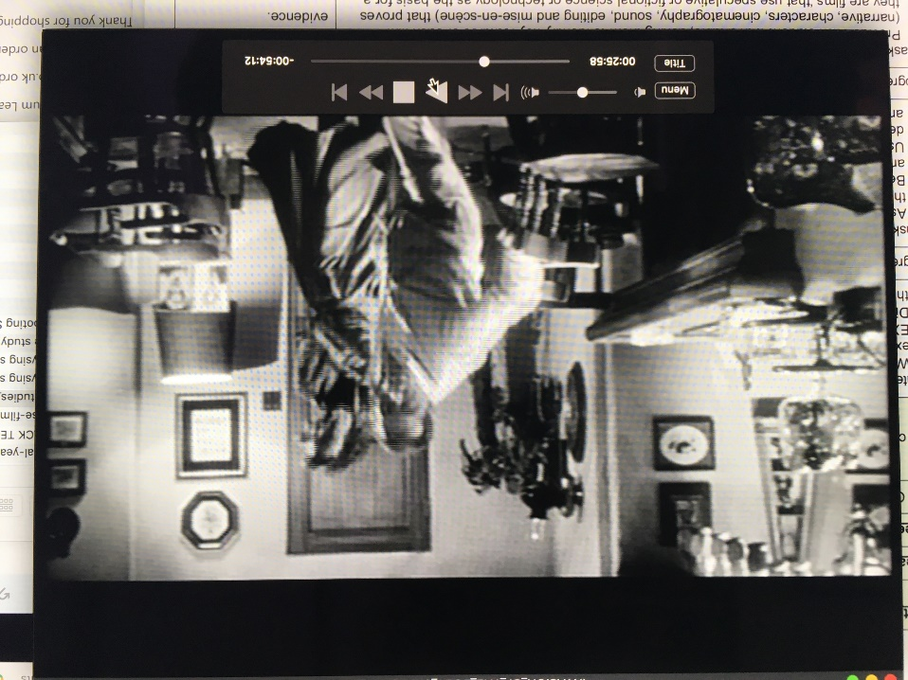
 | 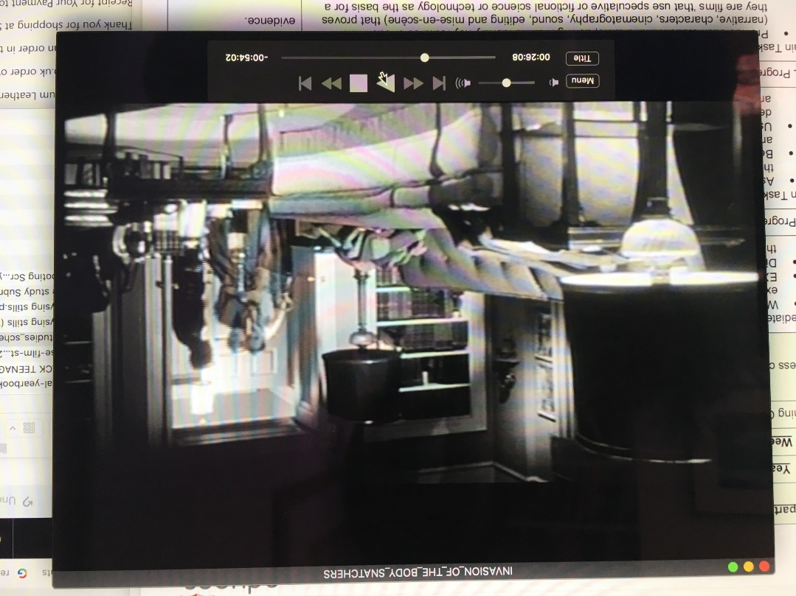
 | 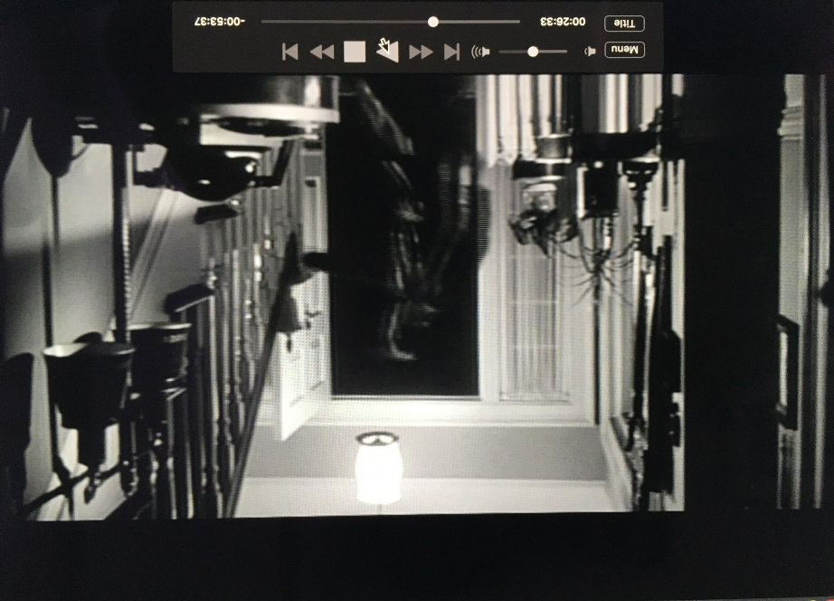
 | 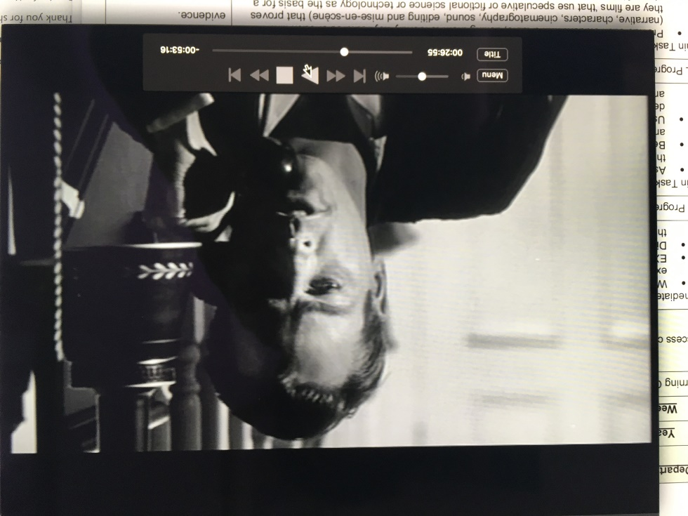
 | 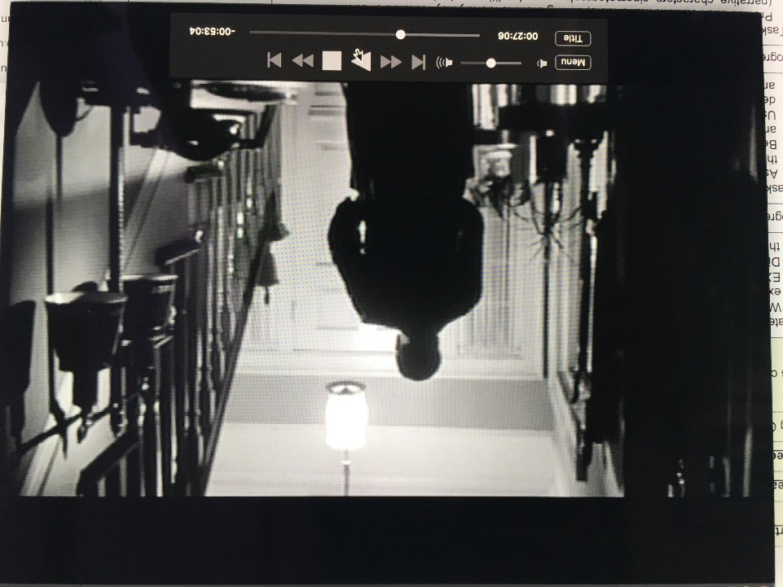
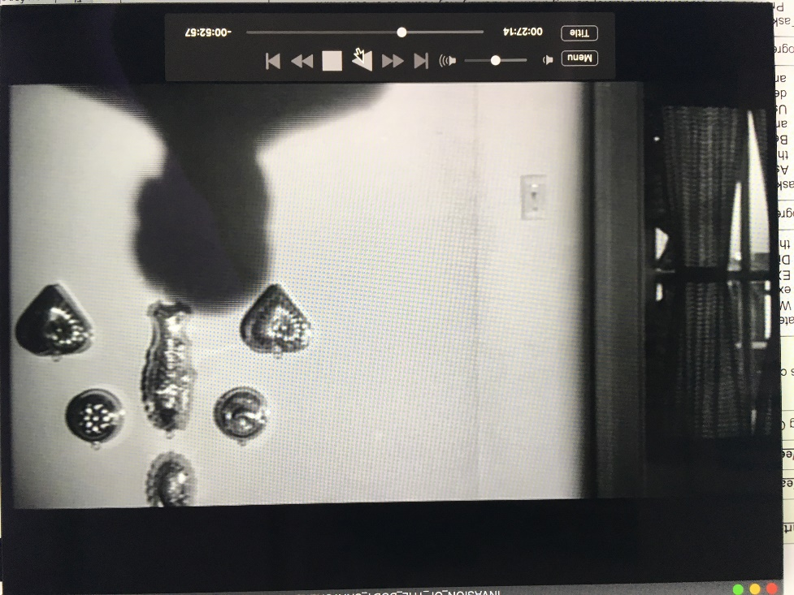

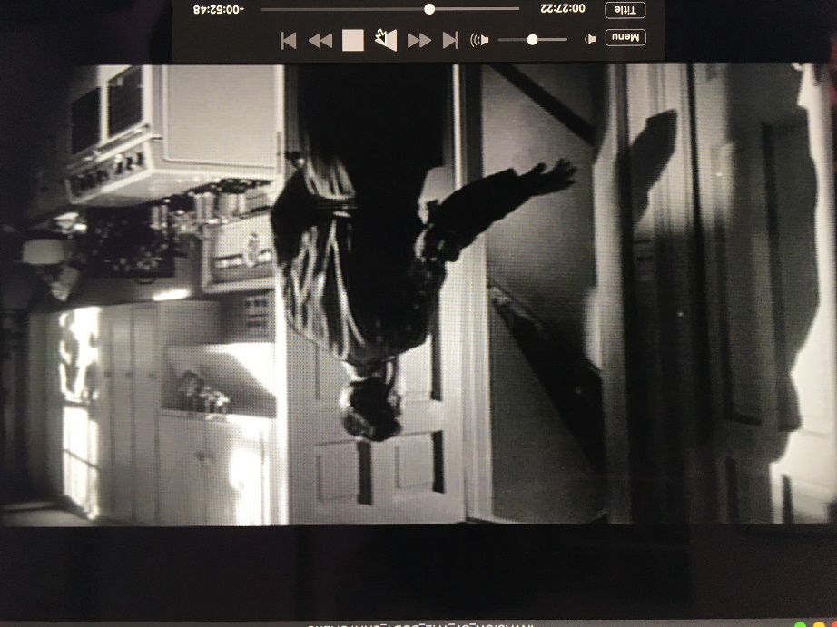

 | 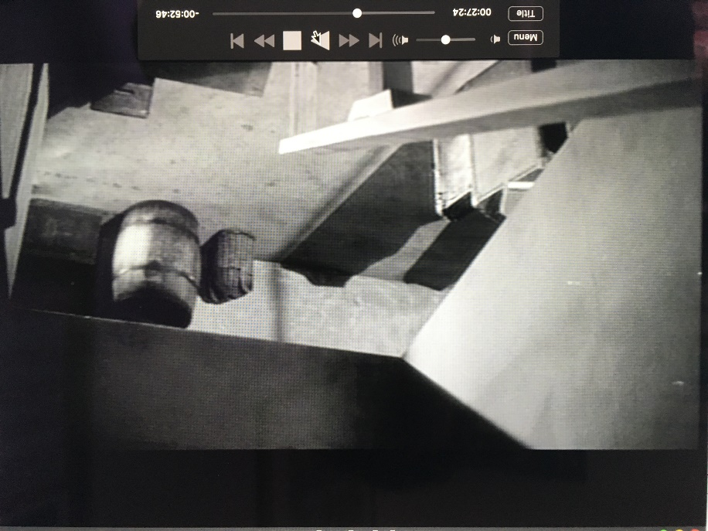
 | 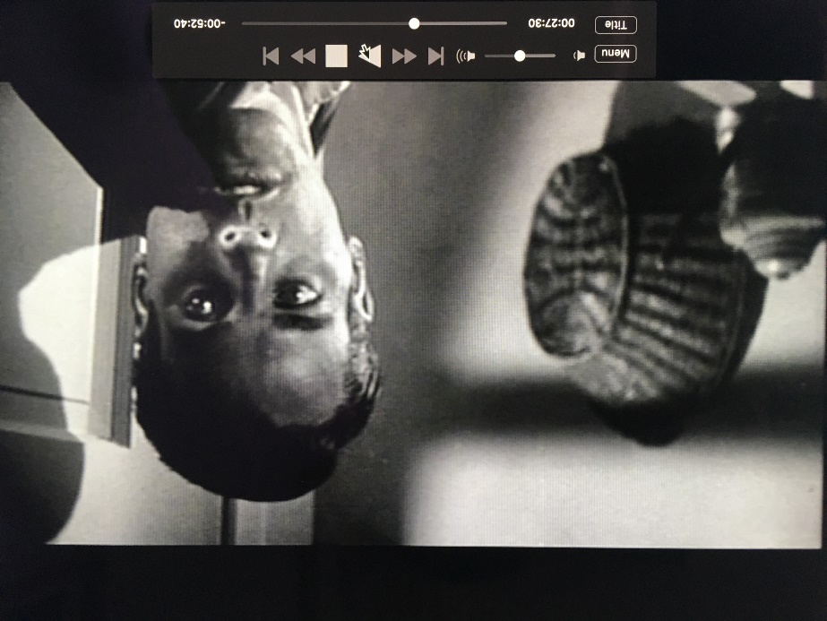
 | 