Name: Class: Mark:

1. Amelia is a solicitor working for a firm of lawyers. Sometimes she works from home using a laptop computer which she takes to and from the office when she travels by car.

(a) State the name given to software that has malicious intent to a user or computer system. [1]

(b) Analyse the risks to data held on the laptop. [10]

2.

(a) Explain what is meant by a “phishing” email attack. [3]

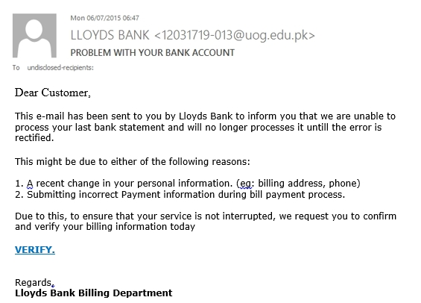 (b) Study the email below. Give **four** clues that may alert Amelia to a   
phishing attack. [4]

(c) Describe **two** actions that Amelia should take if she receives such an email. [2]

[Total 20 marks]