Name: Class:

Task 1
(a) List, with an example of each, ways in which the integrity of data may be compromised.

(b) Look up the following website and make a list of the seven greatest causes of
data loss:
http://www.databackuponlinestorage.com/7_Causes_of_Data_Loss
What is the greatest cause of data loss?
How many of the events described have happened to you?
1.
2.
3.
4.
5.
6.
7.
Number of events experienced:

Task 2
The following are five types of malware:
- Virus
- Worm
- Trojan horse
- Ransomware
- Spyware
Choose two of these types of malware, research them and then describe below how
they work.

Malware 1:

Malware 2:

Task 3

The term hacker can refer to black hat, grey hat and white hat hackers.
(a) Which of these is usually referred to in news reports of company systems being compromised or misused?

(b) What is another name, more commonly used by the media, for a white hat hacker?

(c) Research a famous computer hacker and note the following:
- What was their name or groups name?
- When did they operate?
- What attacks or misuse were they responsible for?
- What was their motivation?

Task 4
Look at the following four emails.
(a) Which of them are genuine?

(b) How can you tell?

(c) What will you do in each case?

Email 1 |  | Email 2
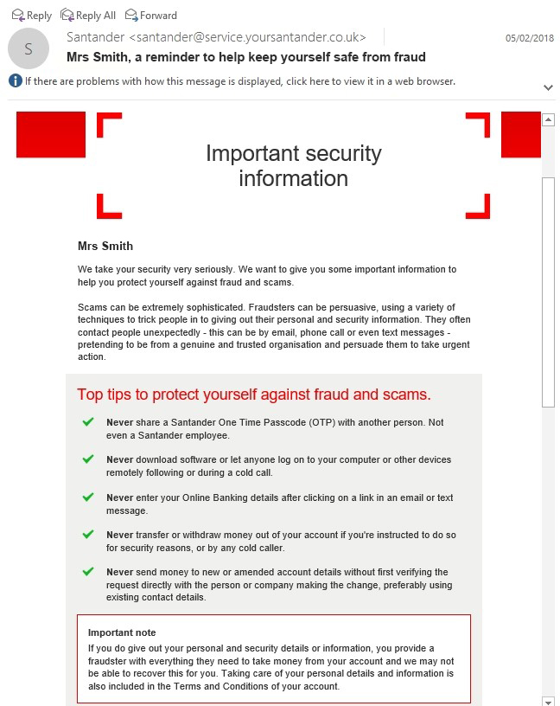 |  | 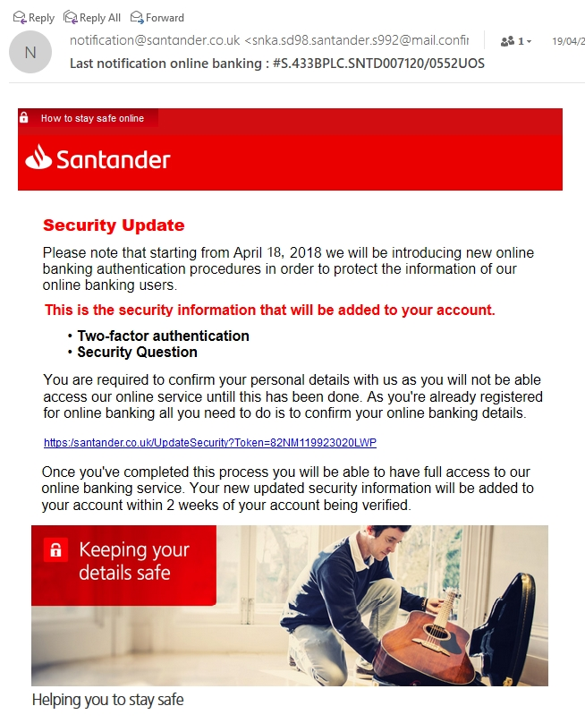

Email 3
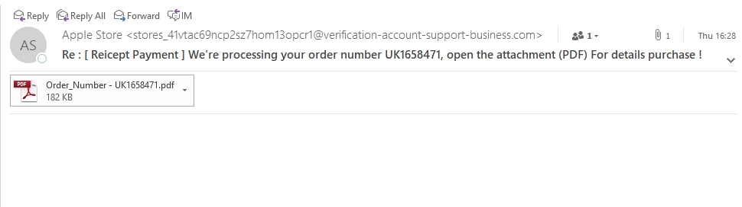
Email 4
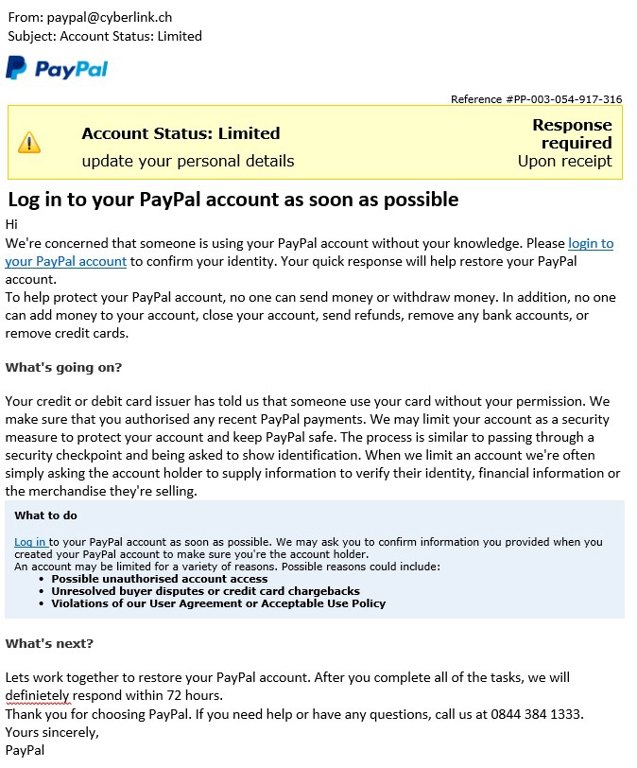

Task 5
List the ways you can reduce the risk of being a victim of phishing.
Tip: Look at the webpage http://www.banksafeonline.org.uk/node/9

