Name: Class: Mark:

1. Pinecoft Car Hire is a large company with a local area network accessible by employees in all departments of the company’s Head Office.

The network server is located in a secure room accessed by a password lock.

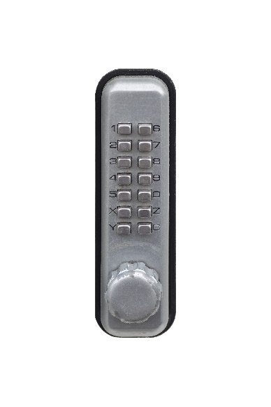

(a) Explain possible security weaknesses in the physical access control system on   
the server room door. [4]

(b) The company wants to improve security and has decided to make use of biometrics to improve access control.

State **two** biometric methods that could be used. [2]

(c) Describe how a biometric system registers new users and operates day to day. [4]

(d) Explain **two** other measures, apart from physical access controls, that Pinecoft Car Hire should take to help prevent users of the internal company network from accessing confidential information which they are not entitled to look at. [4]

(e) Pinecoft currently does not have a backup plan. They are considering a number of methods to implement this.

Discuss the options available along with their advantages and disadvantages. [6]

[Total 20 marks]