**Answers**

1. Amelia is a solicitor working for a firm of lawyers. Sometimes she works from home using a laptop computer which she takes to and from the office when she travels by car.

(a) State the name given to software that has malicious intent to a user or computer system. [1]

Malware

(b) Analyse the risks to data held on the laptop. [10]

**Theft**

* The laptop may be stolen from her car and will possibly on display which will encourage thieves.
* The laptop could be stolen from her house.
* If she travels by train when the car is unavailable it could be left on the train.
* As she transfers the laptop between the car and office, she could have it stolen / be mugged.

**Hacking**

* If personal data is stolen, thieves/hackers may be able to access data about clients / cases / bank details or blackmail a client.
* If a memory stick or removable media is used this could introduce malware/a virus
* Opening an attachment to an email could introduce a virus.
* By using her home Internet, she may be less protected by having no firewall or a less capable firewall.
* By using the laptop on public/unencrypted Wi-Fi she will be vulnerable to a man-in-the-middle attack.

**Damage**

* She could spill food or drinks on the laptop, breaking it and losing data.
* The laptop could be dropped, damaging the hard disk and leading to data loss.

**Backups**

* The laptop will need to be backed up, but may not have access to when at home so…
* Data could be lost by a hard disk failure.

|  |  |  |
| --- | --- | --- |
| **Mark scheme (award up to 10 marks)** | | |
| **Level** | **Mark** | **Descriptor** |
| **Level 0** | 0 | No rewardable material |
| **Level 1** | 1-3 | Technical vocabulary is used but it is not used appropriately to  support arguments, in relation to the issues of the question.  Issues are identified but chains of reasoning are not made,  leading to a superficial understanding of the relative importance  of issues to the scenario. |
| **Level 2** | 4-6 | Accurate technical vocabulary is used to support arguments but  not all arguments are relevant to the issues of the question.  There is consideration of relevant issues using logical chains of  reasoning, but does not reflect on their relative importance to  the given scenario. |
| **Level 3** | 7-10 | Fluent and accurate technical vocabulary is used to support  arguments that are relevant to the issues of the question.  There is a balanced and wide-ranging consideration of relevant  issues, using coherent and logical chains of reasoning, that  shows a full awareness of their relative importance to the given  scenario. |

2.

(a) Explain what is meant by a “phishing” email attack. [3]

An attempt to get personal or sensitive information (1)

**Then any two from:**

* Phishing is a type of social engineering (1)
* It works by sending a fake email with a link that takes people to a fake webpage (1)
* That intended to get information / money / card details / identity theft (1)
* A person could pretend they were from a trusted organisation (1)

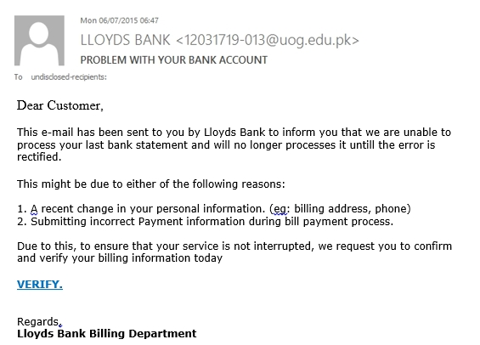 (b) Study the email below. Give **four** clues that may alert Amelia to a   
phishing attack. [4]

The sender’s email address shows it does not come from Lloyds Bank (1)  
The email greeting is not personally addressed to the recipient (1)  
It contains grammar/spelling mistakes (processes / until) (1)  
It asks you to click on a link (1)  
There is a request for personal information, i.e. “billing information” (1)

(c) Describe **two** actions that Amelia should take if she receives such an email. [2]

Report the email (if an option is given in the email software to do so) (1)

Block/blacklist the sender (1)

Delete the email (1)

[Total 20 marks]