**Answers**

1. Pinecoft Car Hire is a large company with a local area network accessible by employees in all departments of the company’s Head Office.

The network server is located in a secure room accessed by a password lock.

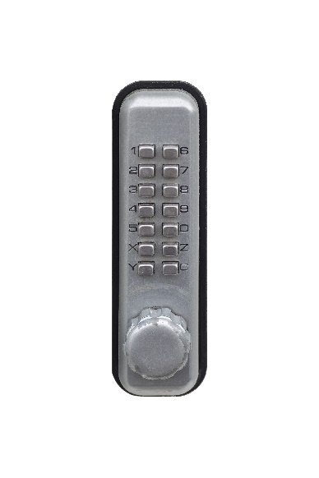

(a) Explain possible security weaknesses in the physical access control system on   
the server room door. [4]

The password could be revealed to an unauthorised person (1) by asking or persuading someone for it (social engineering) (1).

The password could be seen as it is entered (1) by shoulder surfing / CCTV of people entering it (1).

The door may be left open / held open (1) for someone to follow without entering the password (1).

(b) The company wants to improve security and has decided to make use of biometrics to improve access control.

State **two** biometric methods that could be used. [2]

Fingerprint recognition, iris scan, facial recognition.

(c) Describe how a biometric system registers new users and operates day to day. [4]

The new user first has to register their details onto the system (1) by scanning the biometric feature / fingerprint / iris / face (1) a number of times (1). Details / features of the biometric data are stored in a database (1) and associated with the user (1). When the user next scans their biometric feature, the system compares this against what is stored in the database (1). If a match is found the door can be opened (1).

(d) Explain **two** other measures, apart from physical access controls, that Pinecoft Car Hire should take to help prevent users of the internal company network from accessing confidential information which they are not entitled to look at. [4]

The network manager / administrator could set up access controls (1) so that only certain areas of programs / certain software can be accessed / run (1)

Groups of users could be made (1) with access of programs / files given to certain groups of users (1).

Files / folders could have their access restricted by file permissions (1) so that some employees don’t see all the information that the company has (1).

(e) Pinecoft currently does not have a backup plan. They are considering a number of methods to implement this.

Discuss the options available along with their advantages and disadvantages. [6]

(Look for advantages and disadvantages of two or three different alternatives. The following are points which could be included in a reasoned discussion of options.)

**Cloud backup**

* A backup is made on a cloud storage service such as Dropbox or OneDrive.
* The data will be uploaded to the service.
* The service is likely to be owned by a 3rd party.
* It takes bandwidth to upload to the service.
* Restoring data involves downloading it so will take a lot of time.
* The security and reliability of the backup system is in the hands of another company with less control over them.
* This method could reduce the need for technician involvement from the company..
* The company only has to pay for storage that they are using.

**Hard disk / Tape backup**

* Hard disks backup can have a full backup of entire systems.
* Hard disks are fast to backup and restore.
* Data can also be retrieved quickly from hard disks in the case of individual files that are corrupted.
* Tape backups are slower to retrieve individual files as they need to be found at the correct location of the tape.
* Tape backups are cheap.
* The company can make incremental backups which only backup the changes that have been made since the previous backup.
* These backups can be extremely fast.

**RAID (Redundant Array of Independent Disks)**

* RAID systems allow two hard disks to be used at the same time.
* Both disks have the same data on them.
* If one disk fails, the other one will immediately take over.
* The failed disk can then be replaced, and data will automatically be copied back.
* This way, a disk failure will result in zero downtime.

|  |  |  |
| --- | --- | --- |
| * L | Mark | Descriptor (award up to 6 marks) |
|  | 0 | No rewardable material |
| Level 1 | 1–2 | Demonstrates isolated elements of knowledge and understanding, with major gaps or omissions  Few of the points made will be relevant to the context in the question  Limited discussion which contains generic assertions rather than considering the options available along with their advantages and disadvantages. |
| Level 2 | 3–4 | Demonstrates some accurate knowledge and understanding, with only minor gaps or omissions  Some of the points made will be relevant to the context in the question, but the link will not always be clear  Displays a partially developed discussion which considers the options available along with their advantages and disadvantages. |
| Level 3 | 5–6 | Demonstrates mostly accurate and detailed knowledge and understanding  Most of the points made will be relevant to the context in the question, and there will be clear links  Displays a well-developed and logical discussion which clearly considers the options available along with their advantages and disadvantages. |

[Total 20 marks]