Name: Class:

Task 1

For each of the following methods of data collection, tick whether they are a primary or secondary method.

|  |  |  |
| --- | --- | --- |
| **Scenario** | **Primary** | **Secondary** |
| Asking people in a shopping centre how long they have spent there |  |  |
| Emailing visitors to a restaurant asking them to complete a questionnaire about the quality of food provided |  |  |
| Using data about businesses that people follow on a social media site |  |  |
| Using census data about age groups and locations to help run a targeted advertising campaign |  |  |
| Counting the gender balance of people entering a concert venue |  |  |

Task 2

Technology can be used in a variety of ways to capture primary data.

Watch the following video: <https://www.youtube.com/watch?v=Hatmm84sqm0>

(a) Explain how the data is collected and for what purpose.

(b) How would the data be collected without this technology?

(c) Describe why researchers would find a primary data collection method better than a secondary one.

Task 3

Low quality and incomplete methods of data collection can have dangerous consequences. In 1998 a medical journal published a study that linked common childhood vaccinations to autism.   
  
Read the article:   
<https://www.vox.com/2018/2/27/17057990/andrew-wakefield-vaccines-autism-study>

(a) Why was this study flawed?

(b) What has been the effect of the published research?

Task 4

A research company has been employed to find out what type of shops would be popular at a new shopping development in a town location. The following shows a section of the questionnaire:

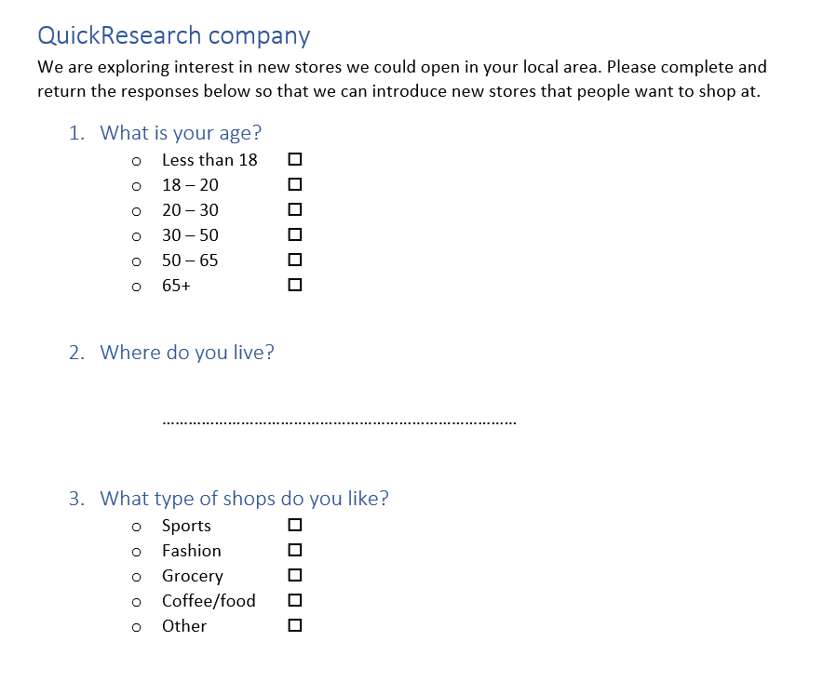

There are several flaws to this questionnaire that make it confusing and could lead to unreliable results. What are **four** problems with the questionnaire?

Task 5

A research group has been commissioned to look at the amount of ‘screen time’ that teenagers experience.

They have already carried out a survey using a questionnaire.

The responses to the questionnaire have not been sufficient to help understand why students spend time on their devices and how they could reduce time on screens.

(a) Why would a focus group be useful in this case?

(b) Construct **five** questions that could be used to guide the discussion in a focus group. These questions should get both opinions around screen time and suggestions in how it can be reduced.

Task 6

A charity currently has a website showing the good causes they help and how they can donate by telephone. They wish to allow online donations too. They want to make the process of data collection of the information needed for a donation to be as easy as possible.  
  
Suggest **10** ways in which the website can be made:

* Easy to use and intuitive
* Accessible
* To help with reducing errors
* To be functional
* To perform well
* To be compatible