Answers

Task 1

For each of the following methods of data collection, tick whether they are a primary or secondary method.

|  |  |  |
| --- | --- | --- |
| **Scenario** | **Primary** | **Secondary** |
| Asking people in a shopping centre how long they have spent there | Checkmark |  |
| Emailing visitors to a restaurant asking them to complete a questionnaire about the quality of food provided | Checkmark |  |
| Using data about businesses that people follow on a social media site |  | Checkmark |
| Using census data about age groups and locations to help run a targeted advertising campaign |  | Checkmark |
| Counting the gender balance of people entering a concert venue | Checkmark |  |

Task 2

Technology can be used in a variety of ways to capture primary data.

Watch the following video: <https://www.youtube.com/watch?v=Hatmm84sqm0>

(a) Explain how the data is collected and for what purpose.

Eye movements of a customer browsing supermarket shelves – used to observe how packaging can make a product stand out from other similar ones. Also, to help understand what customers actually look for when shopping.

(b) How would the data be collected without this technology?

A general survey of the thoughts of the customer would have to be carried out. They would need to answer specific questions either during or after the shop was completed. Human observations would only be able to reveal larger gestures such as picking up a product to look at it.

(c) Describe why researchers would find a primary data collection method better than a secondary one.  
  
There will be secondary data on preferences of customers and what attracts people to look at products. However, this will not be specific to a particular product. Marketing is to some degree an art rather than a science. By using a primary method of data collection, data can be found on the exact product used. It could be used to compare one decision for branding/marketing with another decision and see which is more effective. The data would also be very up to date, whereas secondary data tends to be older.

Task 3

Low quality and incomplete methods of data collection can have dangerous consequences. In 1998 a medical journal published a study that linked common childhood vaccinations to autism.   
  
Read the article:   
<https://www.vox.com/2018/2/27/17057990/andrew-wakefield-vaccines-autism-study>

(a) Why was this study flawed?

The observations were made from a very small sample of children – just 12.  
The type of data collected was case studies, which are a weaker form of data collection  
The author altered or misreported case findings

(b) What has been the effect of the published research?

Many parents were put off giving their children these vaccines. Even though the research was discredited eventually, the fear generated from the publication has meant the many children have not been inoculated against many dangerous diseases.

Task 4

A research company has been employed to find out what type of shops would be popular at a new shopping development in a town location. The following shows a section of the questionnaire:

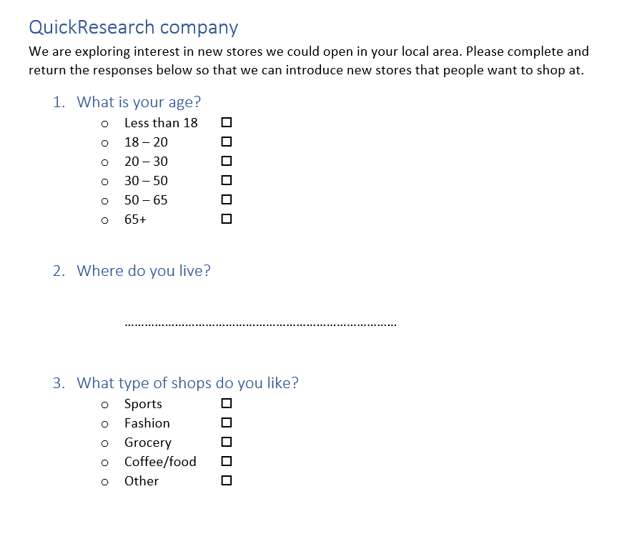

There are several flaws to this questionnaire that make it confusing and could lead to unreliable results. What are **four** problems with the questionnaire?

**Points could include:**

Age groupings overlap meaning that some people will fill in their grouping differently to others of a similar age.

The ‘where do you live’ field does not provide what information is being looked for, (responses might vary from towns, cities, countries, street names and postcodes) making it difficult to group people who live in similar areas.

The ‘type of shops’ question is limited in terms of the number of responses making choice difficult.

The other field does not have the option to identify the type of shop preferred.

Task 5

A research group has been commissioned to look at the amount of ‘screen time’ that teenagers experience.

They have already carried out a survey using a questionnaire.

The responses to the questionnaire have not been sufficient to help understand why students spend time on their devices and how they could reduce time on screens.

(a) Why would a focus group be useful in this case?

The focus group would enable a wider discussion of issues. Follow up questions could be asked, and ideas tested with the group. Some participants may not have taken a questionnaire seriously or spent very long on their answers. A focus group will allow longer answers to be articulated.

(b) Construct **five** questions that could be used to guide the discussion in a focus group. These questions should get both opinions around screen time and suggestions in how it can be reduced.  
  
**Possible questions might include:**

How old do you think you should be before you are allowed to use a tablet/mobile phone?  
How do you think teenagers benefit from the use of mobile devices?  
What do you think are the negative effects of use of mobile devices in teenagers?  
What limits, if any, should there be on teenagers use of mobile devices?  
What areas of mobile usage do you feel you should stop but can’t?

Task 6

A charity currently has a website showing the good causes they help and how they can donate by telephone. They wish to allow online donations too. They want to make the process of data collection of the information needed for a donation to be as easy as possible.  
  
Suggest **10** ways in which the website can be made:

* Easy to use and intuitive
* Accessible
* To help with reducing errors
* To be functional
* To perform well
* To be compatible

**Answers may include**

* Use clear labels for each field
* Don’t have too much information on one page
* Show a progress bar
* Have additional help
* Make use of validation
* Make sure the website responds quickly
* Have different versions for different screen sizes and orientations
* Have alternative methods available for those with disabilities
* Use standard languages such as HTML to make sure it is readable on many devices