Answers

Task 1

Many factors affect the decisions that a business makes. Supermarkets use a huge amount of data to decide what items to stock on a day-to-day basis.

Watch the video: <https://www.youtube.com/watch?v=tf1IIunUSQM>

(a) What sources of data do Sainsburys use when deciding what items of stock should be placed in their stores?

Weather forecasts, previous sales data, regional information

(b) How do they combine this data?

The weather forecast informs them of which items of stock need to be ordered or which products need placing more prominently as sales may fall later in the week. They use sales patterns to match what people buy when certain weather conditions are forecast.

(c) If the company didn’t make use of weather data what would happen to certain items of stock such as lettuces?

If information about poor weather later in the week were not acted upon, too many lettuces (or perishable items) would be ordered. The lower sales due to poor weather would mean that the products wouldn’t sell, resulting in them having to be discarded.

(d) The decision to order lettuce is taken at the last possible moment, often the day before. How does technology, and the use of data, benefit the business in this case?

Stock can be ordered as needed. The supplier receives information electronically as soon as a decision to purchase is made. This allows them to pick and pack the lettuces the same day and have them delivered to stores for the next morning. This efficiency allows stores a longer period of time in which to sell the product.

Task 2

Validation allows data to be checked to see that it conforms to a number of rules. In the table below, a description of a number of checks is given. Beside each one, write the type of check. The first one has been completed for you.

|  |  |
| --- | --- |
| **Description of the check** | **Type of check** |
| Ensures that data entered matches an expected data type – e.g. Numeric or Text | Type check |
| Ensures that values entered are within specified limits | Range check |
| Ensures that a particular field is not left blank | Presence check |
| Ensures that the data entered is not too long or short | Length check |
| Ensures that the data entered conforms to a certain style. For example, <letter><letter><number> | Format check |

Task 3

“Using a combination of carefully selected validation techniques and verification methods, any data being entered into a computer system can be guaranteed to be error free.”  
  
To what extent do you agree with this statement?  
  
Points that could be discussed:

Validation reduces errors as the data is entered and is completed automatically. It will remove data that should never be expected in any complete and accurate set of data.

Verification will catch errors where incorrect data has been entered in manually but might not necessarily be stopped by validation techniques.

Neither technique can stop data being entered that is wrong in the first place. If the data is inaccurate but valid and verified then it will be held within the data structure.  
  
The statement would be better if it said: “Using a combination of carefully selected validation techniques and verification methods, the number of errors of data in a computer system can be significantly reduced.

Task 4

Look at the following data of customers and how much they spent in a shop.

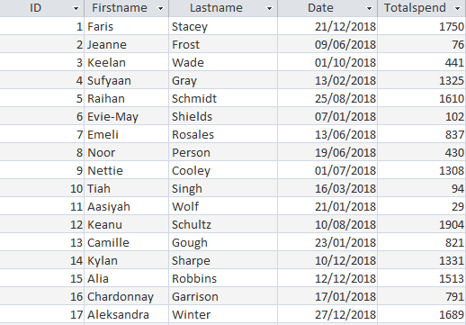

Complete the table below to state which records IDs meet the criteria given. The first row has been completed for you.

|  |  |
| --- | --- |
| **Criteria** | **Matching record IDs** |
| Totalspend < 100 | 2, 10, 11 |
| Firstname = ‘Keanu’ | 12 |
| Date = ‘13/06/2018’ | 7 |
| Totalspend > 1000 | 1,4,5,9,12,14,15,17 |
| Totalspend > 1000 AND Totalspend < 1750 | 4,5,9,14,15,17 (1750 is not included as the criteria is less than 1750) |
| Date < ’01/07/2018’ | 2,4,6,7,8,10,11,13,16 |

Task 5

A small business owner has recorded their sales data for their company over the last five years.

They want to open a new shop and have found an investor to back them, however, the investor wants to make sure their existing shop has done well and wants the owner to convince them in a meeting.

The business owner has produced an analysis of the sales data and stored it in the file “Financial data.xlsx”

(a) Make use of spreadsheet software to improve the presentation of the data.

Students could:

Create graphs/charts compare the different years so that the trends in sales over   
the years/profit/costs can be seen  
Format the table of data to make more important data stand out

(b) Explain how the spreadsheet could be used to help make predictions about the potential future profit of the new shop.

The spreadsheet could be used to help model the data. Sales figures could be adjusted to see their effect on turnover and profit. Predictions could be made about how long it would take for the investor to recover their initial investment.