Name: Class:

Task 1

Many factors affect the decisions that a business makes. Supermarkets use a huge amount of data to decide what items to stock on a day-to-day basis.

Watch the video: <https://www.youtube.com/watch?v=tf1IIunUSQM>

(a) What sources of data do Sainsburys use when deciding what items of stock should be placed in their stores?

(b) How do they combine this data?

(c) If the company didn’t make use of weather data what would happen to certain items of stock such as lettuces?

(d) The decision to order lettuce is taken at the last possible moment, often the day before. How does technology, and the use of data, benefit the business in this case?

Task 2

Validation allows data to be checked to see that it conforms to a number of rules. In the table below, a description of a number of checks is given. Beside each one, write the type of check. The first one has been completed for you.

|  |  |
| --- | --- |
| **Description of the check** | **Type of check** |
| Ensures that data entered matches an expected data type – e.g. Numeric or Text | **Type check** |
| Ensures that values entered are within specified limits |  |
| Ensures that a particular field is not left blank |  |
| Ensures that the data entered is not too long or short |  |
| Ensures that the data entered conforms to a certain style. For example, <letter><letter><number> |  |

Task 3

“Using a combination of carefully selected validation techniques and verification methods, any data being entered into a computer system can be guaranteed to be error free.”  
  
To what extent do you agree with this statement?

Task 4

Look at the following data of customers and how much they spent in a shop.

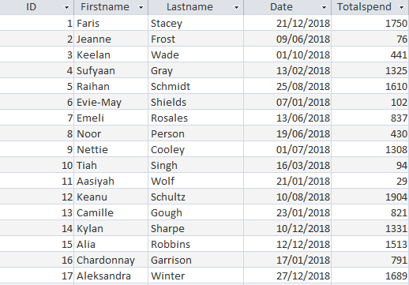

Complete the table below to state which records IDs meet the criteria given. The first row has been completed for you.

|  |  |
| --- | --- |
| **Criteria** | **Matching record IDs** |
| Totalspend < 100 | **2, 10, 11** |
| Firstname = ‘Keanu’ |  |
| Date = ‘13/06/2018’ |  |
| Totalspend > 1000 |  |
| Totalspend > 1000 AND Totalspend < 1750 |  |
| Date < ’01/07/2018’ |  |

Task 5

A small business owner has recorded their sales data for their company over the last five years.

They want to open a new shop and have found an investor to back them, however, the investor wants to make sure their existing shop has done well and wants the owner to convince them in a meeting.

The business owner has produced an analysis of the sales data and stored it in the file “Financial data.xlsx”

(a) Make use of spreadsheet software to improve the presentation of the data.

(b) Explain how the spreadsheet could be used to help make predictions about the potential future profit of the new shop.