**Cinematography** – *Describe the cinematography-* *Shot types and movement. Who are we being asked to align ourselves with? When do we see the use of POV? When are particular angles used?*

**Lighting** – *Consider the use of colour, isolated lighting, high key lighting, low lighting, what is being highlighted?*

**Editing** – *Continuity or non-continuity? Interesting effects and transitions? Shot Length? When does it become fast pace or slow pace?*

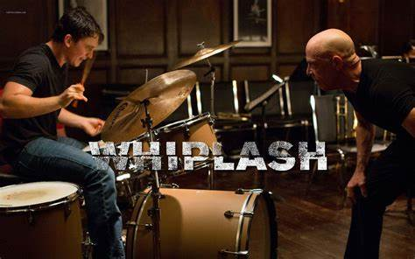

**Genre (this is an independent film)** – *What conventions do you see which are conventional to this genre? Are there any reoccurring themes of images?*

**Representation**

***Men***

***Andrew Neiman (Miles Teller)***

***Terence Fletcher (J.K. Simmons)***

***Women***

***Nicole (Melissa Benoist)***

**Mise en scene** – *Notable* *costumes, props, locations / décor and performance.*

**Sound** *– Describe the musical score, non-diegetic music chosen and sound design, notable dialogue,*