**Carbon Review Notes – Handouts 3&4**

**The factors leading to change, the impacts of changes and possible future changes**

**Change in the Siberian tundra**

1. **How are the cryosphere changes in the Siberian tundra creating a positive feedback loop?**
2. **What has caused a vast amount of carbon to be locked up in the permafrost?**
3. **Explain the different conditions that result in the release of CO2 and methane**
4. **Why is the Yedona region of Siberia important and how does it compare to global permafrost?**
5. **Despite the release of CO2 and methane from melting permafrost, the tundra is acting as a carbon sink. Why is this?**
6. **What are the future concerns and what might happen when the ‘tipping’ point is reached?**

**Causes of change:-**

* **Natural – wildfires, natural climate change and volcanic activity**
* **Anthropogenic (human caused) – Land use change and hydrocarbon fuel extraction**

**For each of the above you need to be able to explain the causes. You also need to be able to give evidence as to how great a change each factor is having on the carbon cycle, i.e. assess the causes of change.**

**Describe the patterns temperature and carbon dioxide over the last 800,000 years.**

**Are the current CO2 levels reflective of past patterns**?

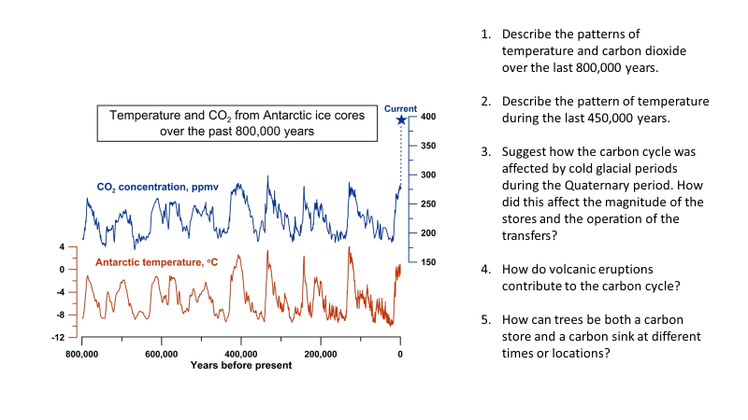

**Which carbon stores are changing the greatest and why?**

**Which carbon stores are changing the least and why?**

What is the natural greenhouse effect?

Explain how greenhouse gases warm Earth.

What is the enhanced greenhouse effect?

What is radiative forcing and how has it changed?

**What are the impacts on the following as a result of changes in the carbon cycle?:-**

* **Ocean**
  + **Ocean acidity**
  + **Ocean warming**
  + **Sea Ice**
  + **Salinity**
  + **Sea level rise**

**Why is it that it is difficult to predict what impact changes in carbon stores is having on the planet?**