**NAME:**

**PAPER D**

**Date to be handed in:**

**MARK (out of 100):**

|  |  |  |  |  |  |  |  |  |  |  |  |  |  |
| --- | --- | --- | --- | --- | --- | --- | --- | --- | --- | --- | --- | --- | --- |
| **Qu** | **1** | **2** | **3** | **4** | **5** | **6** | **7** | **8** | **9** | **10** | **11** | **12** | **13** |
|  |  |  |  |  |  |  |  |  |  |  |  |  |  |

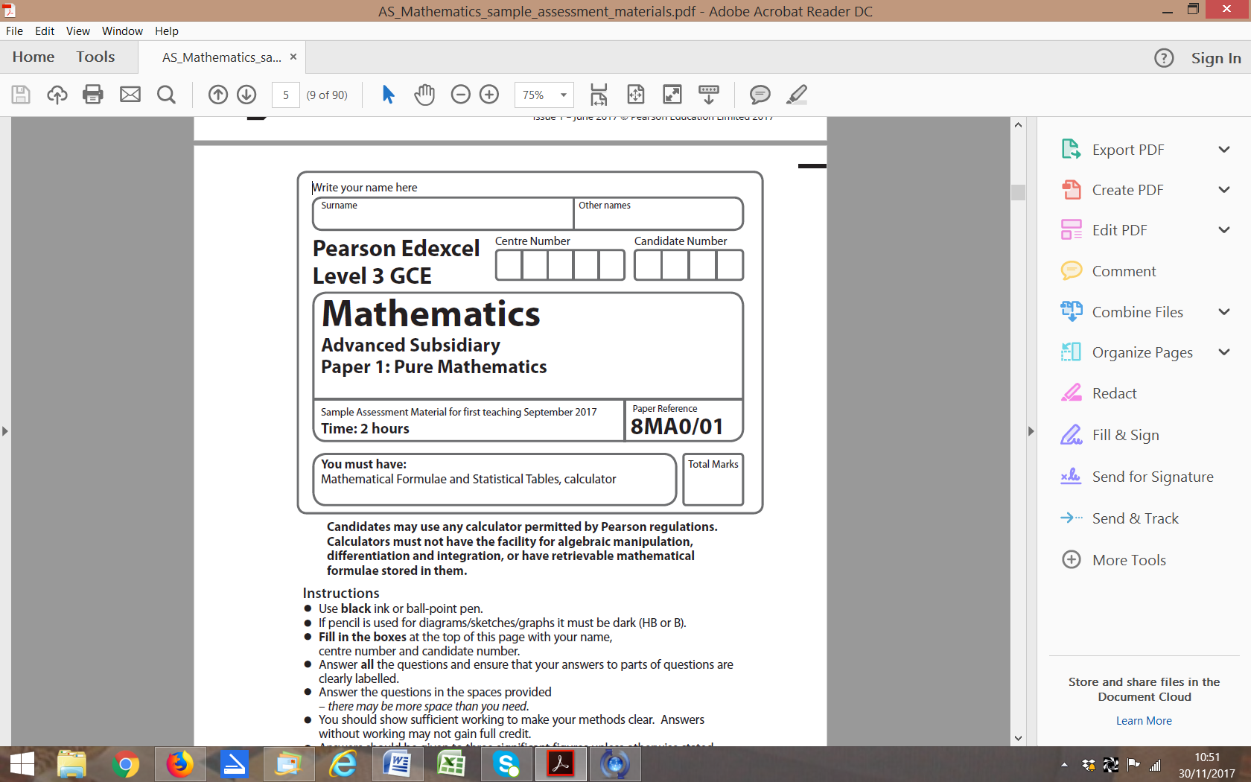

**Practice Paper D:**

**Time 2 hours**

**Questions to revise:**

1. f(*x*) = *x*3 – 3*x* – 2.

The figure below shows a sketch of part of the curve with equation *y* = f(*x*).

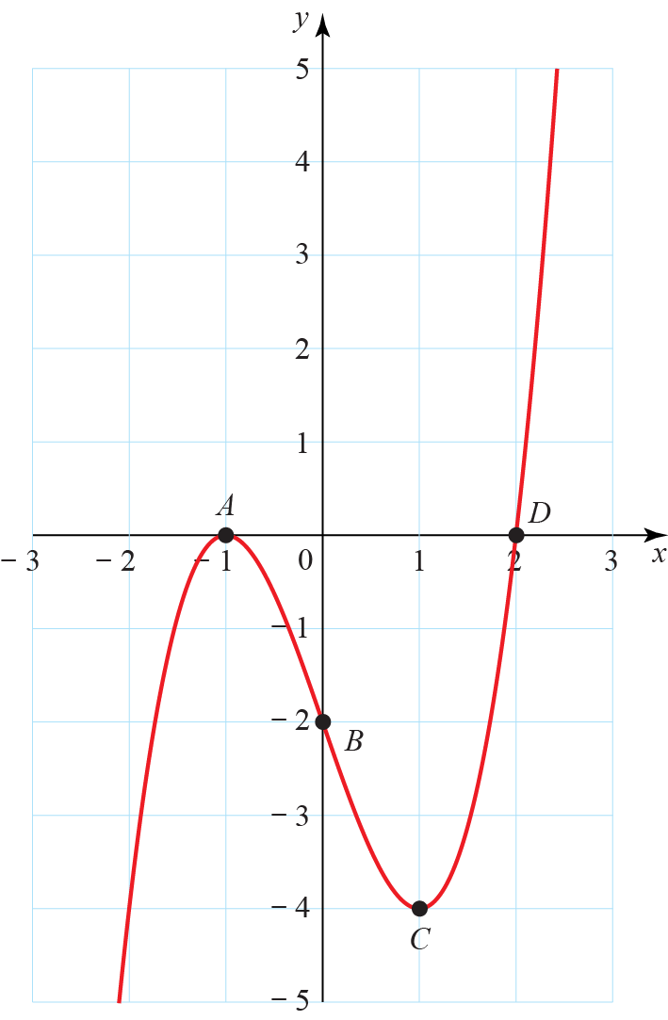

(*a*) On a separate set of axes, sketch the curve with equation *y* = f(2*x*) showing the location and coordinates of the images of points *A*, *B*, *C* and *D*.

**(2)**

(*b*) On a separate set of axes, sketch the curve with equation *y* = f(–*x*) showing the location and coordinates of the images of points *A*, *B*, *C* and *D*.

**(2)**

**(Total 4 marks)**

___________________________________________________________________________

**2.** Find .

**(Total 5 marks)**

___________________________________________________________________________

**3.** Solve algebraically, showing each step of your working, the equation

(8*x* – 1)2 – 18(8*x* – 1) + 32 = 0.

**(Total 5 marks)**

___________________________________________________________________________

**4** A buoy is a device which floats on the surface of the sea and moves up and down as waves pass.

For a certain buoy, its height, above its position in still water, *y* in metres, is modelled by a sine function of the form *y* =  sin 180*t*°, where *t* is the time in seconds.

(*a*) Sketch a graph showing the height of the buoy above its still water level for 0 ⩽ *t* ⩽ 10 showing the coordinates of points of intersection with the *t*-axis.

**(3)**

(*b*) Write down the number of times the buoy is 0.4 m above its still water position during the first 10 seconds.

**(1)**

(*c*) Give one reason why this model might not be realistic.

**(1)**

**(Total 5 marks)**

___________________________________________________________________________

**5.** f(*x*) = *x*3 – 4*x*2 – 35*x* + 20.

Find the set of values of *x* for which f(*x*) is increasing.

**(Total 5 marks)**

___________________________________________________________________________

**6.** The speed, *v* ms−1, of a rollercoaster at time *t* s is given by *v*(*t*) = (50+20*t*2 − *t*3), where 0 ⩽ *t* ⩽ 20.

The distance, *s*m, travelled by the rollercoaster in the first 20 s is given by 

Find the value of *s*, giving your answer to 3 significant figures.

**(Total 5 marks)**

___________________________________________________________________________

**7.** f(*x*) = *x*2 – (*k* + 8)*x* + (8*k* + 1).

(*a*) Find the discriminant of f(*x*) in terms of *k* giving your answer as a simplified quadratic.

**(3)**

(*b*) If the equation f(*x*) = 0 has two equal roots, find the possible values of *k*.

**(2)**

(*c*) Show that when *k* = 8, f(*x*) > 0 for all values of *x*.

**(3)**

**(Total 8 marks)**

___________________________________________________________________________

**8.** The equations of two circles are *x*2 + 10*x* + *y*2 – 12*y* = 3 and *x*2 – 6*x* + *y*2 – 2*qy* = 9.

(*a*) Find the centre and radius of each circle, giving your answers in terms of *q* where necessary.

**(6)**

(*b*) Given that the distance between the centres of the circles is √80, find the two possible values of *q*.

**(3)**

**(Total 9 marks)**

___________________________________________________________________________

**9.** The graph of *y* = *abx* passes through the points (2, 400) and (5, 50).

(*a*) Find the values of the constants *a* and *b*.

**(5)**

(*b*) Given that *abx* < *k*, for some constant *k* > 0, show that , where log means log to any valid base.

**(4)**

**(Total 9 marks)**

___________________________________________________________________________

**10.** (*a*) Calculate the value of −2 tan (−120°).

**(1)**

(*b*) On the same set of axes sketch the graphs of *y* = 2 sin (*x* −60°) and *y* = −2 tan *x*, in the interval −180° ⩽ *x* ⩽ 180°, showing the coordinates of points of intersection with the coordinate axes in exact form.

**(7)**

(*c*) Explain how you can use the graph to identify solutions to the equations

*y* = 2 sin (*x* − 60°) + 2 tan *x* = 0 in the interval −180° ⩽ *x* ⩽ 180°.

**(1)**

(*d*) Write down the number of solutions of the equation

*y* = 2 sin (*x* − 60°) + 2 tan *x* = 0 in the interval −180° ⩽ *x* ⩽ 180°.

**(1)**

**(Total 10 marks)**

___________________________________________________________________________

**11.** A curve *C* has equation *y* = *x*3 – *x*2 – *x* + 2.

The point *P* has *x*-coordinate 2.

(*a*) Find  in terms of *x*.

**(2)**

(*b*) Find the equation of the tangent to the curve *C* at the point *P*.

**(4)**

The normal to *C* at *P* intersects the *x*-axis at *A*.

(*c*) Find the coordinates of *A*.

**(4)**

**(Total 10 marks)**

___________________________________________________________________________

**12.** f(*x*) = *x*3 + *x*2 + *px* + *q*, where *p* and *q* are constants.

Given that f(5) = 0 and f(−3) = 8,

(*a*) find the values of *p* and *q*,

**(7)**

(*b*) factorise f(*x*) completely.

**(5)**

**(Total 12 marks)**

___________________________________________________________________________

**13.** *OACB* is a parallelogram. and.

The points *M*, *S*, *N* and *T* divide *OB*, *BC*, *CA* and *AO* in the ratio 1 : 4 respectively.

The lines *ST* and *MN* intersect at the point *D*.

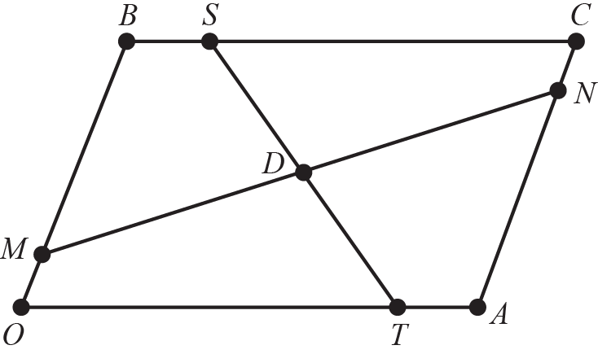

(*a*) Expressin terms of **a** and **b**.

**(2)**

(*b*) Expressin terms of **a** and **b**.

**(2)**

(*c*) Show that the lines *MN* and *ST* bisect one another.

**(9)**

**(Total 13 marks)**

___________________________________________________________________________

**END OF PAPER (TOTAL: 100 MARKS)**