**ACTIVITY 1 PRODUCE A RATIONALE**

**Use the following points and overtype as appropriate**

**Rationale** (4 marks – just an overview of the situation, do not spend too long on this)

* Intro to the organisation stating what the situation is and what they are considering
* Explain the market conditions (the competitive environment for the business) touch on any strengths and weaknesses of the proposal.
* Outline your proposal for the business – what you might suggest for the product, price, place and promotion

**SMART Marketing Objectives** (8 marks, make sure you justify referring to your research why you have chosen each one and how it will benefit the business. Read part B first. 3 objectives **justified** in depth is enough – use the JAM template)

For example

* To diversify by offering a new product of X
* To increase/establish brand awareness and gain X share of the market
* Increase operating profit by 35% in the first 10 months of setting up
* Gain 200 members/regular customers in the first 6 months of setting up
* Create a recognisable brand image for the business within 3 months of setting up

**Research of and Analysis of Market Information (PESTLEC and SWOT analysis – produce a table for each)**

(12 marks – all points should be supported with data/evidence preferably referenced)

* This can all be prepared in advance, data needs to be gathered on the market (size of market, market growth, no. of competitors etc)
* Make a judgement on what the analyses show – eg the PESTLEC analysis is positive for this proposal/product

**Comment on the reliability and validity of the information gathered in your research** – eg all data has been taken from recent and well known publications - say which, eg Government websites, so that you can say that this shows the information is reliable, if it is recent then you can say that it is valid, if it is not too recent you can comment on how this might affect its validity. You need to show understanding of the information gathered and that you have an analysed it and drawn relevant and balanced conclusion.

**Justification for the rationale** (10 marks - what’s going well, EBI) **All sections should be justified as you go**, this is just a brief conclusion

* The SWOT analysis shows that X product/proposal has a number of strengths such as…
* Also the data shows that the trends for this market/product are …….
* In addition, the company could also consider producing …… give a reason for whatever additional suggestions you can add
* Comment on the ability of the company/product to compete having undertaken the PESTLEC and SWOT
* If appropriate, comment on short term/long term implications of your proposal

**ACTIVITY 2 DEVELOPING A BUDGETED PLAN WITH TIMESCALE**

**Use the following points and overtype as appropriate**

**The Marketing Mix** (20 marks) must be related to the case study and your Market Research

* **Message** - a clear and considered marketing message. Identify the target market(s) that are currently considered and any future markets that might be appropriate. Support with any data eg current trends
* **Mix - 4P’s + additional 3 Ps** People, Process, Physical in detail and applied in context. Product - Describe the product and the packaging/presentation, make sure you explain why it is appropriate.

Price – explain the pricing strategy and justify this. Compare with competitors.

Place – where will it be sold? Distribution methods? Why are these good choices?

**Promotion** including **Budget, Timescale and Media**– What types of promotion (the promotional mix) will you use? Why are these appropriate? How much will each type of promotion cost? What do your competitors spend on promotion and what types of promotion do they use? **Media** - relevant to the situation, a balanced range of media required and related to the marketing mix. Reasons for selection of media must be given

**Budget** (8 marks) and **Timescale** (4 marks)

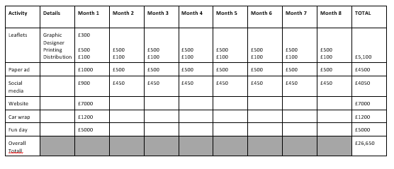

**Justify** why you have allocated the budget to whatever types of promotion you have selected. The budget needs to be realistic with costs of all activities broken down and itemised. Comment on relevance of logo, brand, 7Ps and your research. The promotional mix needs to be realistic and meet your marketing objectives

**Presentation** (4 marks)

Your plan must have a professional format, no written errors and appropriate marketing terminology used throughout