**Methods in Context, planning activity: Interviews and Labelling**

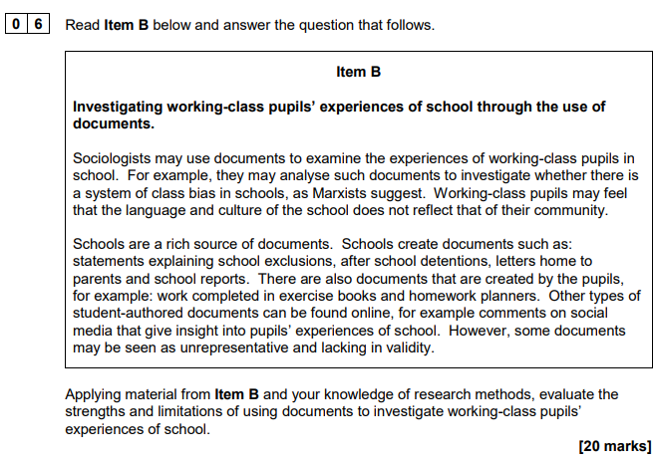

**Who** is the sociologist researching?

**What** is the sociologist researching?

**How** is the sociologist conducting the research?

|  |  |  |
| --- | --- | --- |
| **Who?** | **What?** | **How?** |
|  |  |  |

**Hooks from the item –** identify strengths, limitations and issues from these points

|  |  |
| --- | --- |
| Hook identified | Development into a strength or limitation. Consider issues involved with this hook |
| ‘Experience of working class pupils’ |  |
| ‘system of class bias’ |  |
| ‘language and culture do not reflect their community’ |  |
| ‘schools are a rich source of documents’ |  |
| ‘documents that are also created by the pupils’ |  |
| ‘unrepresentative and lacking in validity’ |  |

**WHO**

Outline some of the characteristics of the participants. What issues might the researcher face with these groups?

**WHAT**

What issues are presented with trying to study pupil exclusions?

**HOW**

|  |  |
| --- | --- |
| **Consider some strengths and limitations of documents – consider different types of documents** | |
| Strengths | Weaknesses |
|  |  |

**Planning:**

In the essay you need to make sure each point tries to consider WHO, WHAT, HOW – make sure you are linking to the context throughout. For top band answers you will need to discuss ethical and theoretical issues, which could include issues like validity, reliability, representativeness, alongside a discussion of who would/wouldn’t like the methodological approach.

|  |  |
| --- | --- |
| **Introduction – WWWE**   * **W**hat? – What is the method in the question? Define and apply detail about the method. * **W**ho? – Who would use it? (Positivist, Interpretivist, Realist) * **W**hy? – Why would they use it? – Relating to the context in the question – in this case pupil exclusions. * **E**valuate – Who wouldn’t use it? Why? | |
| **Strength**  Try and link in at least two aspects of Who, What, How per point | **Weakness** |
|  |  |
|  |  |
|  |  |
| **Conclusion**   * **Summarise strengths and weaknesses** (in relation to the **context**) * Would an **alternative method** be more suitable? Apply **methodological approaches** to this response (Positivism, Interpretivism and Realism) | |