**Company profile – Travellanda**



**Overview**

Travellanda is an online wholesaler of hotels, through its computer systems it offers access to hotel bookings, transport options, and activities at a discount rate for medium sized travel agents and tour operators.

Travellanda is considered a Small / Medium sized Enterprise as it employs approximately 45 employees.



Travellanda offers Business to Business (B2B) services, and its marketing and activities targets other travel and tourism businesses rather than retail customers, and allowing hotels, transfers and activities to connect with travel agents and tour operators without having to market themselves to individual companies.

It describes itself as the fastest growing online wholesaler.

**Business Objectives**

Travellanda’s vision is to develop innovative technology to serve the travel industry and provide the very best rates to its clients.

Travellanda’s mission is to make work and life easier for its clients. Booking hotel rooms must be an automated, easy, and straightforward process with a team of people behind acting in real time to help our partners. Making the work and life of its partners easier is at the core of our values and Travellanda does it in a surprisingly, funny, friendly, unique, and professional way.

Travellanda’s strategy moving forward is to continue increasing the quality and quantity of its supplier base, to revolutionise its technology and to always ensure that human resources are at their best providing the best service and the best rates.

The key to its recognised success is faith in strong partnership's, outstanding customer service combined with Travellanda's exceptional rates, availability, and state of the art technology.

**How Marketing meets business objectives**

* Use of cutting-edge technology
* Provide excellent products
* 24 / 7 customer support through its offices in London, Istanbul, and Bangkok
* Offering a vast choice of over 200,000 hotels from 1 star to 5 stars.
* Allowing companies to create their own corporate branded booking systems by simply uploading their logo to the ‘white label’ customer system.
* Companies can log their credit card details into the computer systems, meaning reservations can be confirmed immediately.

**Marketing activities**

* Company website ([www.travellanda.com](http://www.travellanda.com))

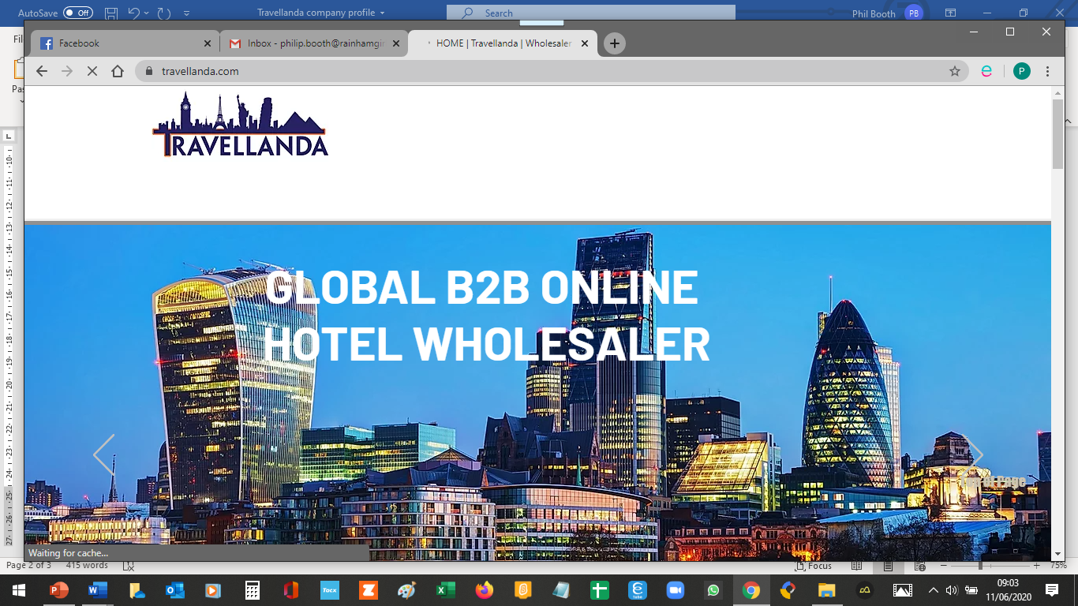

* Membership of Trade groups, eg International Coalition of Travel Partners, and European Tourism Association
* Trade shows, eg World Travel Market, London, a B2B trade show.
* Industry media reports and profiles
* Use of awards the company has won to promote business.
* Use of customer reviews and references to generate business
* A sales team that works with travel agents and tour operators
* A product team that works with hotels and transfer providers.
* A dedicated account manager for each client

**External factors affecting its marketing**

* Economic Environment: The economic downturn as a result of covid 19 has seen a large reduction in travel and hotel bookings, travellanda has been encouraging its customers to postpone rather than cancel. As the global economny has changed to focus on areas such as China which are growing markets.
* Competitor Activity: Competitors range from large organisations such as Hotelbeds which was established by TUI. Being a smaller company travellanda has focussed on the personal nature of its service, with personal account managers for each client.
* Market Size and Growth: Travellanda has worked to increase its partnerships in China, a growing market for Travel & Tourism. A recent partnership has allowed Travellanda to access 17,000 Chinese Travel Agents. It has also grown its business by broadening its activities, moving from just accommodation to including transfers and activities. The Marketing Manager appointed in 2017 was given the task of raising the global profile of the company, and throughout its marketing it stresses it recent growth. Travellanda has been regarded as the 1,000 fastest growing companies in terms of market share, and has increased its market share, although is not challenging the large providers.
* Social and political change: During the covid 19 period Travellanda used the hashtag #dontcancelpostpone to encourage customers to continue to make bookings. Travellanda also had its worldwide team working from home rather than being furloughed, this meant that the company could continue to operate.
* Technology changes: The company has stayed abreast of technological changes, it stresses its various platforms, and assumes that its customers will have knowledge of what it offering. It has also begun marketing a white label solution, allowing agencies to have their own system which is provided by travellanda but is presented as being from the the travel agent.

**Internal factors affecting its marketing**

* Corporate objectives: The objectives include making life easier for its clients making bookings more straightforward.
* Finance: Marketing is aimed at other businesses through the use of the trade press and trade shows rather than a mainstream presence.
* Human Resources: Travellanda are able to stress its worldwide presence, including workers in London, Istanbul, Delhi, Bangkok, Phuket, Beijing, Berlin and Palma. Being a smaller company they also stress the personal nature of their support with each client being given a named personal account manager. Throughout its marketing Travellanda likes to stress its worldwide presence and connects this to 24/7 operations.
* Corporate culture: Travellanda likes to stress its dynamic and growing culture, it talks about having a passion for global wholesale, and providing an enjoyable workplace.
* Organisation issues: Although being a small company Travellanda is able to stress its worldwide presence, including workers in London, Istanbul, Delhi, Bangkok, Phuket, Beijing, Berlin and Palma. Being a smaller company they also stress the personal nature of their support with each client being given a named personal account manager. Throughout its marketing Travellanda likes to stress its worldwide presence and connects this to 24/7 operations.

**Impacts on growth and customer relationships and organisational success**

* The company has continued to grow, but remains a small business as it only employs 45 people.
* Customer relationships are stressed due to the size of the organisation.

**Possible marketing improvements**

**Bibliography**

<https://www.travellanda.com/>

<https://5a545739-a704-4c5c-afcd-d32dcb55aafb.filesusr.com/ugd/e766dc_d2efe2a5a30b453aaeace4712de90d07.pdf>

<https://medium.com/channex/the-future-of-the-hotel-wholesaler-is-in-doubt-775168768e82>

<https://www.aheadrm.com/new-supplier-is-entering-entrada-network-travellanda/>