 Department of Information Technology

**DESIGN YOUR OWN WEBSITE STORYBOARD (five-interconnected pages) My Name: ______________________________**

Name of my website: ____________________________________________________ Audience: ______________________________

Aim of site: _____________________________________________________________________________________________________________________________

_____________________________________________________________________________________________________________________________

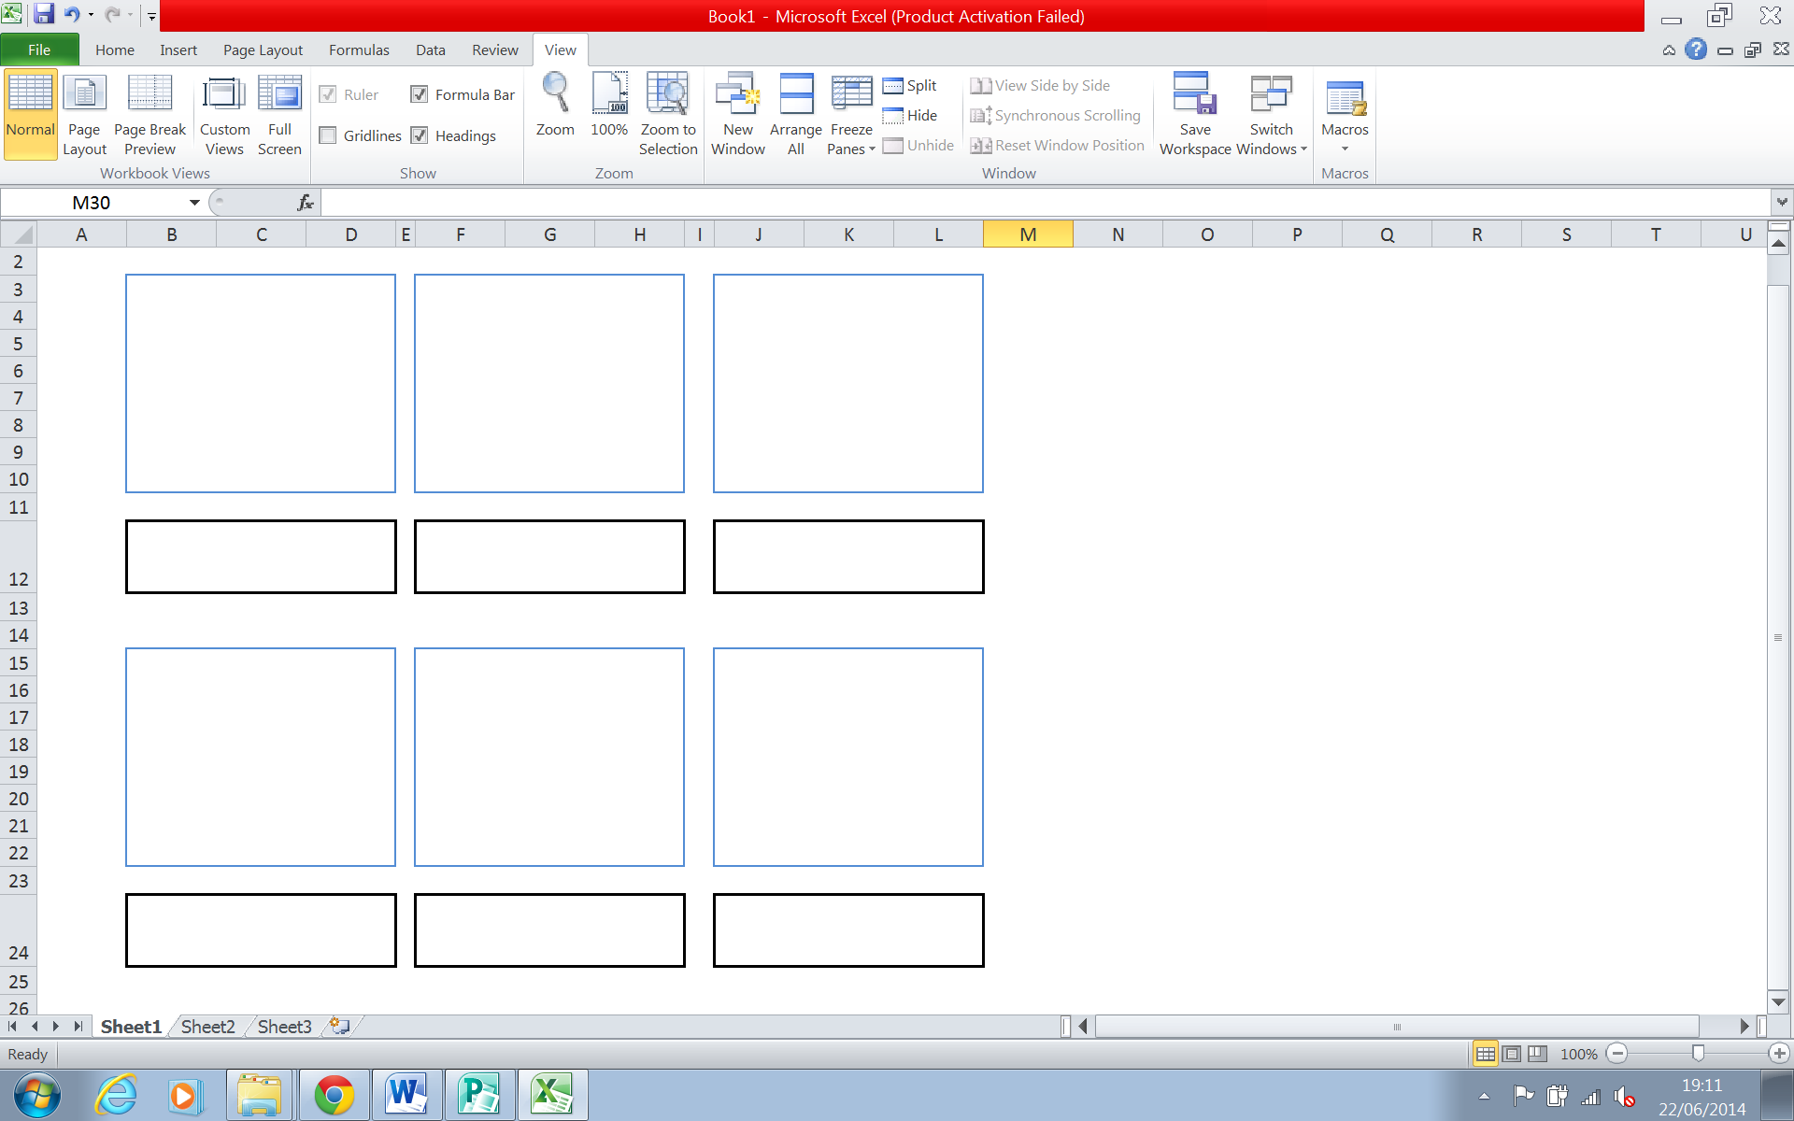Storyboard of Page Contents (use the blue (larger) boxes to draw the page content and the black (smaller) boxes to describe what is going on in each page- including sounds, actions, etc)