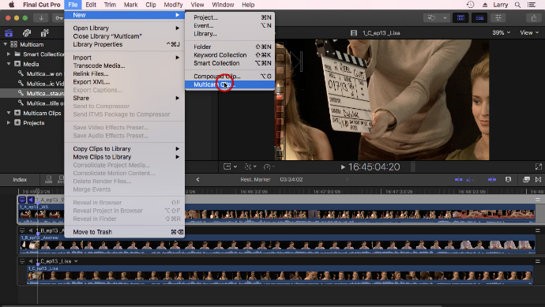**BTEC yr1 Unit 21 – Film Editing Learning Aim B**

Practice shoot and experimental cut

*Having completed your production paperwork portfolio (screenplay, storyboard, treatment, call sheet etc.) and in preparation for your first filming session, you are going to undertake a* ***practice shoot*** *and then do some* ***experimental editing****.*

1. In your production groups, recreate some of the shots and scenes that you have scripted / storyboarded. Don’t worry too much about lack of mise en scene, wrong actors and incorrect location.

-Aim to shoot at least **2** keyscenes from your film, sticking to the usual rules of continuity (180-degree rule, shot reverse shot etc.)

2. Now shoot some additional experimental footage, from the list below:

-Attempt to film a match cut [ ]

-Attempt to film a short parallel / cross cutting scenario [ ]

-Shoot a scenario with a cutaway [ ]

3. Upload your footage to a Mac and start editing the content.

-Edit your 2 scenes [ ]

-Edit your match cut attempt [ ]

-Edit your short parallel / cross cutting scenario attempt [ ]

-Edit your cutaway attempt [ ]

-Now also experiment with editing techniques such as- jump cuts [ ], freeze frame [ ], slow-motion [ ] and splitscreen [ ].

4. Document your results in this week’s diary entry, with consideration to the questions below:

-Was it beneficial to practice shooting your key scene before you went out on location, brought in actors etc.?

-Having attempted a match cut, parallel / cross cutting and a cutaway, might you now include some of these techniques in your finished film?

-Likewise, having attempted a jump cut, freeze frame, slow-motion and splitscreen might you now include some of these techniques in your finished film?

-Finally, give some technical detail about how you created either- jump cut, freeze frame, slow-motion or splitscreen using Final Cut Pro X (i.e. “we used the modify time function in Final Cut Pro X, to slow the clip to 75% speed…”

