**A4. Indexing and storing**

Part of the exam criteria is to prove your ability to label, index and store your assets (footage, secondary sources MP3s etc.).

***Where to store your assets?***

This needs to be secure and backed-up – don’t just rely upon Jono and the college macs. Portable hard drives, memory cards and the cloud are all acceptable places to store. Your assets must be available on demand as you will need them to edit, manipulate and then create your product.

Remember to ensure that your index is up-to-date.

When storing your assets on the Macs, you need to ensure that you have used the following;

* Saved using appropriate filenames (e.g. ‘Audio interviews with Matt and Steve’)
* Saved as an appropriate file type (e.g. ‘MP3’)
* Stored in an appropriate folder structure (e.g. – all audio files are in a parent folder marked AUDIO FILES)
* Stored securely
* Backed-up

***Providing Evidence for your Digital Folder***

It is also essential that you provide evidence of the materials in your folder. The best way of doing this is to collect screen-grabs of the preparation, editing and manipulation processes. You need to demonstrate your skills – for example;

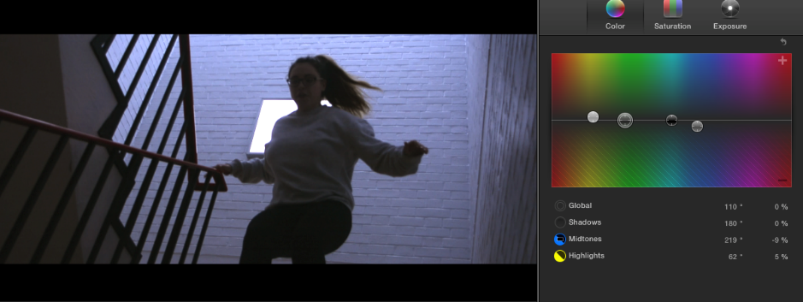

*I have used the Final Cut Pro software to manipulate the colour palate of my film in order to create a dynamic atmosphere which will attract the target audience of 16-24 year olds. Firstly, I selected the appropriate image from my assets of my main character escaping the drudgery of her everyday life before discovering the power of music. The main tools I used here were the Saturation function and the Colour bar – this allowed me to manipulate the mise-en-scene from colder tones to a warmer colour palate. Moving the*

Make sure you have at least one screen-grab of each piece of software you have used and try to describe to the examiner HOW you have used it and WHY you have used it.