**Evidence for your Digital Folders…what do I do?**

First of all, don’t panic! If you have followed all of the guidance I have given you so far you will have enough information to fill the file with evidence of your preparation, editing and manipulation.

**Firstly you must obtain a USB (8GB recommended) to keep all three Activity folders on –please go to Jono to get it formatted for Mac and PC.** The examiner must be able to access your folders easily and find the information they want. Ensure that each of the Activity folders has the following;

**ACTIVITY 1 FOLDER**

The examination paper states that –

*“You will need to create assets/material for your production. For the assets/material that you create, provide evidence of how you created them.*

*You should also use assets/material from secondary sources. For any sourced assets/ material:*

*• provide evidence of the source and explain the processes involved in sourcing the assets/ material*

*• justify their relevance to the production”*

This folder should contain the following;

1. **A contents page** – outlines clearly what’s in the folder
2. +An Assets Folder with sub-Folders of your separate assets – still images / sound files / moving image files / captions / secondary sources. Files within these folders should be labelled clearly. **You must present all of the files you are actually using not all of your raw footage.** Provide evidence of the logical storage of your assets and/or material, which include logging or naming with appropriate file names and saving them in an appropriate file format into an organised folder structure.
3. **Justification folder** – this is where you will keep a written account, with accompanying screengrabs, of the process.
4. **Index of sources**

Justification Folder

Include material / justification on the following, remembering to label the files carefully;

* **Interpreting the brief and research**. *What ideas did you have when reading the brief? What considerations did you have to make etc. What research did you do?* All of this can be found in the first two tasks in your folder **(A1)**. Also include a copy of the storyboard and mind-maps (scans or cut and paste)
* **Sourcing materials.** Include a copy of your *Identifying Assets* table **(A2.).** Justify your reasons for selecting both your secondary (found footage, music etc.) and primary assets (film, music etc. you have made yourself). For example;

*“I wanted to make my film on the influence that 1960s music has on young people today. This initially led me to consider using a soundtrack by Jimi Hendrix – Crosstown Traffic. This is one of his most well-known songs which has featured in films, commercials and TV shows; therefore I felt that my target audience of 16-24 may be aware of the track. It also has a strong driving guitar refrain, which would allow me to edit to the beat. I obtained the MP3 of the song by downloading it from the Apple i-tunes website. I am aware that the brief requires that the product is seen within the commercial public domain of a museum; therefore in order not to break copyright, I would have to obtain permission from the artist’s publisher (Warner Brothers) and to clear the song for commercial use through the Performing Rights Society (www.prsformusic.com)”.*

**Remember if you are using any secondary material you must justify the use, where you got it from and how you are going to approach copyright issues.**You can use still images of any assets you wish to discuss, but insure you use captions / annotations to explain. There is no word limit here, so right as much as you can in your justifications.

Index

Ensure all of the Edublog / cloud links on your index work. If you don’t want to back up using links you can list them as being part of your assets sub-folder.

**ACTIVITY 2 FOLDER**

The examination paper states that –

*“Using the assets/material created and sourced in Activity 1, you must prepare, edit and/or manipulate these assets/material for your production.*

*You must provide evidence of how you have prepared, edited and/or manipulated your assets/material for your production.”*

This folder requires you to provide screen shots of the editing and manipulation process. **Remember to include plenty of detail and annotations.** For example:

Remember to use the following;

*“In this example I used the keyboard shortcut to select the whole of my opening image and then used a filter to change it to greyscale. This was to make the opening still shot of the production stand out and provides a vintage feel that is popular with my target audience of 16-24 year olds. Adding the 1950s TV special effect on Final Cut Pro X, over the top of the image helps to emphasise the timeframe of the 1960s era.”*

* *Media technical language to explain your choices – lighting, film speed, ASO, special effects etc.*
* *Before and after screen-grabs to illustrate changes you have made.*
* *Images of particular settings to illustrate the process your product has been through.*
* *Justifications for image choices, manipulations, and changes for both image and sound.*
* *How you have adapted assets to suit the target audience.*

In the example below (taken from the Examiner’s report) the learner was awarded a high Distinction because they provided comprehensive evidence of the rationale behind their editing decisions in relation to the preferred audience interpretations and demonstrated a high level of practical skill in editing the material together:

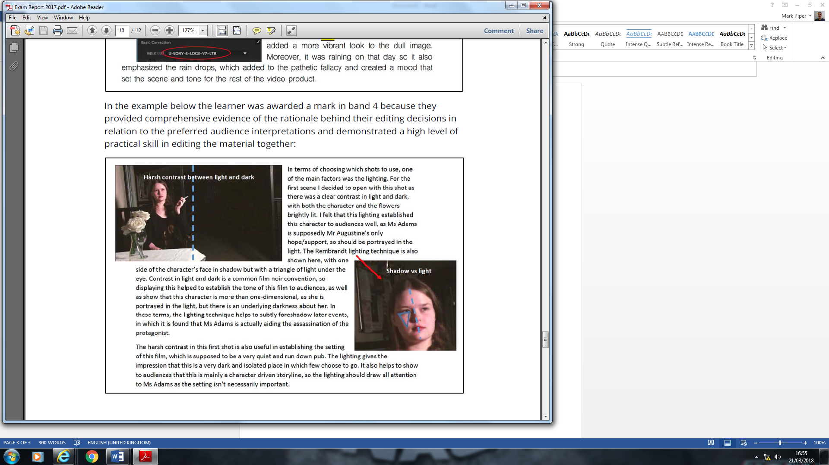

**ACTIVITY 3 FOLDER**

An MP4 exported file of your final product – leave this bit to Jono!