**BREXIT: CONTEXT**

On 23rd June 2016, the UK voted to leave the European Union (EU). This was nicknamed ‘Brexit’. The vote was very close with 51.9% voting leave and 48.1% voting remain.

The controversies from the campaign continued even after the vote. **Remainers accused Leave voters of xenophobia and racism**; **Leavers accused Remainers of being unpatriotic and un-democratic**.

The period following the referendum was one of political turmoil. David Cameron, the Prime Minister resigned shortly after the vote (he was a Remainer), Theresa May became the new Prime Minister. She continued to face regular leadership challenges from within her own party, and in an attempt to show some control, she called for a snap general election in 2017, where the Conservative Party suffered heavy losses, and reduced the size of their majority in the House of Commons. Meanwhile, she was also regularly visiting Brussels and other EU countries to create a Brexit deal that would satisfy both the EU and the UK parliament.

On the date this edition of *The Times* was published, MPs had voted against the deal she had negotiated with the EU. This was very serious as the UK was scheduled to be leaving the EU in just 10 days. Withdrawing from the EU with ‘no deal’ would have had catastrophic consequences on trade, immigration, healthcare etc., affecting all UK citizens.

**Brexit negotiations timeline 2017-2021**

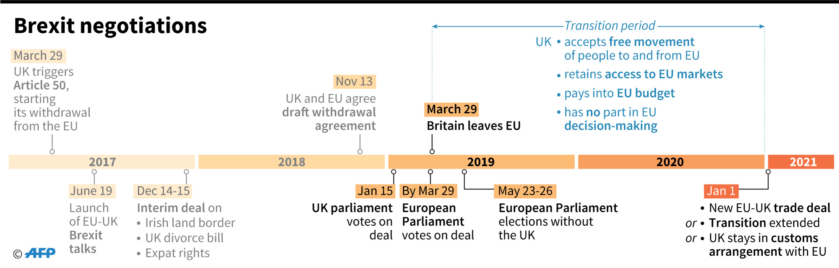

Click on this *BBC News* link and answer the following questions: <https://www.bbc.co.uk/news/uk-politics-47482047>

Why was the vote on 12 March 2019 so important?

What took place on 15 January 2019? Click on the [***Haven’t MPs already rejected May’s exit plan*?**](https://www.bbc.co.uk/news/uk-politics-47482047) link.

Watch ***Brexit Basics: The backstop*** short clip. Why is the backstop such an important part of the Withdrawal Agreement?

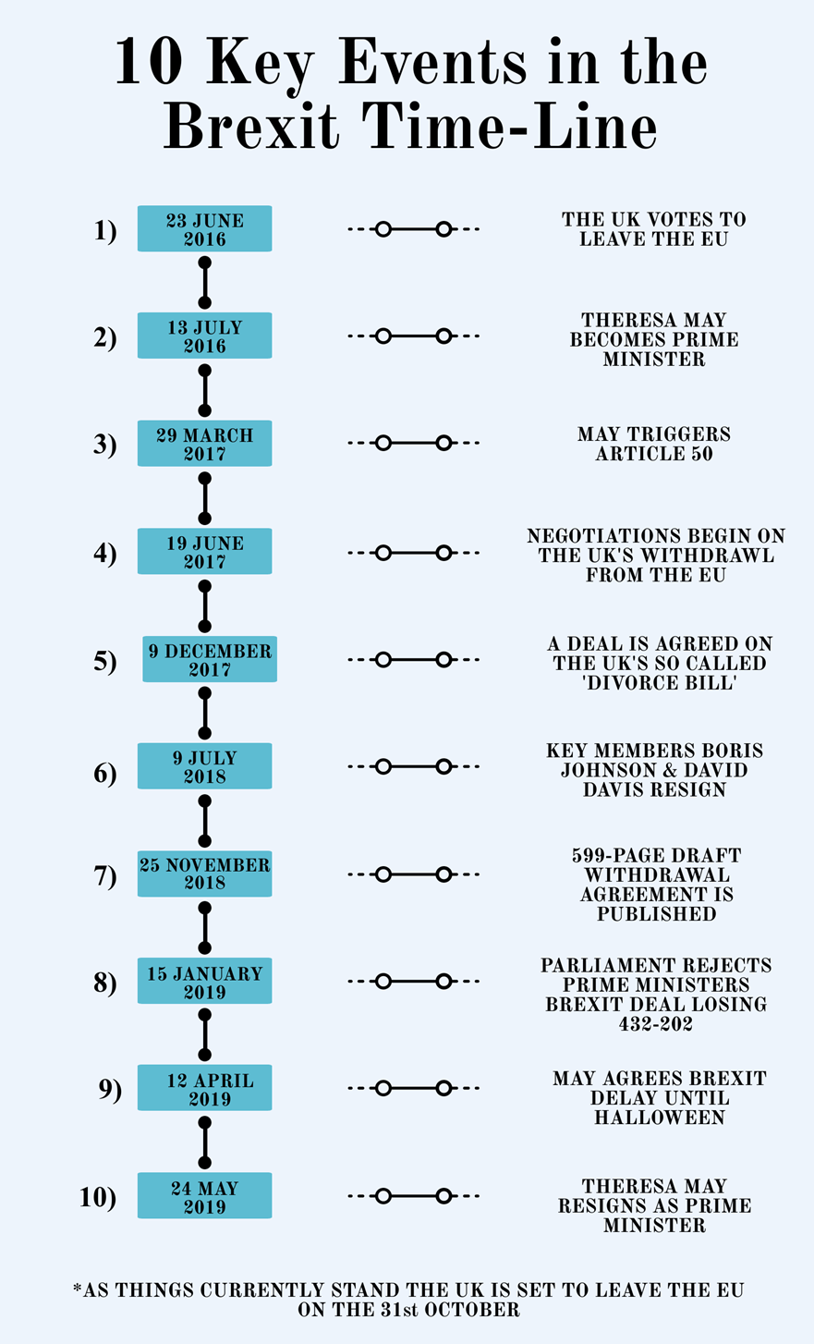

Further background information/reading can be found at:

<https://fullfact.org/europe/brexit-timeline/>