**AQA Geography Independent Investigation (20% of A level)**

The independent investigation must:

* be based on a research question or issue defined and developed by the student individually to address aims, questions and/or hypotheses relating to any part of the specification content
* involve research of relevant literature sources and an understanding of the theoretical or comparative context for a research question/hypothesis
* incorporate the observation and recording of field data and/or evidence from field investigations that is of good quality and relevant to the topic under investigation
* involve justification of the practical approaches adopted in the field including frequency/timing of observation, sampling and data collection approaches draw on the student's own research, including their own field data and/or secondary data, and their experience of field methodologies of the investigation of core human and physical processes
* demonstrate knowledge and understanding of the techniques appropriate for analysing field data and information and for representing results, and show ability to select suitable quantitative or qualitative approaches and to apply them
* demonstrate the ability to interrogate and critically examine field data in order to comment on its accuracy and/or the extent to which it is representative, and use the experience to extend geographical understanding
* require the student to independently contextualise, analyse and summarise findings and data, and to draw conclusions, by applying existing knowledge, theory and concepts to order and understand field observations and identify their relation to the wider context
* involve the writing up of field results clearly, logically and coherently using a range of presentation methods and extended writing
* demonstrate the ability to answer a specific geographical question drawing effectively on evidence and theory to make a well-argued case
* require evaluation and reflection on the investigation including showing an understanding of the ethical dimensions of field research.

Essential/Useful Information and links:-

**On GoL**

NEA booklets 1 & 2

AQA Independent Investigation Ideas (pdf - possible titles, methods etc)

Teaching Guide Fieldwork – (AQA pdf)

Exemplar AQA investigations (pdf)

Candidate record form 2022 (word document – Proposal Form)

**Online**

<https://maps.nls.uk/> Historical maps from National Library of Scotland

[https://geographyfieldwork.com](https://geographyfieldwork.com/BeachProfile.htm) Barcelona Field Studies

[https://www.geography-fieldwork.org](https://www.geography-fieldwork.org/a-level/coasts/) Field Studies Council – ideas for titles, methods and data presentation

<https://schools.esriuk.com/> ArcGIS

<https://datashine.org.uk/> Census maps

<https://www.nomisweb.co.uk/> Census data

<https://www.police.uk/> Local crime data

<https://www.gov.uk/government/publications/shoreline-management-plans-smps> Shoreline management plans

<https://maps.cdrc.ac.uk/#/geodemographics/imde2019/default/BTTTFFT/10/-0.1500/51.5200/> Index of multiple deprivation

Some stages of the investigation must be carried out independently. Other parts of the investigation may be carried out collaboratively, either as a class, group or pair.

**Independence is compulsory in the following stages of the investigation:**

* defining and developing a question or issue to address aims, questions and/or hypotheses relating to any aspect of the specification
* drawing on research, including field data and if relevant, secondary data which must be sourced by the student
* contextualising, analysing and summarising findings and data
* presenting data and drawing conclusions.

**Collaboration is allowed in the following stages of the investigation:**

* exploring the focus of potential investigations
* collecting field data and/or evidence from field investigations.

If students collaborate where independence is expected then the teacher must record this additional assistance on the Candidate record form (CRF) and take it into account when marking the work.

Students should select a manageable focus for their investigation which enables them to select one or more specific research question(s) or issue(s) with both a theoretical basis and a locational context. Appropriate and feasible methods should be used to collect relevant data. The data collected should permit the use of appropriate cartographical, graphical and statistical skills to enable a full interpretation to be made, which should include reference to the title/aim. The conclusion should include a summary of the results, the relevance of these to the title/aim and an evaluation of the overall investigation, including the contributions and limitations of geography in understanding the topic and opportunities for further research.

Students are expected to submit a written report which is 3,000–4,000 words in length. This includes all text, text boxes and supplementary material such as photographs and data presentation techniques. It does not include appendices.

Students who offer work that is below the advisory word count may be penalising themselves by not allowing appropriate coverage of the required assessment objectives. Students who exceed the advisory word count may be penalising themselves through a lack of precision and focus.

**NEA Timeline**

|  |  |
| --- | --- |
| **Action** | **Date** |
| **Proposal form** – You should start the completion of the proposal form as soon as possible once you have decided what your investigation is going to be based on. This proposal form will need to be reviewed and approved by your teacher and it is highly likely that it will need to have multiple revisions. Please allow time for this process. | **Finalised and approved** by the **end of the w/b 24th May.**  **Organisation of fieldwork equipment** – we have some equipment that can be borrowed if required. This will need to be issued by your teacher. Some equipment may be in demand and so we cannot guarantee it will be available when you require it. |
| **Data collection**  It is strongly advised that you collect your data over half term. If this is not possible, then you will need to ensure that the data is collected the first weekend back.  **Start of the introduction and methods write up**. | **HALF TERM** |
| **Introduction and method to be fully completed** | w/b 21st June |
| **Data presentation to be fully completed**  **Formal progress check** – parents and tutors to be contacted if insufficient progress has been made. | w/b 5th July |
| **Conclusion** -aim to complete this by the end of term.  There will be a benchmark in the first few weeks of the Autumn Term covering the content of Year 1. Therefore, your focus over the summer should be on revision for this and not completion of your NEA. | 14th July |
| **Summer holiday** | |
| **FINAL SUBMISSION DEADLINE** | The 3rd week of the Autumn Term. Exact date to be confirmed. |

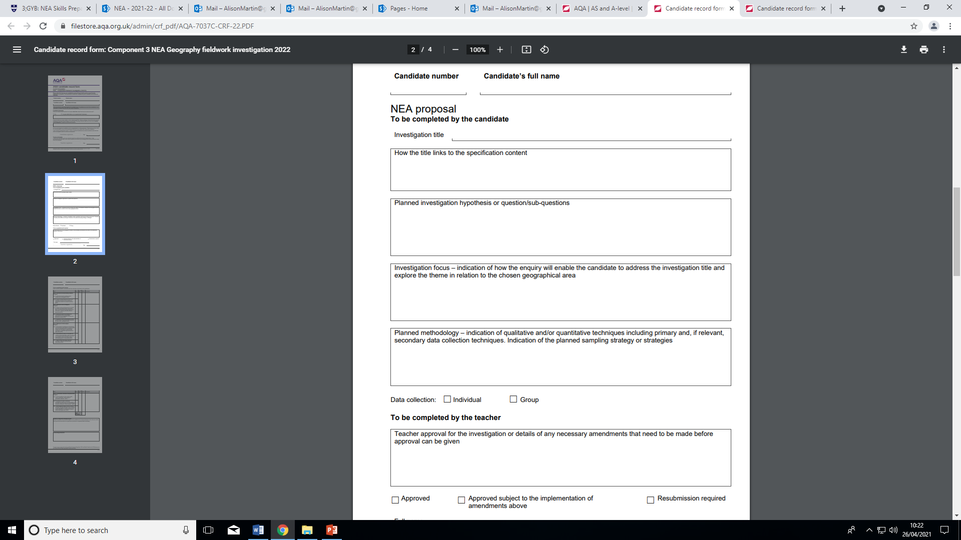

**A soft copy of this document can be found on GoL in the Independent Investigation folder.**

**Once your proposal form has been approved it will need to be submitted on GoL.**

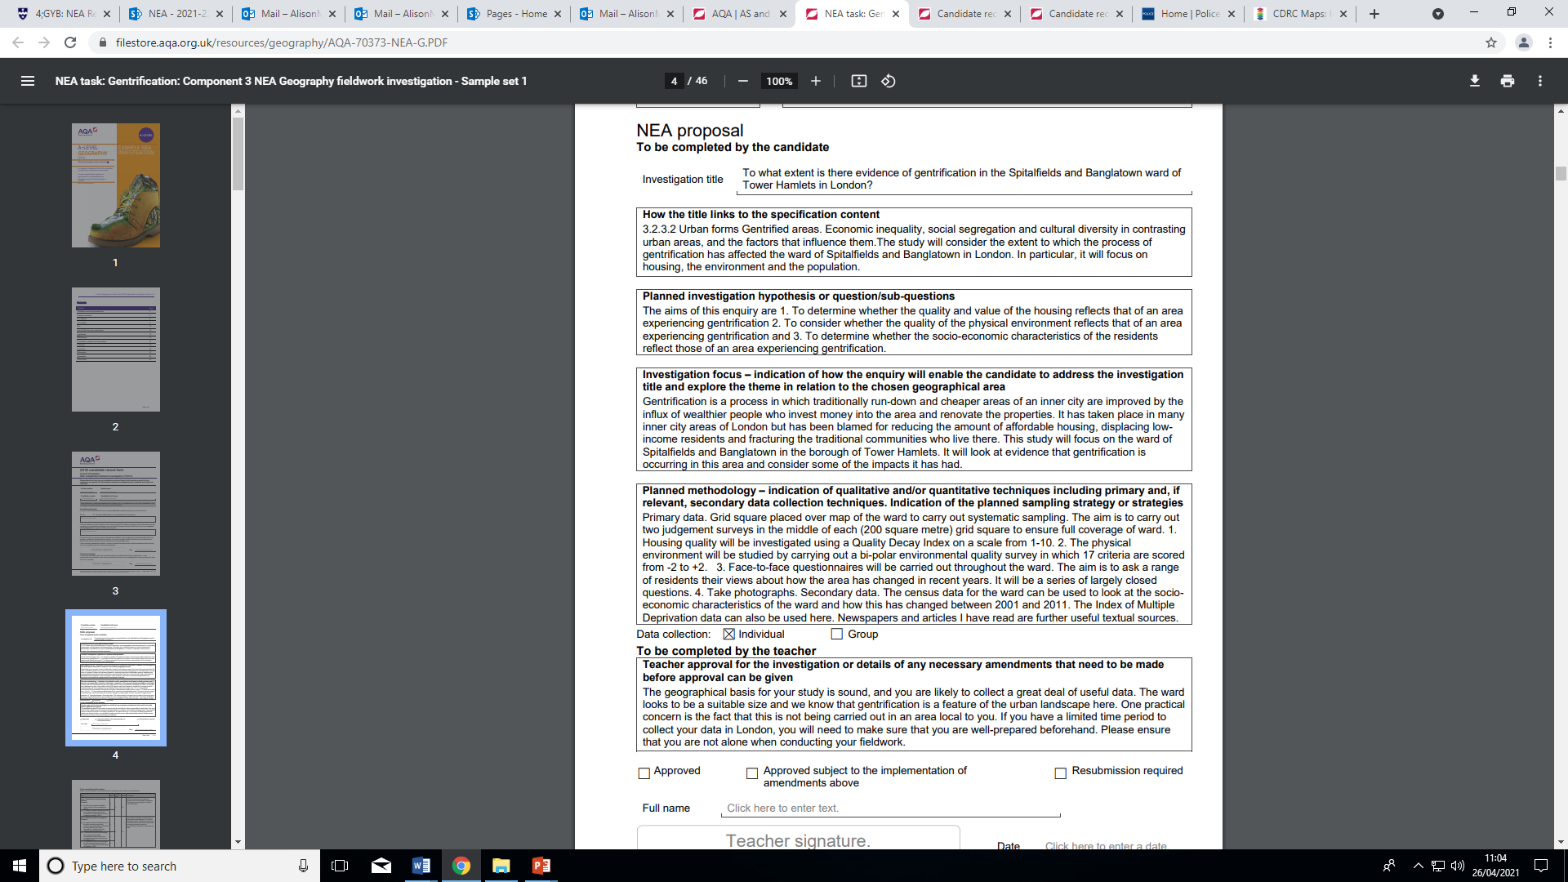

Example NEA proposal taken from the AQA Website. Other examples are also available. <https://www.aqa.org.uk/subjects/geography/as-and-a-level/geography-7037/assessment-resources?f.Resource+type%7C6=Candidate+record+forms&f.Resource+type%7C6=NEA+tasks>

**What could your sub-questions or hypotheses be?**

How do resident’s perceptions of crime vary? (Question)

The physical environment of Place A is better than Place B (hypothesis – something that can be proved or disproved)

**What could your title be?**

GoL – Independent Investigation folder – **Independent Investigation Ideas**

FSC weblinks <https://www.geography-fieldwork.org/a-level/#primary-nav>

See p 16 AQA Coursework Workbook

**How can this data be collected?**

**Data Collection**

What kind of things could be investigated? What data can be easily collected?

THIS IS THE KEY TO A SUCCESSFUL INVESTIGATION AS ANY DATA USED NEEDS TO BE EASY TO COLLECT AND RELEVANT TO ANSWERING YOUR INVESTIGATION TITLE

|  |  |
| --- | --- |
| Physical | Human |
| **Primary data**  e.g.  Beach profiles  Pebble size, angularity etc  Bi-polar assessments of different coastal defences  Longshore drift measurements  **Secondary data and research**  e.g. Shoreline Management Plans  Wind and wave direction data from the internet search | **Primary data**  e.g.  Environmental quality surveys  Pedestrian counts  Questionnaires on people’s perceptions  Clone town surveys  Building decay surveys  **Secondary data and research**  e.g.  Census data  Local planning documents  Local crime reports  House prices – zoopla |

**What statistical tests/methods of critical evaluation could be used?**

**Tests for differences in seats of data**

Chi- squared test, Student’s t-test, Mann-Whitney test

**The linkage (correlation) between two sets of data**

Scatter graph and lie of best fit, Spearman’s rank correlation

**Summarising and describing data – central tendency**

Mean, mode and median

**Spread, dispersion and range of data**

Standard deviation, quartile deviation and interquartile range

**How can this data be presented?**

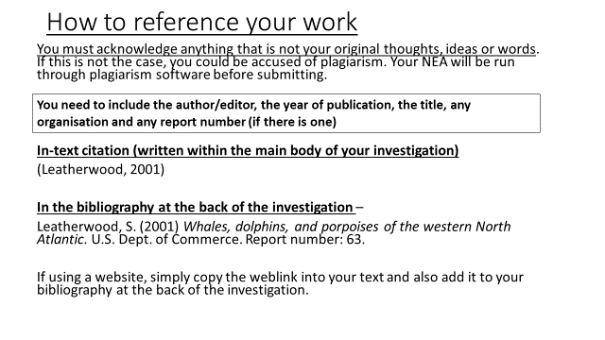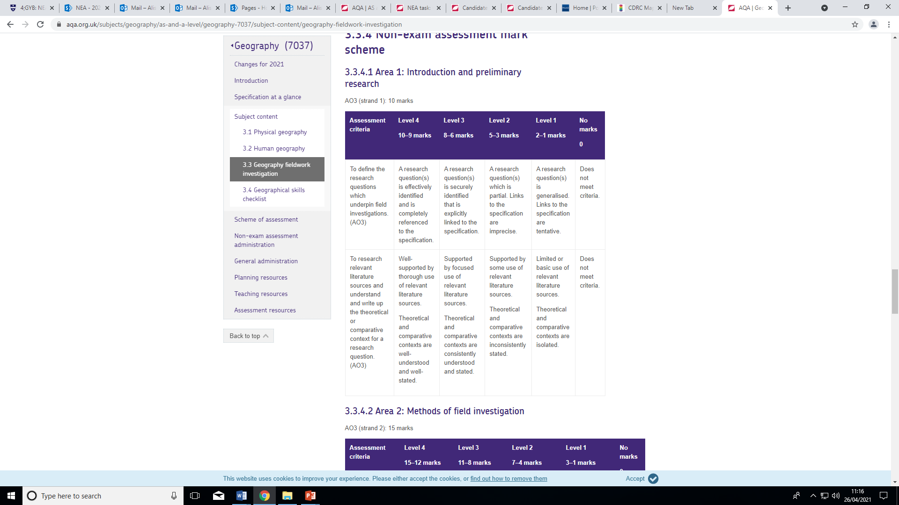 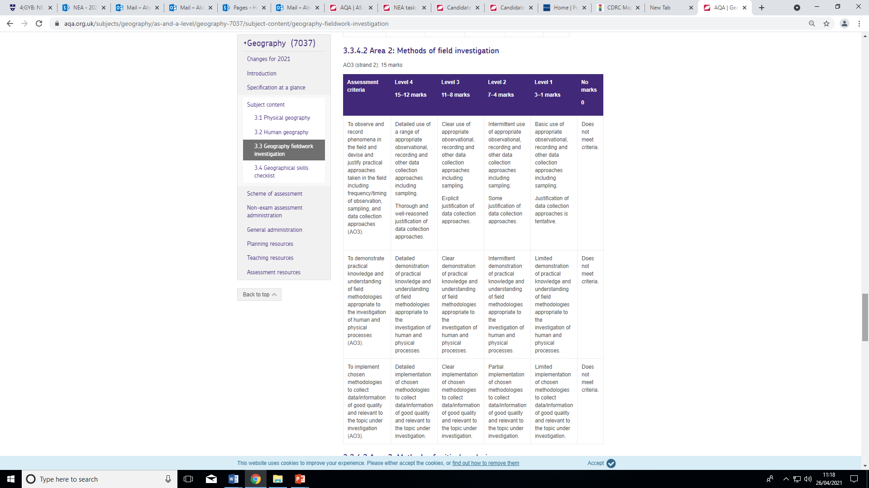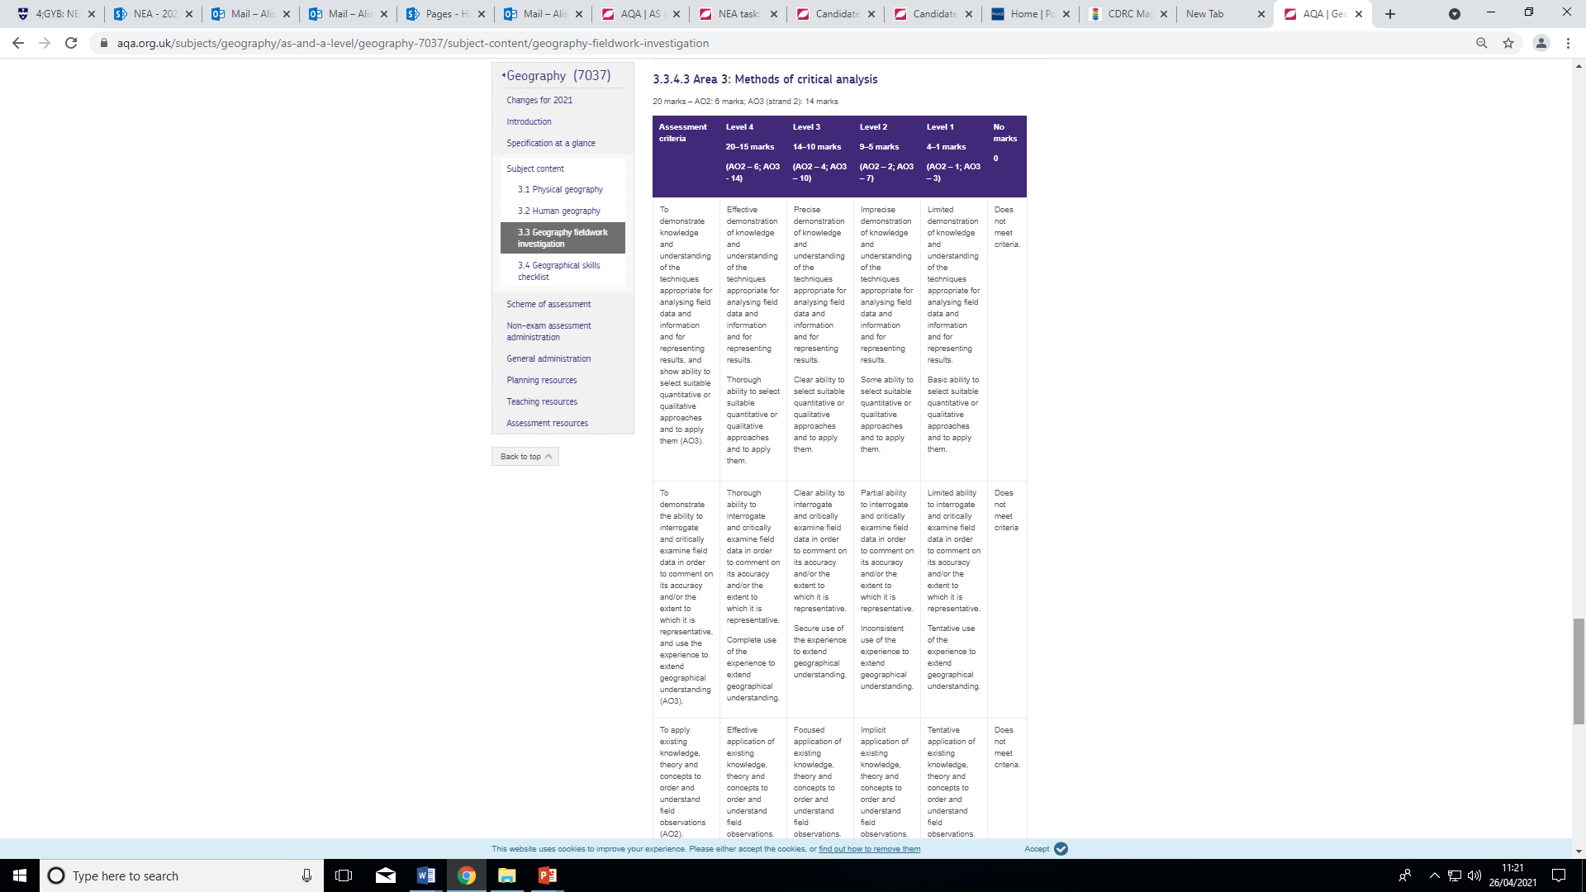 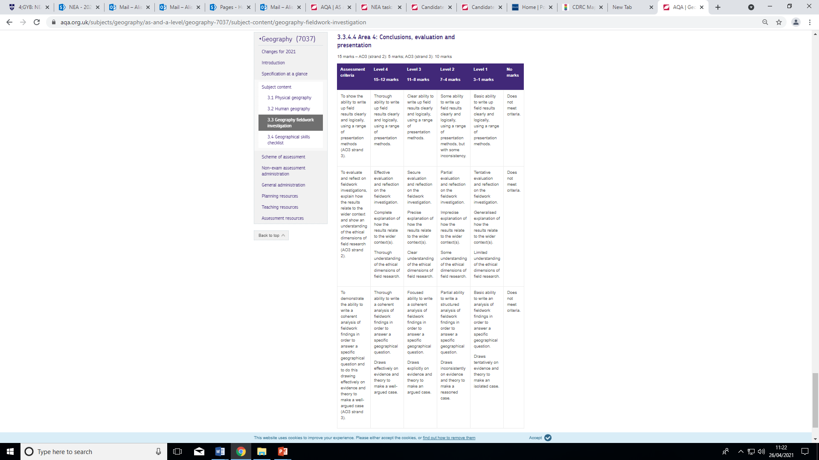

**Formatting Requirements**

* Use A4 page size
* Choose line spacing that aids readability (1.5 line spacing)
* Use Arial, Times, New Roman, Verdana, Candara or Calibri Fonts (11-12 points)
* Use page numbers
* Use spell/grammar check
* Include word count on the front cover page
* Include the following in a header or footer:
  + 5-digit centre number
  + Candidate number
  + Component Code

Abbreviations (acronyms) can be used if they are in common use and meaningful to the reader. They should be explained in the first instance, e.g. HDI (Human Development Index)

Table and figures, in general, should be comprehensible without reference to the text, i.e. labelled and numbered, followed by a short description of the contents.

* Include page breaks between the different sections of the investigation, e.g. Introduction, page break and then Methodology etc.
* Contents page (advisable to show structure)
* Referencing – make sure that this is integrated throughout. You should refer to all documents / websites that you have used to help you with the investigation, e.g. sampling techniques in your methodology – you may insert a reference to a particular fieldwork guide / book.
* Bibliography (at the end and Harvard style – see guidance on Godalming Online)
* Proof read your work to make sure that it makes sense
* Candidate record form – update and format

How to use the referencing tool in Word:

* Open a Word document
* Type something that you have copied from a book/article/website
* Click on the reference tab and insert citation and then click on new source.
* Complete as many of the fields as you can (some may not be relevant) and click OK.
* When you have completed all the citations you can click on the bibliography tab and it will automatically create a bibliography at the end of your document.

YOUR INVESTIGATION WILL START WITH RESEARCH AND SO THIS MUST BE COMPLETED FROM THE START

AQA Mark Scheme

<https://www.aqa.org.uk/subjects/geography/as-and-a-level/geography-7037/subject-content/geography-fieldwork-investigation>

**Geography NEA Checklist**

**Name:**

**This checklist is designed to help you ensure you have fulfilled the minimum requirements of the NEA. It is not a guarantee of success as this will depend on the quality of the investigation itself.**

**The checklist needs to be submitted with your Independent Investigation fully completed with the relevant evidence and page number where you demonstrate the requirements.**

|  |  |
| --- | --- |
| **Area 1. Introduction and preliminary research - 10 marks** | **Evidence and page number in your Independent Investigation** |
| A research question(s) is effectively identified and is completely referenced to the specification with a suitable comment as to how it is relevant. |  |
| You may have broken your key question down into specific key questions or hypothesis. |  |
| Well-supported by thorough use of relevant literature sources and fully referenced within the text and a bibliography. |  |
| You have included clear maps to show where your study area is located. Maps should be labelled/annotated or referred to in your text. |  |
| Your maps each have a source, title, scale and north arrow. |  |
| You have linked your question to geographical theory (i.e. the type of information you would find in a text book and online sources). This may be a model, concept, idea or geographical theory. |  |
| You have compared your study area to another with similar characteristics/problems/management where relevant. |  |
| You have included a literature review table at the end of your introduction |  |

|  |  |
| --- | --- |
| **Area 2. Methods of field investigation - 15 marks** | **Evidence and page number(s) in your Independent Investigation** |
| You have included methods of primary data collection. |  |
| You have included sources of secondary data collection. |  |
| Every type of data collection links very closely to your coursework question. If it doesn’t, change the method! |  |
| You have explained in detail exactly how you will collect each type of data. |  |
| You have said whether each type of data collection is stratified, systematic, random or pragmatic and why you selected this method. |  |
| You have said how much data you will collect (frequency and repetition), when you will collect it and referred to any collection methods requiring timing. |  |
| You have been specific on the timing of your data collection (time of day, date, season etc.) |  |
| You have justified your choice of study sites, making clear reference to your question. |  |
| You have a detailed paragraph referring to the ethics of collecting accurate and fair data. |  |
| You have identified problems, limitations and improvements for your data collections methods. |  |
| You have made a clear point to explain why you think your data is as accurate as it can be (evaluation will come in later). |  |
| You have mapped and labelled individual data collection sites |  |

|  |  |
| --- | --- |
| **Area 3. Methods of critical analysis - 20 marks** | **Evidence and page number(s) in your Independent Investigation** |
| You have used at least 4 different presentation methods and included a range of styles of presentation methods. |  |
| Where possible, use a statistical test to show the significance of your findings. Tests such as Spearman’s or Standard deviation are ideal although simpler calculations such as the interquartile range are also acceptable. |  |
| Every type of presentation is accurate and complete with scales, north arrows, titles, sources etc. |  |
| You have evaluated how well you think you followed the ethical dimension of your fieldwork (look back at your methodology for this) |  |
| You have justified your choice of presentation methods and have suggested other possible methods you could have used in hindsight. |  |
| You have a detailed analysis of your field data presentation techniques. |  |
| You have linked every piece of data presentation back to your original question to form a **conclusion.** |  |
| You have used evidence (more than one piece of evidence per point) to back up your conclusive statements. |  |
| You have interrogated and critically examined your field data in order to comment on its accuracy and/or the extent to which it is representative. |  |
| You have clearly answered your overall question/aims/hypothesis, showing alternative answers too (how your evidence might show other answer). |  |
| You have used evidence to show how the experience has extended geographical understanding. |  |
| You have shown effective application of existing knowledge, theory and concepts to order and understand your field observations. |  |
| You have ensured photograph annotations are detailed and of good quality |  |

|  |  |
| --- | --- |
| **Area 4. Conclusions, evaluation and presentation - 15 marks** | **Evidence and page number(s) in your Independent Investigation** |
| You have written a coherent analysis of your fieldwork findings in order to answer a specific geographical questions. |  |
| You have a complete explanation of how the results relate to the wider context. |  |
| You have a thorough understanding of the ethical dimensions of field research. |  |
| You make frequent links back to the question and you have backed up each point with evidence. |  |
| You have questioned whether your conclusions would be any different if you had collected different data or changed your methodology. |  |
| You have evaluated whether you think you chose the right methods and if not, why not. You have suggested what other possible methods you could have used. |  |
| You have linked every piece of data presentation back to your original question (these are like mini conclusions). |  |
| Your report is well organised throughout. |  |
| You have used a wide range of key terms. |  |
| You have proof-read your NEA to eliminate SPAG errors |  |