19. External Opportunities and Threats.
1. Missing words
However well a business _______________ and budgets, factors outside its control may disrupt the plan. In 2014 a new café opened in Hull just one week before a severe flood wiped it out. It was insured for flood damage, but the loss of earnings meant the owner had to return to his former job as a mini-cab driver. For many firms ______________________ factors are crucial; one bad summer can ruin the start-up of a surfing school. Even tougher can be the arrival of a _______________________, just when you are starting up. Your plan to be the town’s first Nail Boutique is undermined when the 2nd one opens nearby within a week.
HINT: words include seasonal, competitor/rival … plans.

2. Relate the external cause to the internal effects (Choose one from A-F and one from U-Z)
external factor | effect on business | effect on business
2.1 Fading consumer demand for luxury products | A. Customer numbers fall at the Oxford Weightwatchers franchise outlet | U. A car showroom specializing in luxury cars finds a sharp fall in sales
2.2 There is a sharp rise in world oil prices | B. Sales of women’s coats boost demand at the few shops that stock wide ranges | V. Demand for winter sun holidays is much higher than expected
2.3 Huge growth in high-spending customers in China | C. A small, independent petrol station finds weekly revenue slipping slowly but surely | W. The independent Halkin Hotel trains staff in Chinese language and culture
2.4 A new, powerful battery boosts sales of electric cars | D. A small, independent petrol station struggles to find the cash to pay suppliers | X. Sales of bottled water slip back, but fruit smoothies do better than ever
2.5 An exceptionally cold, wet Autumn | E. A new, upmarket jewellery shop struggles to achieve break-even sales | Y. As pollution fumes decrease, cafés with outdoor tables do very well
2.6 New fashion trend focuses on curves, not thinness | F. Palace Jewellers of London opens its first overseas outlet - in Beijing | Z. Price competition starts up among producers of top perfumes

3. Look at this data of oil prices 2005-2015. What if you had started a green energy business in 2014?
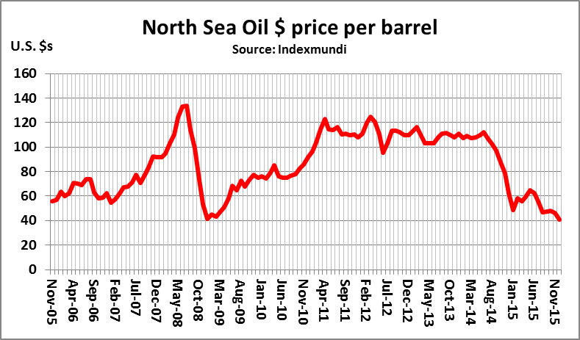
In January 2014 a new, green energy business started up. Its plan was to persuade drivers to switch from diesel to plug-in electric cars. How might this movement in the oil price have affected the business? Explain your answer.
Source: Nationwide Building Society
______________________________________________________________________________________
______________________________________________________________________________________
_______________________________________________________________________________________________

19. ANSWERS – External opportunities and threats

1. plans … seasonal … competitor

2.1 E. Z
2.2 D. U
2.3 F. W
2.4 C. Y
2.5 B. V
2.6 A. X

3. The oil price slump in late 2014 would have hit hard at the business plan. Although people talk green, they tend to act in their own economic best interests, so a high oil price would have been a huge help in persuading people to accept the relative insecurity of a plug-in car.

