20. Human Resource Competitiveness.
1. Missing words
Businesses with a multinational structure check constantly on the relative performance of the workforce in different _________________________. If Ford Germany is 20% more productive than Ford UK when making engines for its Focus model, Head Office will want to know why. Why is an interesting question; but what may be even more interesting. What should managers do about it? One answer may be to pay higher wages to German workers than British; another might be to close a ____________________ Ford factory. Senior managers are also interested in labour _______________________: if it’s very high in one country, that may indicate possible future problems with quality of production or service. Missing words from: turnover, productivity, British, countries.
2. Data Response
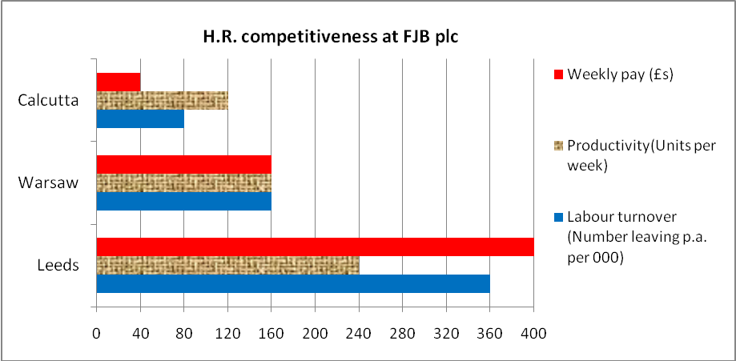
2.1 Calculate the labour cost per unit for each of FJB plc’s three main factories, in Leeds (England), Warsaw (Poland) and Calcutta (India).
a) Labour cost per unit at Leeds: _______________ Warsaw: _______________ Calcutta:________________
b) If FJB plc planned to double capacity at one of its factories, which location would it be likely to choose, and why?
______________________________________________________________________________________
______________________________________________________________________________________
2.2 Explain one possible reason why labour turnover is higher in Leeds than in Warsaw
______________________________________________________________________________________
______________________________________________________________________________________
3. Match the effect to the cause
H.R. Issue | effect on competitiveness | effect on competitiveness
3.1 Low productivity at a British tractor factory | A. The UK factory remains more competitive and therefore more secure | D. The UK businesses will have better staff continuity and therefore reliability
3.2 Higher labour retention at a French bank than at its UK rivals | B. Probable effect is that labour cost per unit is too high | E, Relatively low pay levels may encourage staff to take strike action against the company
3.3 Slightly lower productivity at a UK factory is offset by much lower hourly pay than at the firm’s Swiss division | C. The UK business may be weakened a little by having too few new staff to bring new ideas or activities | F. It may be difficult to provide enough output to meet demand – especially in busy periods.

20. ANSWERS – Human Resource Competitiveness

1. countries … British … turnover

2.1a) Leeds: £400/240 = £1.67 (£1.66 is also OK) Warsaw: £100/100 = £1 Calcutta: £40/120 = £0.33

2.1b) Despite its relatively low productivity, Calcutta labour cost per unit is 1/6th of the level in Leeds, therefore making it far more attractive as a way of producing profitably.

2.2 Labour turnover is the rate at which staff leave and need to be replaced. If unemployment is high in Warsaw, few people would voluntarily leave their job in search of another. So they stay with their existing employer. Perhaps unemployment is lower in Leeds than Warsaw.

3.1 B + F
3.2 C + D
3.3 A + E

