64. Global environmental issues
1. Missing words
Until the Volkswagen ______________________ scandal in 2015, most people would have assumed that companies were trying to contribute towards a slowing down of greenhouse gas emissions and therefore global ________________. Genuine innovations such as Toyota’s hybrid and Tesla’s electric cars seemed to be showing the way. And in Britain, every retailer’s annual report contained masses about ‘reducing our ________________ footprint’ and ‘reducing food miles’. Despite VW’s deceitful and unethical behaviour, it may yet be that companies are genuinely being more responsible. Oddly, Toyota had already proved the global value of being seen to be ______________, making VW’s shame all the greater.
Hint: words from – green, warming, quality, emissions, sustainable, carbon
2. Data Response: global warming gases. 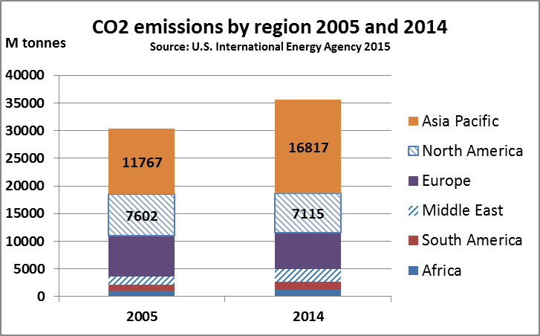
Global total
30,279m
Global total
35,500m
2.1 Calculate the percentage change in CO2 emissions between 2005 and 2014 for a) Asia Pacific and b) the rest of the world. _____________________________________________________________________________
2.2 Outline two possible reasons for the scale of the increase in Asia Pacific.______________________________
______________________________________________________________________________________
______________________________________________________________________________________
______________________________________________________________________________________
2.3 Outline one way in which businesses may have helped to reduce CO2 emissions in America. _______________
______________________________________________________________________________________
______________________________________________________________________________________
3. Suggest two:
3.1 Ways businesses can help postpone the depletion of finite resources such as copper.
______________________________________________________________________________________
______________________________________________________________________________________
3.2 Benefits a company can gain as a result of being seen by consumers to be strong on environmental issues
______________________________________________________________________________________
______________________________________________________________________________________
______________________________________________________________________________________

64. ANSWERS – Global environmental issues

1. emissions … warming … carbon … green

2.1a) +42.9%
2.1b) ROW 2005 = 18,512 ROW 2014 = 18,683, so the % increase is +0.9%

2.2 The extremely rapid growth of China and (to a lesser extent) India would have had a significant impact
Also, China became more and more the world’s production site, so emissions that might previously have come from America started to come from China

2.3 Companies may have chosen to cut their CO2 emissions, e.g. by switching from petrol to electric cars and vans (or, more probably, switching from petrol to diesel)

3.1
- Recycle more
- Invest more heavily in R&D into new, perhaps lighter materials – especially those in more plentiful supply

3.2
- A green or ethical glow adds value (that’s why mums shop at John Lewis)
- In the long run, few things are more important to business success than great recruitment; young bright staff would rather join a green than a tainted company

