68. Global Sourcing
1. All Mixed Up! – The words in bold are in the wrong place, cross out and replace with the correct word.
Global sourcing is the strategic competitiveness of goods and services beyond a firm’s domestic market. A Dell computer, for instance, contains parts sourced from many different countries; call Dell’s support line and you will be talking to someone in Ireland or maybe even Slovakia. Global sourcing gives companies access to lower cost goods and services, access to products/raw materials not available domestically and increases total supply risky. Firms, large and small, use global sourcing to enhance procurement, lower costs and drive profits. Global sourcing can, however, be a complex and capacity business.

2. Sort ‘em Out - benefit (B) or risk (R) of global sourcing:

Increasing total supply capacity  Fuel price volatility 
Shipping delays  Exchange rate changes 
Access to/learn about a potential market  Lower per unit prices 
Loss of intellectual property  Access to new products 

3. What, Why and How:

3.1 WHAT criticism might an environmentalist say about global sourcing?________________________________
______________________________________________________________________________________

3.2 Suggest one reason WHY global sourcing has become increasingly common. ___________________________
______________________________________________________________________________________

3.3 Suggest HOW a firm might try to reduce one risk of global sourcing. ________________________________
______________________________________________________________________________________

4. Data Response:
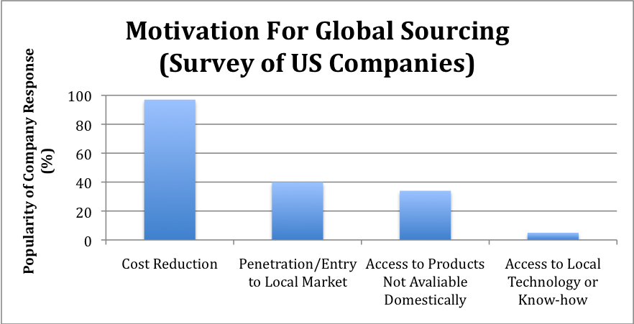
Nike has developed an extensive supply base of approximately 40 locations -- predominantly in low-wage Asian countries. As a result, the cost of producing Nike shoes is about 25% of the retail price.

Interestingly, Nike’s supply chain mixes low-cost countries with higher-cost ones. Initially, much of Nike's production was in South Korea and Taiwan. As wage rates increased, Nike sourced from lower-cost countries like Indonesia. Nike continued to use the technological superiority of South Korean and Taiwanese suppliers to produce increasingly complex products, while suppliers in low-wage countries make the simpler products.

4.1 Briefly compare Nike’s motivations for global sourcing with those shown in the graph.
______________________________________________________________________________________
______________________________________________________________________________________

4.2 Suggest why global sourcing is a motivator for firms wishing to penetrate/enter local markets.
______________________________________________________________________________________
______________________________________________________________________________________
4.3 Suggest two reasons (other than technological superiority) why Nike may have maintained relationships with its South Korean and Taiwanese suppliers.
______________________________________________________________________________________
______________________________________________________________________________________

68. ANSWERS: Global Sourcing

1. In order – procurement…capacity…competitiveness…risky

2.
Increasing total supply capacity B Fuel price volatility R
Shipping delays R Exchange rate changes R
Access to/learn about a potential market B Lower per unit prices B
Loss of intellectual property R Access to new products B

3.1 The carbon footprint of goods sourced and transported globally can be very high (note the recent move by supermarkets to more locally sourced produce); others criticisms might include noise and congestion.
3.2 Faster and cheaper transportation methods; globalisation of consumer tastes (supermarkets now sell large quantities of what once would have been considered ‘exotic’ produce); increase in free trade areas/agreements.
3.3 Source from countries relatively local; source from countries with similar cultures/business practices; source from stable countries (politically and economically); hedge against exchange rate changes; develop and maintain strong links with suppliers.

4.1 Seem broadly similar (cost the main factor), but evidence that Nike perhaps values technological know-how more highly than the firms surveyed.
4.2 Sourcing from within a country allows firms to develop an understanding of the country, its culture and ways of doing business. It may also help in developing relationships with potential partners (the current supplies). Thus, a low(er) cost and low risk way to test a market for entry.
4.3 Suppliers may have demonstrated reliability, ability to meet Nike’s quality standards and/or flexibility of production (enabling Nike to quickly meet fluctuating demand); countries may be considered politically and economically stable; sunk costs of developing supplier relationships, safety net if new suppliers do not work out.

