71. Growing power of China
1. Missing words
Between 1990 and 2013 China’s economy grew at 10% a year – the fastest rate ever recorded. In 2014 and 2015 there was a slowdown as the Chinese moved the economy away from dependence on ___________________ and investment towards consumer spending and the _______________________ sector. By the beginning of 2016 the Chinese economy had settled back to a growth rate of 6-7% a year – still around three times the growth rates in the west. By this time China’s was the biggest economy in the world (at PPP: __________________________ Power Parity), the biggest exporter of goods and the second largest purchaser of imported goods. It was the clear global number one market for cars, luxury watches, bags and clothing – and for every single industrial _____________________. HINT: words from commodity, service, exports, purchasing
2. Data Response: look at the bar chart then answer the questions below
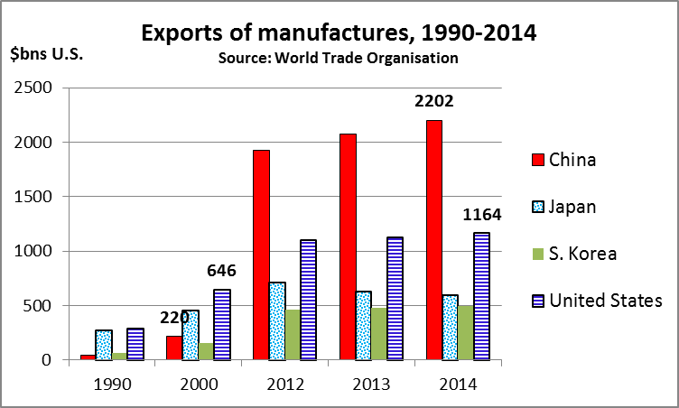
2.1 Calculate the percentage increase in exports of manufactured goods from China and from America between 2000 and 2014. Briefly comment on your findings.
______________________________________________________________________________________
______________________________________________________________________________________
2.2 Explain how China might have benefited from its sharp rise in exports of manufactured goods.
______________________________________________________________________________________
______________________________________________________________________________________
2.3 Now that growth has slowed, Chinese producers of steel and cars are thinking of expanding their exports, especially to developing countries that need cheaper, practical products. How might that affect western producers?
______________________________________________________________________________________
______________________________________________________________________________________
3. Find The Word formed by the first letter of the terms defined below
3.1 A government policy that disrupts imports.
3.2 What China might do if America decided to block imports from China.
3.3 The way in which China still spends more than 40% of its GDP: to boost economic growth
3.4 The country that manufactures half the world’s steel
3.5 The trading bloc that provides China with its largest overseas market

71. ANSWERS – Growing power of China

1. exports … service … purchasing … commodity

2.1 Calculate the percentage increase in exports of manufactured goods from China and from America between 2000 and 2014. Briefly comment on your findings.
- China growth: 1982/220 x 100 = +900.9%
- USA growth: 518/646 x 100 = + 80.2%
- Comment: China’s massive rise in exports seems to have been partly at Japan’s expense, though America has held up pretty well

2.2 Explain how China might have benefited from its sharp rise in exports of manufactured goods.
- Exports bring foreign currency into the country; this can be used to buy imports (in China’s case, especially of western luxury goods such as Swiss watches) and/or to build up the country’s foreign currency reserves, so that it can control its exchange rate
- Exports cannot simply be a matter of price; to sell in developed countries requires tight control over production quality as well (all those iPhones); this will help improve Chinese producers’ attitudes to quality throughout the economy

2.3 Now that growth has slowed, Chinese producers of steel and cars are thinking of expanding their exports, especially to developing countries that need cheaper, practical products. How might that affect western producers?
- Western companies fear markets being flooded by Chinese producers; there’s always room in a market for the lowest-cost item, so Chinese-built cars could sell in the west – but more importantly they can take market share in countries such as Nigeria, Russia, Iran and Indonesia
- New Chinese competition is increased supply that is bound to push prices down

3.1 Protectionism
3.2 Retaliate
3.3 Investment
3.4 Consumer
3.5 European Union
Word is PRICE

