73. Growth of the UK compared to emerging economies
1. Fill in the gaps
The UK is a wealthy and mature economy in which a growth rate of 3% in a year would be regarded as racy and perhaps _________________________ (because we don’t have a lot of spare resources). Emerging economies can grow relatively rapidly because they can learn from (OK, copy) the things that have already worked well elsewhere, e.g. shopping malls, clothing ___________________ and intensive, specialised farming of cash crops for western markets. In relatively recent times, Japan, South Korea and China have shown how to grow from an impoverished to a wealthy society; other ___________________ economies such as India and Nigeria have a long way to go. In the very long term (more than 200 years) the UK has grown by an average of 2.25% a year; we got rich slowly but surely. Emerging economies want more: with 5% being regarded as strong, and China’s historic 10% a year the ultimate dream. Missing words: factories, emerging, unsustainable
2. Data response (Study the graph then answer the questions below)
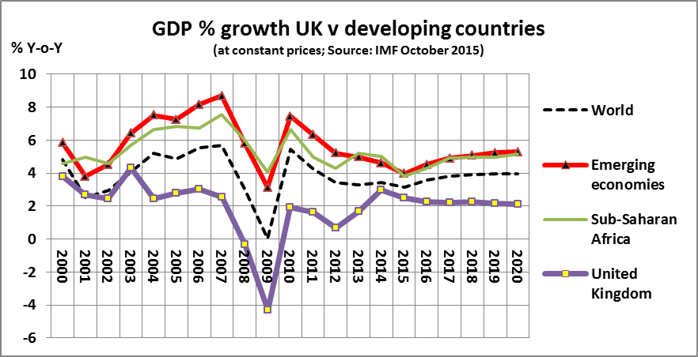
2.1 For the period between 2004 and 2012, estimate the average GDP growth rate for a) the UK and b) Emerging economies. Comment briefly on your findings.
______________________________________________________________________________________
____________________________________________________________________________________________________________________________________________________________________________
2.2 From the graph, describe what happened to emerging economies in 2009 compared with the UK.
______________________________________________________________________________________
____________________________________________________________________________________________________________________________________________________________________________
2.3 Use the graph to compare the performance of sub-Saharan Africa with the world as a whole from 2000 to 2015.
______________________________________________________________________________________
______________________________________________________________________________________
3. True or False? Put in your answer, but discuss why with your partner/group (or yourself)
3.1 In the long run countries such as China will catch up with the UK’s GDP per capita. True / False
3.2 Growth figures for emerging economies can be misleading because they ignore the much higher population growth than in the west. So per capita GDP figures would be more useful. True / False
3.3 Sustained economic growth requires stable and intelligent government locally. True / False

73. ANSWERS – Growth of the UK compared to emerging economies

- Unsustainable … factories … emerging

2.1 For the period between 2004 and 2012, estimate the average GDP growth rate for a) the UK and b) Emerging economies. Comment briefly on your findings.
- UK’s looks to average less than 2%; anywhere between 1 and 2% a year is fair
- Emerging economies averaged about 6% a year; a reasonable spread is 5.5% to 6.5%
- Emerging economies grew at about 3 to 4 times faster than Britain over this period

2.2 From the graph, describe what happened to emerging economies in 2009 compared with the UK.
- While the UK’s GDP plunged into recession in 2009, emerging economies suffered a downturn, but without negative growth; so technically they were never in recession

2.3 Use the graph to compare the performance of sub-Saharan Africa with the world as a whole from 2000 to 2015.
- Sub-Saharan Africa grew almost as fast as emerging economies as a whole over this period of time, with growth rates that were about 2% higher each year than the world as a whole.

3. True or False? Put in your answer, but discuss why with your partner/group (or yourself)
3.1 In the long run countries such as China will catch up with the UK’s GDP per capita.
False: it may prove to be true, but the word ‘will’ gives a degree of certainty that is impossible to go with

3.2 Growth figures for emerging economies can be misleading because they ignore the much higher population growth than in the west. So per capita GDP figures would be more useful.
True: but for some reason per capita GDP growth figures are rarely published (Unicef is a good source for them)

3.3 Sustained economic growth requires stable and intelligent government locally.
True: probably too obvious; note that I didn’t say ‘honest’; corruption is widespread in developing economies but doesn’t necessarily get in the way of growth (as in America until quite recently)

